** **



**Development of Global Positioning System (GPS) for Enhanced Public Safety during Saving Our Souls (SOS) Disaster**

**By**

**DARSHRNNEY A/P PUSHPANATHAN**

**TP072253**

**APD3F2411CS**

A report submitted in partial fulfillment of the requirements for the degree of

B.Sc. (Hons) Computer Science

at Asia Pacific University of Technology and Innovation.

**Supervised by Mrs. Mary Ting**

**2nd Marker: Mr. Abu Bakar S. Santuraki**

**2025**

# ACKNOWLEDGEMENT

During the course of my Final Year Project (FYP) there has been significant people I would like to address my admiration and thanks to them. Firstly, my dear supervisor Mrs.Mary Ting, for her guidance and support throughout this project. Mrs.Mary Ting played an important role in guiding me with the project title and giving me suggestions on my questionnaire at the beginning of this assignment. We brainstormed on how the project can be modified for better use and establishment in real world scenarios. Secondly, I would like to thank my second supervisor, Mr.Abu bakar S. Santuraki , for his input with the ethics form and also taking his time to mark my FYP. Besides that, I would like to extend my thanks to my mentor for this course, Dr Dewi Octaviani, for briefing us on the requirements and process of this documentation. Nevertheless, Mrs. Nur Amira Abdul Majid also helped continue Dr.Dewi’s work with reminders on when the submission is due and to help in FYP challenges.

I am grateful to my parents, friends and other lecturers who has helped me shaped my ideas and gave me valuable inputs during the ethics form process. My mother and brothers were there to give me idea on what the current trends are and what they would be looking forward for as an IOT solution in their daily life. A special thanks to Mrs.Lai Chew Ping, and Mr. Dhason Padmakumar for their time to conduct a meeting with me personally and give me inputs on how good my system is with its title. To my friend Lubaina Khan, I would like to thank her for helping me with frequently asked questions about my FYP and for her positive support in the contents needed for the Investigation Report.

# ABSTRACT

Disasters can strike any person at any time and any place, it is up to the person themselves to learn and educate themselves in safety procedures in the long run. Relevant parties that manage this type of crisis should be reliable and dependable for the citizens who are unprepared. That is why, in this study we will be looking into users’ opinions who have undergone natural disasters and learning about what systems are required to relay timely and efficient warnings to the user. The total number of surveys collected was 37, from people above the age of 19 to justify the problem statement is true by using the spiral methodology. This project’s main analysis is created to develop the requirements for a proposed system. The study includes the use of Application Programming Interface (API) for weather updates, real-time geolocation and news dissemination. This project will consist of Spiral methodology to understand the steps needed to build the application by using Dart as its programming language and Flutter as its framework. This whole project uses Sustainable Development Goal (SDG) 13 as its way to combat ongoing impacts done by climate change for the safety of the citizens.

*Keywords: Global positioning System (GPS), Prevention for Natural Disaster, Application Programming Interface (API), Emergency Response System, Online Learning*

**SDG GOAL 13: Take urgent action to combat climate change and its impacts**

# TABLE OF CONTENTS

ACKNOWLEDGEMENT 2

ABSTRACT 3

TABLE OF CONTENTS 4

LIST OF FIGURES 6

LIST OF TABLES 8

CHAPTER 1: INTRODUCTION 9

1.1 Introduction 9

1.2 Problem Context 11

1.3 Project Aim 14

1.4 Objectives 15

1.5 Scope 16

1.6 Potential Benefit 17

1.7 Overview of the IR 18

1.8 Project Plan 19

CHAPTER 2: LITERATURE REVIEW 22

2.1 Introduction 22

2.2 Domain Research 23

2.2.1 Similar Systems 28

2.3 Technical Research 34

2.3.1 Physical Hardware 34

2.3.2 Programming language 34

2.3.3 Libraries and tools 35

2.3.4 Testing tools 36

2.3.5 Operating System 36

2.4 Summary 37

CHAPTER 3: METHODOLOGY 38

3.1 Introduction 38

3.2 System Development Methodology 38

3.2.1 Introduction of methodology 38

3.2.2 Methodology Choice and Justification 40

3.2.3 Activities and Processes 40

3.3 Data Gathering Design 42

3.4 Data Analysis 53

Section 1: Demographic Section 53

Section 2: Community Section 57

Section 3: System Section 62

Section 4: Accessibility and Inclusivity Section 68

Section 5: Challenges and Barriers Section 73

Summary for Analysis 75

3.5 Summary 75

CHAPTER 4: CONCLUSION 75

4.1 Achievements Reached 75

4.2 Adequate Research and Analysis Justification 76

4.3 Gaps and Future Enhancement 76

REFERENCES 77

APPENDICES 82

Screenshot of PPF 82

Screenshot of signed ethics form 95

Screenshot of Log sheets 99

Log sheets 1 99

Log sheets 2 100

Log sheets 3 101

Gantt chart for FYP Semester 1 102

Respondence Demographic Profile 103

# LIST OF FIGURES

Figure 1: Media Richness Theory 25

Figure 2: Shows a spiral model which consist of 6 task 41

Figure 3:Consent sheet and information about the project 42

Figure 4:Demographic section of the intended research, part 1 43

Figure 5: Demographic section of the intended research, part 2 44

Figure 6: Community questions for the responders , part 1 45

Figure 7:Community questions for the responders , part 2 46

Figure 8:System questions for the responders, part 1 47

Figure 9: System questions for the responders, part 2 48

Figure 10: Accessibility and Inclusivity questions for the responders, part 1 49

Figure 11: Accessibility and Inclusivity questions for the responders, part 2 50

Figure 12: Challenges and Barriers questions for the responders 51

Figure 13: Gender of the total respondents. 52

Figure 14: Different age group of the total respondents. 52

Figure 15: Different country nationality residing in Malaysia. 53

Figure 16: Martial status of the total respondents. 54

Figure 17: Number of years the respondents have resided in Malaysia. 54

Figure 18: Total number of people the respondents live with 55

Figure 19: Total number of people owns their space 55

Figure 20: Statistic of knowledge on preparation of a natural disaster 56

Figure 21: Statistic of education programs about natural disaster 56

Figure 22: Statistic of education programs about natural disaster 57

Figure 23: Statistic of real-time disaster alert about natural disaster 57

Figure 24: Statistic of SOS system feature about natural disaster 58

Figure 25: Statistic of campaign programs reach about natural disaster 58

Figure 26: Statistic of empowerment of system on natural disaster 59

Figure 27: Statistic of trust in natural disaster system 59

Figure 28: Statistic of reminder system about natural disaster 60

Figure 29: Statistic of collaboration of community in natural disaster 60

Figure 30: Bar chart for respondents who carry their mobile phones. 61

Figure 31: Bar chart for lack of sending signals. 61

Figure 32: Bar chart for GPS system. 62

Figure 33: Bar chart for traditional response system. 62

Figure 34: Bar chart for SOS system in sending signals to relevant parties. 63

Figure 35: Bar chart for gaps in public safety infrastructure. 63

Figure 36: Bar chart for simple SOS system 64

Figure 37: Bar chart for report mechanism. 64

Figure 38: Bar chart for GPS use. 65

Figure 39: Bar chart for API integration. 65

Figure 40: Timely notifications 66

Figure 41: Timely notifications on losses and damages. 66

Figure 42: SOS system for accuracy and speed 67

Figure 43: News notifications. 67

Figure 44: Timely notifications for vulnerable population. 68

Figure 45: SOS notifications graph. 68

Figure 46: Verifying reports graph 69

Figure 47: Cost free graph. 69

Figure 48: Collaborating with government. 70

Figure 49: Development cost graph. 70

Figure 50: Funding and resources graph. 71

Figure 51: Technical challenges graph. 71

Figure 52: Funding and resources graph. 72

Figure 53: System trust graph. 72

Figure 54: PPF page 1 77

Figure 55: PPF page 2 78

Figure 56: PPF page 3 79

Figure 57: PPF page 4 80

Figure 58: PPF page 5 81

Figure 59: PPF page 6 82

Figure 60: PPF page 7 83

Figure 61: PPF page 8 84

Figure 62: PPF page 9 85

Figure 63: PPF page 10 86

Figure 64: PPF page 11 87

Figure 65: PPF page 12 88

Figure 66: PPF page 13 89

Figure 67: Ethic form page 1 90

Figure 68: Ethic form page 2 91

Figure 69: Ethic form page 3 92

Figure 70: Ethic form page 4 93

Figure 71:Log sheets 1 94

Figure 72:Log sheets 2 95

Figure 73:Log sheets 3 96

Figure 74:Gantt chart for FYP Semester 1 98

# LIST OF TABLES

Table 1: Project plan table 21

Table 2: Compilation of various similar system 33

Table 3: Summary for development of supplication system. 34

Table 4: Comparison with RUP, Spiral and SCRUM 39

Table 5: Responder’s Demograph 98

# CHAPTER 1: INTRODUCTION

## Introduction

In our globally digitized world, technology has become an outstanding success to aid many people in their daily routines. Not a day goes by when people have not used their smartphones, to browse through applications such as social media, banking, fitness and many more. Hence, in a smartphone era there should be an application to help in such a crisis such as a disaster alert system. For example, Malaysia is situated at the equatorial line of the world, which has a lesser chance for natural disaster to happen. However, natural disaster such as, floods are one of the most common occurrences to happen in Malaysia because of many factors such as heavy rain, unsuitable infrastructure, disposal of rubbish and many more. All these complex factors for natural disaster can be prevented with simple integrations of an application.

One of the key topics that is discussed is how climate change will affect the natural environment surrounding the citizens. This project focuses on tackling climate issues on the earth and its effect that landslides into natural disaster. One of the most noticeable works done by organizations is the World Wild Fund for nature (WWF), they recently have cited from the sixth Intergovernmental Panel on Climate Change (IPCC) report predicted that the carbon emissions have impacted the planet’s temperature since pre-industrial times to 1.1 °C causing big impacts on glaciers and effecting floods on North Carolina(WWF, ). Methods to change infrastructure and default flood management are not impactful enough to minimize the negative effects of the disaster. Another major agreement that aligns with SDG goal 13, is the Paris Agreement, which is known for limiting global warming to well below 2°C (preferably 1.5°C) compared to pre-industrial levels. Both of these actions closely relate to one another because of the mitigation and adaptation process that helps to combat climate change. The Paris Agreement is one of the efforts made for SDG 13 to be achieved and recognized as improving awareness as well as educating the public on the changes adopted by stronger countries.

Public safety

Global positioning system (GPS) will be a part of this project’s exploration in sending the SOS signals to the host from client system. GPS are very useful in working in any conditions and anywhere in the world. Therefore, this system has the potential to receive and allocate help to those who are in crisis. Experimentation with different frameworks, styling and language is what we will be using to find the best-performing model, evaluated using latitude, longitude, altitude, speed, and accuracy(Salim et al., n.d.). This work focuses on designing and developing the system where data are sent, transmitted, and stored on a database server in receiving it by the immediate host and issuing services to users’ application to help them on possible natural disaster in their vicinity. Ultimately, the goal is to send and receive location between the host and client and send a dispatch team to help the victims.

The system consists of app integration with databases to store the data, as well as using APIs to transmit real-time geographic reports of the client. The users’ application is for viewing disaster reports, and to receive warning notifications. On top of that, there will be an informational guide on how to be safe during these disasters in their area. The use of an app is easier as users can access the app at any time anywhere without the need to call the relevant parties in a panic moment. The app is more convenient as people are always carrying their phones and it’s easier to receive a notification from them. Downloading an app is more suitable for situations like this than having a website that buffers for emergencies like this. The faster performance is key to deliver a better service for clients using the app, leading to better speed and reliability compared to websites.

This project will do a further in-depth research, of real-time system for sending location and warning notification in SMS. Scalability will be a key consideration to ensure the system can handle multiple simultaneous users in disaster-prone areas. Integration with local emergency services will be prioritized for easy coordination, while the user interface will be designed for simplicity to enable quick help requests. Through detailed analysis, the research aims to develop a robust and reliable system for minimizing response time and maximizing public safety.

## Problem Context

Now that the introduction of the project has been studied regarding the background in the field of GPS systems, climate change and proper news outlet. Hence now a proper investigation will be conducted to discuss issues and challenges encountered by other researchers.

The first issue discussed will be preparation taken by the public when a natural disaster occurs. Most people who haven’t experienced it would have knowledge from movies which exaggerate and do not provide accurate information to people. A simple search on a search engine gives us lengthy notes filled with information where people would seem uninterested or difficult to follow. It is up to the government to help clear the doubts of the public by providing clear steps to save them. According to, Melanie Gall in the United States, a one-dollar pre-disaster mitigation expenditure can save six dollars in prospective disaster damages(Gall et al., n.d.). This would highly benefit for third world countries and as well a good practice for many countries who have natural disaster. Furthermore, disaster risk management would fall under this category to calculate the risk factor of the nation by measuring risk of life and property. Second, it is evaluated by whether it has sufficient capacity to continue to promote the social, ecological, and economic life of the community while adjusting to changing conditions or providing needed services and recovering from a poor incidence. It is extremely hard to recover from a natural disaster as, houses and jobs could be destroyed. This touches the SDG goal 13 where is helps to overcome impact of climate change upon civilians that has no survival knowledge to natural disasters.

According to “The International Disaster Database (EM-DAT)”, they have gathered intel from all over the world and surveyed how many fatalities are there across the continents. The appalling review is that Asia is recorded 73.4% of fatalities among the continents. That’s a total of 63,471 people just in the Asian region that have been affected by natural disasters(Ballester et al., 2023). Hence, natural disasters shouldn’t be a topic to shy away from, as there are countless ways to prevent this natural disaster. The lives of countless people should not be easily taken away from their loved ones. This can affect them for a long time by creating mental health issues, homelessness, financial issues and many more. To quote, Einar H. Dyvik, ‘Asia was by far the continent that registered the highest share of fatalities from natural disasters in 2023, with almost 75 percent. Contributing to this was the earthquake that caused more than 55,000 fatalities in Syria and Turkey. Africa recorded the second highest share of deaths from natural disasters that year (Einar H. Dyvik, 2024).’Moreover one of the leading causes of natural disaster is climate change.

According to Swetha Rani Kasimalla (2024), they have mentioned the United States Government Accountability Office (GAO) has significant increase in funding from natural disasters that cause power outages. Natural disaster such as, hurricanes is one of the most avid disasters they receive and despite that, the United States of America (USA) funded a sustainable power system resilience feature for most grids across their country. Their resilience to create a product that is more robust and adaptable made the power outages bearable. However, their limitations with security problems and system transits that adds to the current outages cannot bear for long run, becoming unreliable in the future. This problem is explored when developing the app, to make a more secure and disaster proof in keeping all functionality running despite the failed outages.

According to FEMA ( Federal Emergency Management Agency), their step procedure to help the affected citizens is to monitor the situation to gain awareness , advance evaluation, FDRC (Federal Disaster Recovery Coordinator) and RSF (Recovery Support Functions) activation/deployment, recovery support strategy (RSS) report development, RSS report implementation and lastly to transition and return to steady-state operations(*Natural Disaster Response and Recovery*, 2020). In these steps, there is no mention of bystanders reporting or immediate help is needed for distress signal sent from people. In a moment of panic, citizens may feel frightened upon realizing a natural disaster is occurring. This impacts their mental health and fear for when the next outburst will happen. Besides that, in current trends relevant parties that dispatch relief teams have a 10-step method and labor extensive cause it uses various parties (*Emergency Response Plan*, 2023). This plan needs to be updated and have shorter and more effective methods of locating and dispatching the proper teams for the correct tasks. Furthermore, it contributes to the SDG goal 13 by acknowledging the efforts taken from the relevant parties ,and using this data to further develop better future enhancements.

News is essential to the common person as it gives information and helps citizens to make personal decisions that impact their life. It provides people with local and international awareness, which includes emergencies and natural disasters. Our World in Data, released an article saying that, Populations can now better prepare for storms, floods, droughts, and wildfires because to significant improvements in weather forecasting during the past 50 years. There are early warning systems in many more nations (Hannah Ritchie, 2024). This shows that technology has developed to the point where we can get information easily and faster. However, when there is too much information, it drowns the other higher priority information by decreasing the relevance of showing natural disaster type of news (Laya et al., n.d.). Hence, important information from the web would make it easier to receive accurate and reliable sources in amidst a natural disaster. This works in SDG goal 13 because it highlights timely warnings, disaster preparedness, and mitigation strategies, all of which are key components of SDG 13.

## Project Aim

The project aims to develop a disaster alert notification platform to inform the relevant parties by using global positioning system (GPS) technology that can help the public to prepare before, after and during the occurrence of a natural disaster depending on their location by conveying important disaster alerts news.

## Objectives

The project's objectives are as follows:

1. **To develop an integrated SOS alert system within the app** that communicates with relevant parties, utilizing GPS and real-time data to provide immediate assistance to users during emergencies.
2. **To raise public awareness** about natural disaster preparedness and response, empowering citizens with knowledge to protect themselves and their communities.
3. **To disseminate timely and accurate information** about natural disasters through SMS, WhatsApp, and in-app notifications, ensuring users stay informed and safe.
4. **To provide users with access to donation and community support resources**, fostering wellness, growth, and resilience within affected communities.

## Scope

The researcher has planned to use Flutter framework, which implements Dart programming language to build a Saving Our Souls (SOS) application using **Global Positioning System (GPS)** with **API** to gather data and display from news outlets. API such as **real-time news, weather data and GPS platforms** are planned to be used in this project. The use of this will influence proper transmission of signals between the **client and server** of the operation. The app will also integrate features such as **disaster preparedness information** to tackle before, during and after a crisis has happen. Focusing on this area will give better crisis management support to lower cost damages and losses.

The system will also handle **multiple simultaneous users** to have a more effective reach, ensuring scalability and reliability in natural disaster scenarios. **Database** is one of the key factors for this system to store the user information, disaster reports, and location data needed. The application aims to be produced in Malaysia as there is diverse population and relevant to the researcher’s area of study. The scope will also satisfy the Sustainable Development Goal 13, to promote a safer living area against natural disaster impacts.

## Potential Benefit

**Tangible Benefits**

The system is used to enable **fast response time**, in emergency situations such as natural disaster. Therefore, the app will **be measured before and after deployment** of the system to calculate the average response time carried out by an parties organization to dispatch a relief team and rescue the victim. Next tangible benefit we can analyze is the project’s **news outlet section**, this tangible benefit can be achieved with timely news notifications or alerts and educational content to prepare for a natural disaster. It **saves costs** by sending less relief teams with their equipment as well as saves cost on infrastructure damages due to the diligent preparation of the users’. **Donations** carried out will also help victims with their spoilt machines and objects.

**Intangible Benefits**

The success of the app can result in intangible benefits such as **increased public awareness**. The app will educate users on disaster preparedness, ultimately encouraging a culture of readiness and resilience. In the long run, this would be a common practice and lead to positive changes that **improve community safety** against natural disaster, as SDG 13 intended. **Enhanced trust to public parties** will also increase because users would more likely trust trained professionals more than themselves in a crisis. This inflicts **confidence that help is always available** and will be responded on time. Innovative technology such as the app will bring faith to the public that **technology can save lives**, even though a calamity has struck them. Hence, **mental health of the public is improved** with ease of mind regarding disaster situations that is unavoidable. During situations like those, users will be relived as the app gives appropriate support to reduce panic and anxiety (Dong Hong Zhu, 2020).

**Target User**

This project, which includes GPS integration, SMS alerts, real-time news outlets, and extrasafety information, is designed for users of all ages who are looking for a reliable and user-friendly app to stay informed of current disasters, ensure personal safety with informatics and navigate high-stress situations with reporting feature.

## Overview of the IR

**CHAPTER 1: INTRODUCTION**

This chapter gives a brief introduction to the topics that will play an important role in this project, topics such as Global Positioning System (GPS), integration of app that produces timely warnings, and issues of natural disasters affecting infrastructure and cost of living. Furthermore, this chapter explains the problem content whereby the researcher is explaining the problem of other current systems could solve from. The chapter highlights measurable objectives , project’s scope and its potential benefits.

**CHAPTER 2: LITERATURE REVIEW**

In this chapter, the researchers investigate more literature and articles relevant to the project's fields. This research and investigation are critical in supporting the proposed problem statement and the requirement to construct the proposed system at the conclusion of this project. The literature review provides a summary of the most recent domain research papers, giving a quick overview of the current development and status of the technology employed in this project. Data collecting and analysis methods, project development approaches, and technology are analysed and justified in comparison to other accessible options. This chapter covers domain research, similar system research, technical research, and a summary.

**CHAPTER 3: METHODOLOGY**

This section discusses and justifies the research approach used for system creation, various data collecting, and analysis. This is to guarantee that the research methods utilised are viable and appropriate for this project, which will help to improve the quality of the project's research results.

**CHAPTER 4: CONCLUSION**

The final chapter will include a quick summary of the project's accomplishments from the first segment, as well as the explanation for why the inquiry is appropriate for the report. Gaps in the study and design will be indicated for the researchers' records, allowing them to refer to any future project additions.

## Project Plan

|  |  |  |  |  |
| --- | --- | --- | --- | --- |
| Name of Tasks | Durations | Start Date | End Date | Status |
| Final Year Project Sem 1 | 72 days | 4/12/2024 | 13/3/2025 | 100% |
| Project Proposal Form | 24 days | 4/12/2024 | 6/1/2025 | 100% |
| Questionnaire Form Preparation | 6 days | 10/2/2025 | 17/2/2025 | 100% |
| Fast Track Ethics Form | 32 days | 29/1/2025 | 13/3/2025 | 100% |
| Questionnaire Form Collection | 11 days | 17/2/2025 | 3/3/2025 | 100% |
| Acknowledgement | 2 days | 17/2/2025 | 18/2/2025 | 100% |
| Abstract | 2 days | 10/3/2025 | 11/3/2025 | 100% |
| CHAPTER 1: INTRODUCTION | 6 days | 17/2/2025 | 24/2/2025 | 100% |
| Introduction | 1 day | 17/2/2025 | 17/2/2025 | 100% |
| Problem Context | 4 days | 17/2/2025 | 20/2/2025 | 100% |
| Project Aim | 4 days | 17/2/2025 | 20/2/2025 | 100% |
| Objectives | 3 days | 20/2/2025 | 24/2/2025 | 100% |
| Scope | 3 days | 20/2/2025 | 24/2/2025 | 100% |
| Potential Benefit | 4 days | 19/2/2025 | 24/2/2025 | 100% |
| Overview of the IR | 2 days | 24/2/2025 | 25/2/2025 | 100% |
| Project Plan | 1 day | 25/2/2025 | 25/2/2025 | 100% |
| CHAPTER 2: LITERATURE REVIEW | 10 days | 25/2/2025 | 10/3/2025 | 100% |
| Introduction | 1 day | 25/2/2025 | 25/2/2025 | 100% |
| Domain Research | 5 days | 25/2/2025 | 3/3/2025 | 100% |
| Similar Systems | 5 days | 3/3/2025 | 7/3/2025 | 100% |
| Technical Research | 2 days | 5/3/2025 | 6/3/2025 | 100% |
| Physical Hardware | 2 days | 5/3/2025 | 6/3/2025 | 100% |
| Programming language | 2 days | 5/3/2025 | 6/3/2025 | 100% |
| Libraries and tools | 2 days | 5/3/2025 | 6/3/2025 | 100% |
| Testing tools | 2 days | 5/3/2025 | 6/3/2025 | 100% |
| Operating System | 2 days | 4/3/2025 | 5/3/2025 | 100% |
| Summary | 2 days | 5/3/2025 | 6/3/2025 | 100% |
| CHAPTER 3: METHODOLOGY | 5 days | 6/3/2025 | 12/3/2025 | 100% |
| Introduction | 1 day | 6/3/2025 | 6/3/2025 | 100% |
| System Development Methodology | 2 days | 7/3/2025 | 10/3/2025 | 100% |
| Introduction of methodology | 2 days | 7/3/2025 | 10/3/2025 | 100% |
| Methodology Choice and Justification | 2 days | 7/3/2025 | 10/3/2025 | 100% |
| Activities and Processes | 2 days | 7/3/2025 | 10/3/2025 | 100% |
| Data Gathering Design | 2 days | 7/3/2025 | 10/3/2025 | 100% |
| Data Analysis | 4 days | 7/3/2025 | 12/3/2025 | 100% |
| Summary | 2 days | 7/3/2025 | 10/3/2025 | 100% |
| CHAPTER 4: CONCLUSION | 3 days | 10/3/2025 | 12/3/2025 | 100% |
| Achievements Reached | 3 days | 10/3/2025 | 12/3/2025 | 100% |
| Adequate Research and Analysis Justification | 3 days | 10/3/2025 | 12/3/2025 | 100% |
| Gaps and Future Enhancement | 3 days | 10/3/2025 | 12/3/2025 | 100% |
| APPENDICES | 3 days | 10/3/2025 | 12/3/2025 | 100% |

Table 1: Project plan table

# CHAPTER 2: LITERATURE REVIEW

## 2.1 Introduction

In this literature review, the researcher will be exploring different types of domains suitable for the application, for SOS emergency response, GPS development, and deep investigation upon methodologies used. The purpose of this section will be to understand what requirements are needed and an idea on how to solve the relevant problems.

The domain the researcher will be exploring is for the purpose of creating an application that can satisfy the objectives and aims of the project. The project carries out on investigation on natural disaster guides, and Geolocation studies for teaching communities that are unaware of this topic. Furthermore, a similar system that has done research paper on their system gives us an idea on what the project standard should be among various different suggested project. These projects can be seen as a foundation features needed in a basic GPS alert system.

Finally, the chapter concludes with a gist of key results that relate to the underlying themes of the domain's difficulties, insights acquired from current systems, and the technical reinforcements that support this overall project.

## 2.2 Domain Research

**Disaster Management Systems**

* 1. **Disaster Management Cycle Model**

In this domain it’s important to understand, various steps are taken into consideration to utilize the support needed for this cycle in managing people. The Philippine Disaster Risk Reduction and Management Act of 2010 is one of the prime examples used to strengthen the Philippine disaster risk reduction and management system, shifting focus from disaster response to preparedness, mitigation, and resilience building (E.Victor James, 2023). Preparedness can help one expect the unexpected by planning evacuation routes and resource placement. Meanwhile, mitigation is mapping the possible risk zones there are in the area to avoid furthermore casualties in the future and also mark focus on the vulnerable area. Next, the response would be to track real-time victims and responders. This helps to communicate back and forth to know what the current situation is in. Lastly is the recovery stage, where they plan to assess damage and plan for reconstruction from the damage.

These phases are important to emphasis to protect the people of the nation in regard to SDG 13 as well. Relevant responders can use this guide to plan a successful extraction and save many lives by using a timely, accurate, and actionable guide. The impact of natural disasters will decrease tremendously and strengthen human societies against the rising frequency and intensity of natural catastrophes, with the use of technology such as mobile applications and AI in disaster management (E.Victor James, 2023).

* 1. **Natural disaster guides**

Guides give us a free range of knowledge for future events, or previously known events. The Crisis and Emergency Risk Communication (CERC) serve as a tool to reduce uncertainty and promote self-efficacy during disasters. Therefore, the purpose of this model can be to educate the public about potential risks and encourage preparedness. The article states that when there is a region that is prone to natural disasters, it encourages the public to use stockpile supplies and monitor weather conditions. Besides that, uncertainty reduction in this model helps to identify immediate actions that need to be taken and information on how to access the emergency services. In the Crisis and Emergency Risk Communication model, the public is advised to boil their water to avoid any bacteria and infections during a flood crisis. Lastly, this model also advises to seek immediate refuge during a tornado warning. Guides are one of the types of information that can be followed easily and clearly communicate what is known and what actions to take during certain situations. Continuing, the next step to the guide is when after the natural disaster occurs, known as the recovery process. The phase teaches about the efforts that need to be conducted by the public or government after a crisis has happen. Information and resources for financial aids, is what should be incorporated for a positive community and environment. New behaviors can also be developed through this experience and help to avoid future risks involved into these events. Lastly, the last step to this model is the lessons evaluated. New ideas and technology can be created to improve communication and crisis response. Updating old guides and getting feedback is one of the ways to learn when avoiding upcoming disaster events( R.Barbara , 2005).

**News perceptions and acceptance**

1. **Media Richness Theory (MRT)**

Technology has evolved that, news is now at the fingertips of one person through a mobile application. The flexibility of this tool is best used for communication and spreading of news to various types of people. According to, Bharti Rinayat, the data sharing experience that occurs to users bring many benefit as exchanging knowledge, enjoyment of learning and connective learning (Bharti Rinayat, 2023). This brings to the theory of Media Richness Theory (MRT), where the ability to understand information by a person can be quantified by the time and medium they received the information. The higher the richness of media , the more synchronous the media is. Below shows the Attributes of media that influence the richness of information processed.

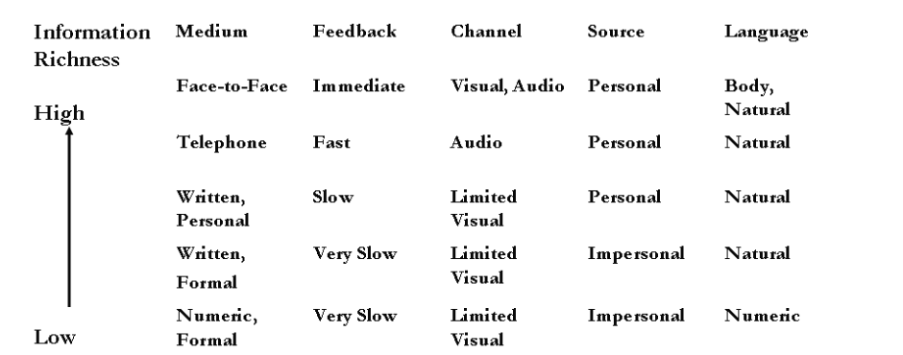

Figure 1: Media Richness Theory

As we can see, the media is spread fastest face-to-face and secondly with the use of telephone. Therefore, the significance of using this theory is important to convey messages in an effective way. Data suggests that, smartphone are one of the prime communication technology that is used during a natural disaster to streamline data in real time( E.Victor James, 2023). It helps us to learn what users can want to obtain their information in leading to effective conveyance and convergence. Conveyance is the transfer of information without the need for all participants to agree on the meaning or emphasise the same material at the same time. Low media synchronisation is typically favoured for this procedure. Convergence is the process of developing a shared meaning for knowledge. All participants must collaborate to build the same meaning for each bit of information. High media synchronisation is typically preferred for this process (Kumi Ishii, 2019).

**Current Technological Advancements in Disaster Technology**

Technology is always advancing at an unprecedented pace in today's fast-globalizing world. Below are some of the topics investigated for current disaster technologies:

1. **Client-Server Architecture**

**Distributed and Mobile Collaborative (DMC) Systems** is the most successful way to compute real-time integrations for distributed systems. These systems integrate distributed computing and mobile computing concepts to enable users to interact, share data, and coordinate easily, regardless of location or device. The system functions via the internet where it takes multiple nodes and carry out different inputs for each user. This is suitable for multiple users accessing a single resource to communicate and work together as a team. Most places use this concepts for real-time editing and messaging within a platform within a workplace. The system often dynamically adapts to its surrounding by taking data such as location, network conditions or device capabilities. DMC should also hold to one of its advantages which is to support the number of users without compromising its overall performance. This brings challenges to its security and consistency of data being transferred across distributed nodes. However with a hybrid architecture to connect to a multiple API and proper connection to its database. This system will be an innovative technology to use for fields such as healthcare, education, and emergency response.

1. **Emergency Communication Systems (SMS (Short Message Service), WhatsApp)**

In an emergency, a message can potentially help many different parties to respond to the certain situation in time critical situation. Therefore, the use of SMS (Short Message Service) and mobile WhatsApp messages will be helpful to use as a mobile instant messaging (MIM) platform. It is known that WhatsApp does not provide any type of open API, therefore WhatsApp business will be used as the prime example of communication. According to Andrés Moreno et al., integrating MIM into crisis response systems helps reach a diverse audience and uncover situations not visible on other social media sites. They retrieved messages and contributed into saving multiple crisis such as the Ghana elections. Similarly, they discuss that SMS also used into their web platform, Aggie, but these channels are often confined to a single recipient or small group. Current crisis management and response methods have largely neglected these old pathways.

In other words, these mediums can directly communicate with ease to users about the dangers that are in their area. The use of WhatsApp also guarantees a cheaper cost than SMS, as it can support multimedia such as pictures, videos and etc. for internal communications when reporting incidents. The one challenge when using WhatsApp that was stated by one of the participants, was the trust of where the source is from. Fake news can spread easily and waste valuable time on checking its validity.

1. **Geolocation and Positioning Systems**

Wi-Fi-Assisted GPS (A-GPS) is one of the most common ways to access a person’s Location based services (LBS) in a mobile device. Using Wi-Fi access, the signals will boost a much more accurate location, especially in urban areas where GPS signals are weaker due to the obstruction caused by large concrete buildings. In the study, the GPS chip from an iPhone 6 gave an average horizontal position accuracy of 7 to 13meters, which is consistent with recreational-grade GPS receivers. Multiple errors such as obstruction of skyscrapers, trees and other infrastructure can reduce the accuracy of GPS. Whereby, it affects critical situations like natural disasters in urban areas.

Time accuracy also plays an important role in having the best GPS signal. In the afternoon period, GPS accuracy improved tremendously due to congestion of people . This shows that when more people are present, the higher the accuracy is as well due to high Wi-Fi usage in the area. The Mann-Whitney test is commonly used to measure GPS accuracy. The Mann-Whitney test was used at a 95% confidence level to test the null hypothesis that the static horizontal position error recorded during GPS-only data collection was not statistically different from the static horizontal position error collected when Wi-Fi was turned on.

## 2.2.1 Similar Systems

The table below shows the summary of existing platforms and projects used to detect the location of people, real-time system communication, and successful information guide for natural disasters.

|  |  |  |  |  |  |  |  |
| --- | --- | --- | --- | --- | --- | --- | --- |
| Research Topic | Author(s) | Description | Dataset Used | Analysis Techniques | Evaluation Techniques | Result / Outcomes | Limitations |
| A Communication, Management and Tracking Mobile Application for Enhancing Earthquake Preparedness and Situational Awareness in the Event of an Earthquake | Pinar Kirci ,Davut Arslan and Sureyya Fatih Dincer | The study focuses on the mobile application , DeApp that they have developed to improve earthquake preparedness and situational awareness. | Earthquake data from Kandilli Observatory located in their country Istanbul. | GIS (Geographic Information System) for mapping safe locations, user feedback collection via surveys, and a questionnaire . | The app is assessed using feedback to determine usability, efficacy, and emergency response efficiency. | Information for preparing before an earthquake was revealed to include real-time earthquake alerts, safe zones, and emergency communication tools​. | Their area of testing didn’t gave a good prediction of earthquakes. |
| iHanda: A Mobile Application for Disaster Preparedness | Ma. Corazon G. Fernando, Maria Vicky S. Solomo, Ace C. Lagman | The study develops a mobile application to raise awareness and improve disaster preparedness for residents of Manila, Philippines. | Information from PAGASA (Philippine Atmospheric, Geophysical and Astronomical Services Administration), emergency response agencies, and government offices​ | The system uses software quality evaluation technique, that is for software quality model, assessing functionality, reliability, usability, efficiency, and portability​. | Beta testing was conducted using survey forms to 2 types of parties. | Users rated the app excellent with the features of weather forecasts, emergency hotlines, evacuation maps, and SMS notifications for disaster alerts​ seamlessly running. | No cross-platform available and only limited to Manila. |
| A Comprehensive Study of Disaster Support Mobile App | Muhamad Syukron ,Anuradha Madugalla , Mojtaba Shahin , and John Grundy | This study examines the features , feedback and effectiveness of tackling natural disaster via an app. | The study collected data from 45 disaster apps and analyzed 28,161 user reviews from the Google Play Store and Apple App Store​ | Topic modeling and sentiment analysis was used to get user’s review and carry out an analysis. | The reviews gave positive/negative feedback of an app , and comparison of disaster app functionalities with different geographic regions | The study concluded that most apps has to have alert functionality, app crash avoidance , network connectivity, and seamless sign-in . | There was language barriers in different geographic regions and data availability. |
| Mobile phone technologies for disaster risk reduction | Jonathan D. Paul, Emma Bee , Mirianna Budimir | This article is a discussion on how mobile phones can have potential to enhance disaster risk reduction (DRR) | It is based on 45 workers representing 20 organizations about the  disaster risk management (DRM) cycle. | A qualitative analysis is used to identify best practices and challenges in using mobile technologies for DRR. | - | The article highlights what are the necessary guidelines that should be taken during each type of natural disaster. Further it explains technology should be scalable and adaptable. | The article is dependent on stakeholder experiences which limits the guide comprehension. |
| Android Based Emergency Button with Position Share System | L. D. Setia, S. V. Yulianto, A. P. Atmaja | The paper is used develop a panic button for emergencies by sending notifications to near by hospitals. | The system relies on real-time user inputs like SOS button and location data from the device. | The system uses black box testing and system requirement Analysis. | The system used real-life scenarios to get effective feedback and usability. Integration testing was used to communication between the mobile app, management system, and alarm system. | The system successfully sent emergency notifications to hospital medical workers when the SOS button was clicked. | There was no further clarification of images or videos to provide more emergency details. |
| Smart Reminder SOS & Emergency Detection Device | Shashikala H.K,  Priyanka.S,  Madhumala RB ,  Rangareddygari Meghana,  Chanchani Keerthana ,  Yarragunta Thammai (2022) | The project focuses on medication reminder, SOS button, accident detection using machine learning and IoT devices. | The system relies on real-time sensor data from MPU6050 accelerometers and pre-saved collision patterns for machine learning model training. | K-Nearest Neighbor (KNN) and Support Vector Machine (SVM), GPS module (NEO-6M) is used for location tracking. | Real-world scenarios are used to detect collisions and alert emergency system. | The SOS button gave an immediate way to alert emergency contacts. | Using battery life can dimmish the use for long uses. Therefore using these types of solution can bring a negative effect to the platform. |
| Using Rule Base System in Mobile Platform to Build Alert System for Evacuation and Guidance | Maysoon Fouad Abulkhair, Lamiaa Fattouh Ibrahim | Their system uses mobile-based alert system to assist  students, staff, and visitors to inform real-time disasters in their area. | The system relies on real-time data from GPS, Google Maps, and user inputs. | The system uses GPS, google maps integration, rule-based system, push notifications and social media integration. | The system was tested in real-world scenarios, including university campuses and urban areas in Jeddah. | The iCalamityGuide (iCG), gave proper instruction to student and staff during emergencies while, The Disaster Smart Road Guidance (DSRG) gave real time updates of disasters. | The system may generate false alerts if the rule-based system incorrectly interprets user data or disaster conditions. That is why its better for relevant parties to make the post and distributed than automatically posting it. |
| InSight: A Bluetooth Beacon-based Ad-hoc Emergency Alert System for Smart Cities | Raiful Hasan, Ragib Hasan, Tanveer Islam (2021) | The study is for an automated system that gives necessary information for public safety via using Bluetooth . | The researchers used their data on beacons they have set up around the city. | The system calculates the user's distance from the beacon based on signal strength (RSSI) and determines the user's direction of movement (toward or away from the hazard zone). | The system was tested in three real-world scenarios: a traffic intersection, a construction site, and an evacuation route. | The system was able to successfully communicate its data to give timely warnings to all types of users. | The effective range of beacon signals can vary based on environmental factors (e.g., obstacles, interference). Therefore its best to use a distributed system to get signals. |

Table 2: Compilation of various similar system

## 2.3 Technical Research

## 2.3.1 Physical Hardware

The physical hardware chosen will determine the performance of the overall system. Transfer of data using distributed system is very important to understand the execution of timely notifications and justifying the need for a reliable system. The communication between two parties must be flawless and seamless within its own application.

There are specific hardware components like the processor that are very important for overall performance level. This is used for executing commands from the selected programming language. The processor is also responsible for data processing that can include sorting, searching, and manipulating data according to the program's requirements. Thus, a standard Intel® Core™ i7-1355U (up to 5.0 GHz with Intel® Turbo Boost Technology, 12 MB L3 cache, 10 cores, 12 threads) can be used for this laptop system (HP Pavilion x360, nd.). The core divides all the task into smaller tasks that can process it in less time. Therefore, when the users use their develop app, the server can handle all the GPS, incoming notifications and running news posts.   
  
The system uses Random Access Memory (RAM) to efficiently use multitasking features. A 16 GB RAM would be ideal to sufficiently run multiple clients and use tools like GPS for real live location. Most emulators take up a lot of space to compile and code the system, thus a recommended 256 GB of space is needed for this project. Below is the summary of the system:

|  |  |
| --- | --- |
| **Type of hardware** | **Allocated needs** |
| Processor | Intel Core i7 or i5 |
| GPU | Integrated or dedicated (like NVIDIA GTX 1650 or better). |
| RAM | 16 GB. |
| Storage | 256 GB SSD. |

Table 3: Summary for development of supplication system.

## 2.3.2 Programming language

The programming language that is chosen is **Dart**. This language is similar to Java, JavaScript, or C# and can be easily learnt. Dart is a client-optimized language for creating quick programs across any platform. Its purpose is to offer a productive programming language for multi-platform development, together with a versatile execution runtime platform for app frameworks. It can **support both front-end and back-end** in an application, making it ideal for this project to function. This languages is fully object-oriented works perfectly with the **selected framework, Flutter.**

Flutter can perform fast and efficiently for one code to access **multiple platforms** (Android, iOS, web, desktop, etc.). This framework is created by google using different types of widgets to enable the development of an Android app(*Building user interfaces with flutter,* nd.) . Another reason why Flutter is the best framework is because of its cross-platform development. Flutter potentially allows their developers to write a single codebase that is functional in both iOS and **Android** platforms. This saves time and development cost when creating a complicated project such as a SOS system . Other framework like Angular or React isn’t suitable for this project due to its non-mobile focus, not ideal for real-time system and complex code bases (Digvijay’s, 2024).

## 2.3.3 Libraries and tools

Easiest libraries I can use inside this framework is **geolocator and location** where it retrieves the GPS location of the user’s phone. To navigate specific locations, libraries that google provide is **google_maps_flutter ,** making the system to display the user's location on a map and show nearby emergency services or safe zones. **Mapbox_gl** can be used to customize the map im using to connect the relevant parties and victims. Notification sending like SMS can be integrated by using libraries like **flutter_sms** or **url_launcher** . To make the function of a SOS panic button, the researcher will need to use **socket_io_client** to stabilize the real time communication for emergency responders. Other additional tools can be added in the future to beautify the app or add extra useful tools (*Top Flutter Geolocation and Maps packages*, 2025).

One of the most useful integrations to this project will be an Application programming interface (API). In the context of APIs, the term Application refers to any program that performs a certain purpose. Interfaces can be thought of as service contracts between two apps. This contract specifies how the two will interact with one other through requests and answers. Their API documentation includes guidance on how developers should organise their calls and answers(*What is an API?* , nd.). Some of the API that I would like to possible use **OpenWeatherMap API, Google Maps Geocoding API,** and **NewsAPI.**

## 2.3.4 Testing tools

To check the functionality of my system, ill be using the standard Flutter’s built-in testing framework where it parses and tests the classes or functions. A unit testing helps to check the accuracy in a unit of logic that has been included in different conditions. In general, unit tests do not read from or write to disc, render to screen, or take user input from processes other than the one conducting the test. Therefore widget testing is applicable in our project to check the appropriate functionality of the system. This further justifies , to check the logic and UI together when developing the application. Users need to have a fully functioning button and tabs to be able to access the various functionality of the application.

## 2.3.5 Operating System

There is various types of operating systems that can develop the application. All systems are good at performing their task, but there is one system that satisfies the research while the researcher has access. Windows 11 is one of the most common machines to use compared to MacOs and Linux. Developers are comfortable using this system because there are multiple sources of help online to navigate the OS. The simple user interface helps to access and discover new API for the IDE. The file format from the internet can seamlessly be integrated into the system with ease. Windows, uses technology introduced by ChatGPT and Google Gemini, generates new content in response to user commands (for example, "create a budgeting spreadsheet") and is integrated into applications such as Microsoft 365 (which includes Microsoft Word and PowerPoint), Bing and such . However the application can only be catered to the android users only, as there is no support to integrate an iOS system from a windows 11 computer.

## 2.4 Summary

In conclusion domain such as Disaster Management Cycle Model (DMCM), Natural disaster guides, Media Richness Theory (MRT), Client-Server architecture, Emergency Communication Systems (SMS (Short Message Service), WhatsApp) and Geolocation and Positioning Systems gave valuable insight into developing the application. While in the process of learning the language and framework , we best believe that Flutter will be chosen for this project. Furthermore, library tools and API from the internet is used to further extend the capabilities of the application. Besides that, similar system has displayed what are the primary features needed for a basic SOS system in many different type of project. The best suitable needs are when there is guidance for natural disaster, SOS alert system, news outlet for further understanding on the situations in the area and notifications to alert the user beforehand.

# CHAPTER 3: METHODOLOGY

## 3.1 Introduction

This chapter is about selecting a structured methodology that is suitable for the whole project and gathering the data needed to justify the methodology. A clear methodology is needed to have logical progress into the project. Throughout the whole project the researcher will have to follow the same steps and progress to justify the data collected and conclusions drawn. This section will explain the use of a methodology, its benefits and data gathered.

## 3.2 System Development Methodology

## 3.2.1 Introduction of methodology

It’s important to have a clear methodology to have valid results and complete reliable progress on the project. Data obtained from the project leads to quantitative and qualitative research. Qualitative uses data that people can see or describe on the situations they have experienced. However, in quantitative it would be using numbers that can be calculated for our necessary data needed in our project. In this project we will be doing a quantitative progress report, to collect survey from people of different background.

Firstly, we need to discuss the relevant methods to use for the entire project. This project includes factors such as flexibility, risk management, and the need for iterative testing. Hence, based on the objective of providing a SOS system, raising public awareness, sending timely notification and having community support. These objectives would help in realizing the SDG 13, where the impact of global warming can be reduced. According to Sara Shafiee, the Product Configuration Systems (PCSs) is one the ways to evaluate the methodology in alignment with maintaining documentation, IT-related constraints and knowledge acquisition and modeling. Therefore, comparison of different methodology will help to state the pros and cons of the entire effect of the system. Methodology that aligned with the framework of the project are **Rational Unified Process (RUP), Spiral and SRUM.** The table below shows the comparison of each methodology with its advantages.

|  |  |  |  |
| --- | --- | --- | --- |
| Characteristic | RUP | Spiral | SCRUM |
| Traditional or Agile | Agile | Traditional | Agile |
| Flexibility | Moderate | Moderate | Very High |
| Risk Management | High | Very High | Moderate |
| Delivery Time | Moderate to Long | Moderate to Long | Fast (incremental) |
| Best For | Large, complex, regulated projects | High-risk, complex projects | Projects requiring frequent changes and collaboration |
| Adaptability | Moderate | Moderate | Very High |
| Testing | Continuous (within iterations) | Iterative | Continuous (within sprints) |
| Focus | Structured, iterative development | Risk management and iteration | Flexibility, collaboration, and rapid delivery |
| Development Cycle | Slow, due to planning (Inception, Elaboration, Construction, Transition) | Slow, prioritizes risk analysis and iterative refinements(Planning, Risk Analysis, Engineering, Evaluation) | Fast, due to adaptable changes (Planning , Execution, Review , Retrospective, Release) |
| Limitations | Complex, documentation-heavy, resource-intensive, steep learning curve | Complex, time-consuming, requires expertise, not ideal for small projects | Requires experienced teams, not ideal for regulated industries, scope creep |
| SDG | Occasionally used in large, complex SDG projects | Used in high-risk SDG projects (e.g., disaster recovery, climate adaptation) | Most common, because of dynamic environments with evolving requirements |

Table 4: Comparison with RUP, Spiral and SCRUM

## 3.2.2 Methodology Choice and Justification

Based on the table above, I would suggest spiral methodology would be the best approach to my disaster system project. The reason behind this methodology was chosen is because of the steps taken to make the system and document process. Its flexibility makes it suitable as there is a need to research into the risks encountered during the requirements phase. The structured process makes it better than RUP and SCRUM in terms of iterative process and incremental development on the project. The iterative process makes each small change better and increases the chance of my project to be safe and strong.

## 3.2.3 Activities and Processes

Spiral methodology is an **iterative development and structured planning process.** There is 4 phases into spiral methodology which are planning phase, risk analysis phase, engineering and development phase and evaluating and planning for the next iteration phase. The process conducts into a loop where all stages are repeated until a satisfied outcome is concluded. All these phases can be paired with a mobile application prototype. This is because mobile applications are now in more demand than a website or desktop application. Users want to use cross-platform applications to make use of the memory space that mobiles have. This adds more phase to communicating with the stakeholders and has a rigid plan for the development (Dhruv Doshi, 2021) .

**Planning:**

During this first phase of development, heavy research must be conducted to construct the project aims and objectives. According to my topic which is “Development of Global Positioning System (GPS) for Enhanced Public Safety during Saving Our Souls (SOS) Disaster”, this project needs to implement various integration of API, front-end and back-end coding and research on natural disaster. This research on the domains will help to further develop a proper idea and design of how the overall system will function. Next the analysis of the project aim, problem statement and objectives were concluded to have clear directions of the project. On top of that, the design of the survey form was done, and questions were decided based on the objectives of the project. The survey also is constructed to get the opinion of the public from various age groups about the current lifestyle and future needs of their lifestyle.

**Risk analysis:**

In this stage, risk depending on my aims, objective and problem statement were drawn out. This phase is important to be carried out in identifying which system needs has to use more time and effort in developing its section. For example, the SOS alert can have multiple problems such as corrupt files, unsuccessful coding and unable to retrieve data from the system. The risk stated would help prepare the developer and focus on absolute adjustment of the system and its constraints. Other than coding risks, there are also development risks, where the time to develop the system will have to be extended or unforeseen circumstances happens.

**Engineering:**

When all of the conclusions of how theoretical prototype would function is drawn out, the step can continue to the engineering the system using codes and framework. A functioning system for the basic step should be developed, such as buttons and layout of the application can be constructed. Then shown to the supervisor for further understanding of what to change and how it can be improved. The databases, testing tools and API that are used in this phase should have seamless integration into the system. This can be taken as the first loop, then when the second loop is initialized, the system will have better functioning buttons that can have animations and such. The loop extends till a satisfactory outcome is achieved and aligns with the aim and objectives of the project in conjunction to the SDG goal 13.

**Construction and Release:**

On this last sequence, the system will be tested to see if the features constructed meet the requirements. If there is any issues in this step, the problem must be solved before continuing to the next phase. The test should be conducted from the development team before it is carried out to deployment. This is important to check if the alerts are received and sent on both ends, therefore there could not be any issues in the future. Functional testing, performance testing, security testing and usability testing should be performed when each feature is developed. In short black box testing can be considered because it fits all of these type of testing from a user point of view (Harsh Bhasin, 2014). This consistent loop will have a secure and safe app for users to use when deployed. All of the steps repeat again from the beginning until the app is complete to mark the end of the project. Below shows an example of how a mobile application with spiral methodology would be developed:

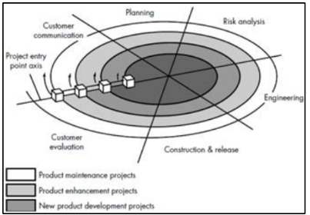

Figure 2: Shows a spiral model which consist of 6 task

## 3.3 Data Gathering Design

The method used in this project to gather data is a survey. Survey research is the compilation of a series of questions and their sequential placement to achieve acceptable responses (P. Nidhi et al., 2024). The general knowledge acquired by this data gathering method can help researchers explore the domain in depth with the people’s thoughts and opinions on the matter. In this project, the questions available to the responder consist of close-ended questions. The aim of the survey is to gather as much qualitative information related to the responder’s experience through natural disaster. A total of 37 responders were randomly obtained to answer the curated questions, by following the instructions of the fast-track form in our ethics form. The target audience obtained from this survey is 20 people who have undergo natural disaster before and 17 people who didn’t went through the experience. The details of the survey also were checked by the supervisor to ensure accurate results were obtained.

The survey consists of six sections with information sheets, 34 Likert scale questions and multiple-choice questions for demographic. The five main sections are **Demographics Section**, **Community Section,** **System Section**, **Accessibility and Inclusivity** **Section** , and **Challenges and Barriers Section** . These are the design and questions of the survey :

**Cover Page and Introduction**

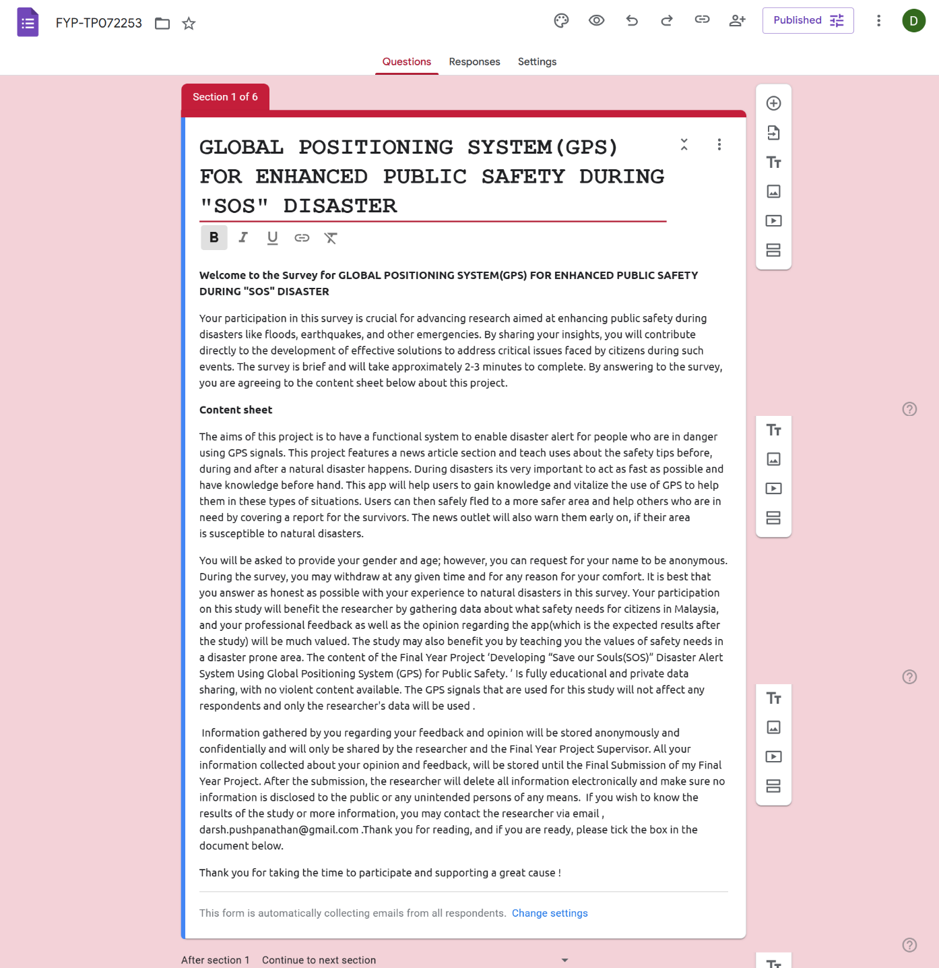

Figure 3:Consent sheet and information about the project

Above shows the information sheet for the terms and conditions the responders will read and acknowledge their consent to this project. Responders are informed of their rights to stop at anytime during the survey and remain anonymous during this project. All of the findings will only be for academic purposes and further information about the research could be reached out.

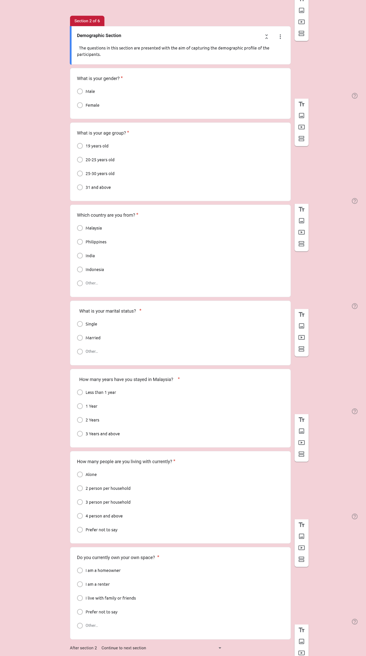

Figure 4:Demographic section of the intended research, part 1

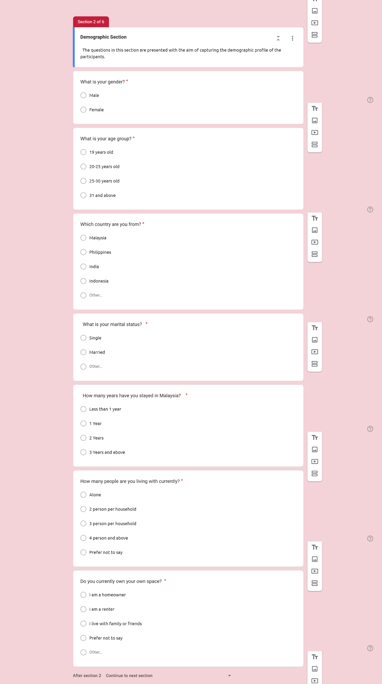

Figure 5: Demographic section of the intended research, part 2

In this section different types of demographic questions were asked. This is to understand our future audience better who have different backgrounds experiencing natural disaster.

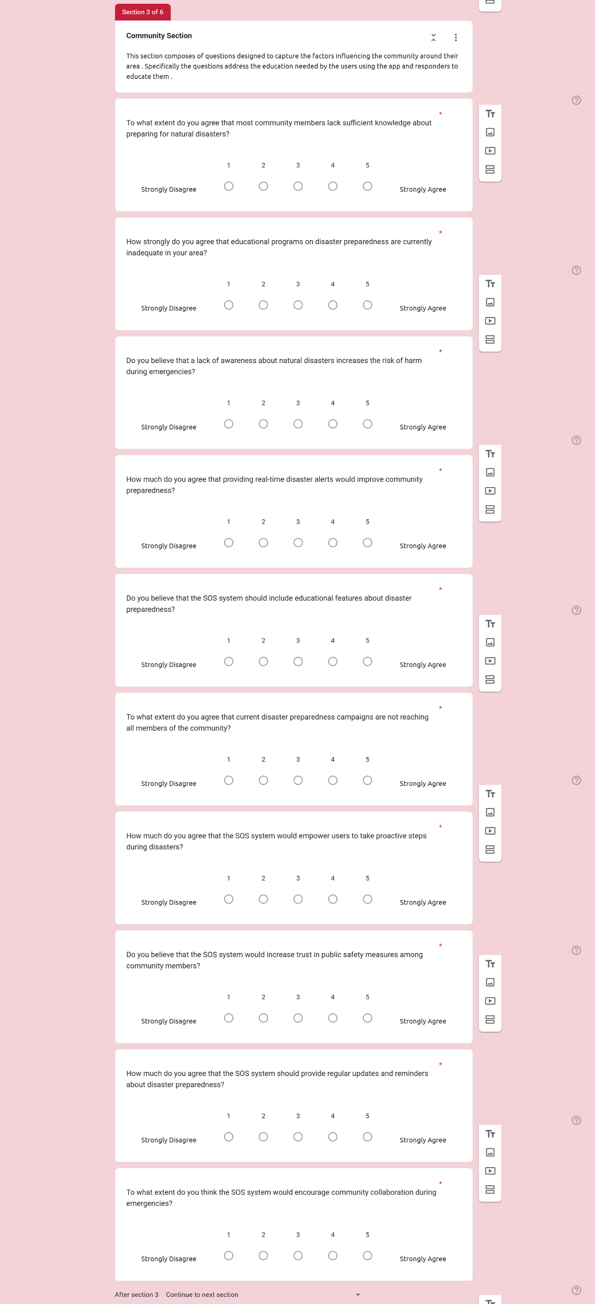

Figure 6: Community questions for the responders , part 1

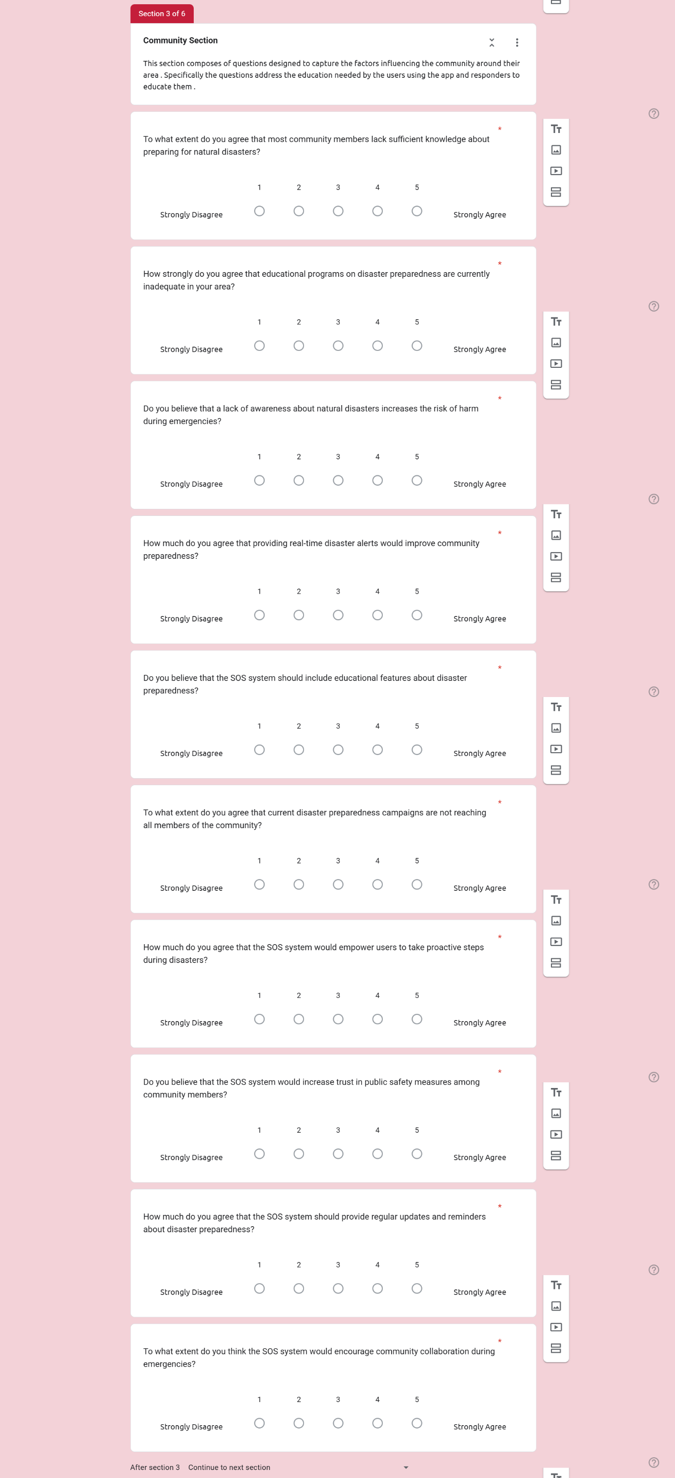

Figure 7:Community questions for the responders , part 2

This section is composed of questions designed to capture the factors influencing the community around their area. Specifically, the questions address the education needed by the users using the app and responders to educate them.

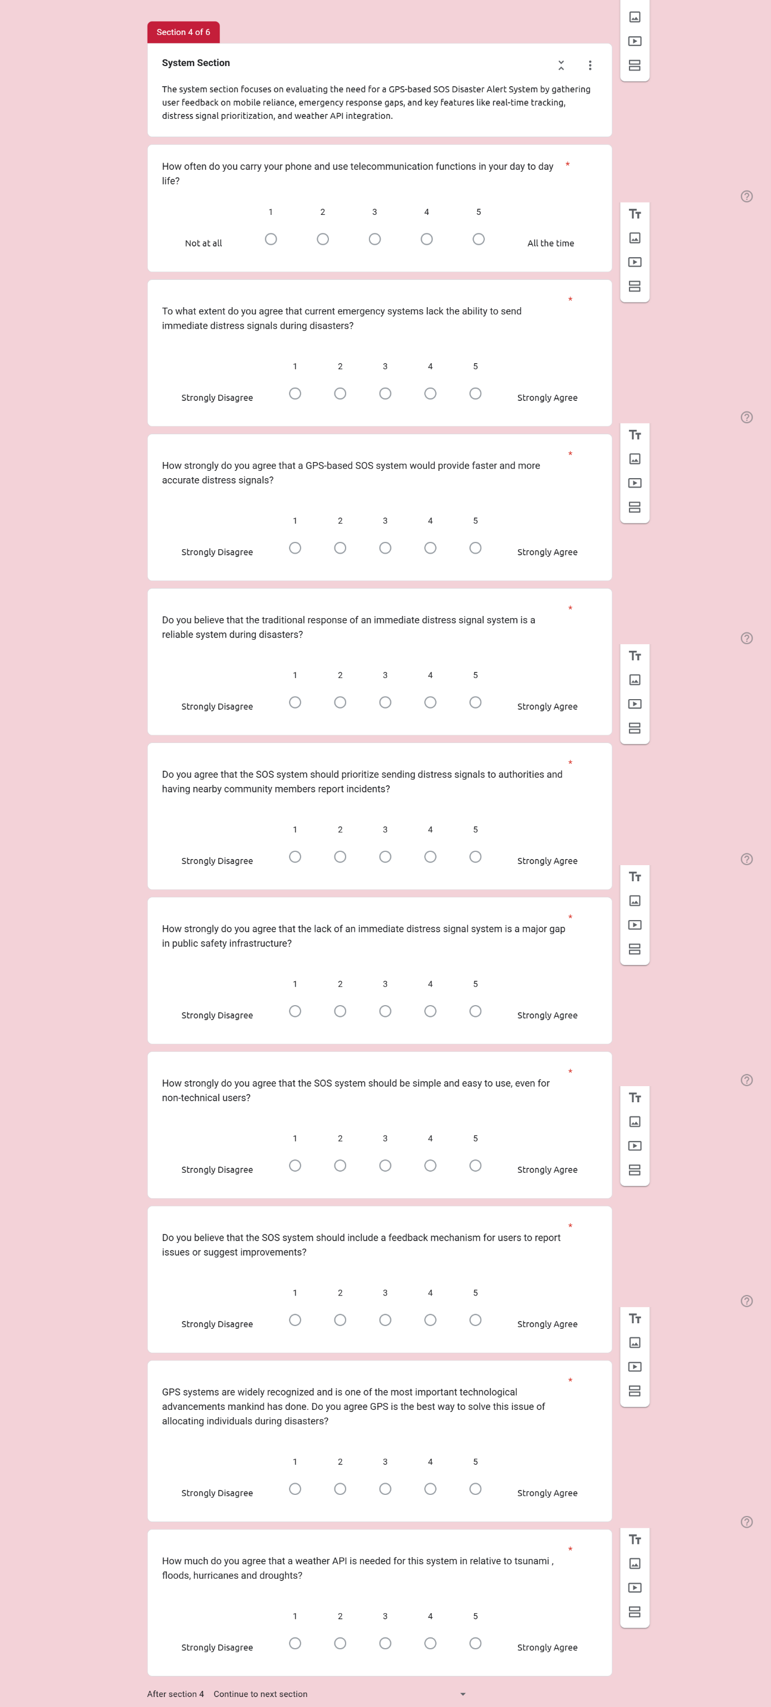

Figure 8:System questions for the responders, part 1



Figure 9: System questions for the responders, part 2

The system section focuses on evaluating the need for a GPS-based SOS Disaster Alert System by gathering user feedback on mobile reliance, emergency response gaps, and key features like real-time tracking, distress signal prioritization, and weather API integration.

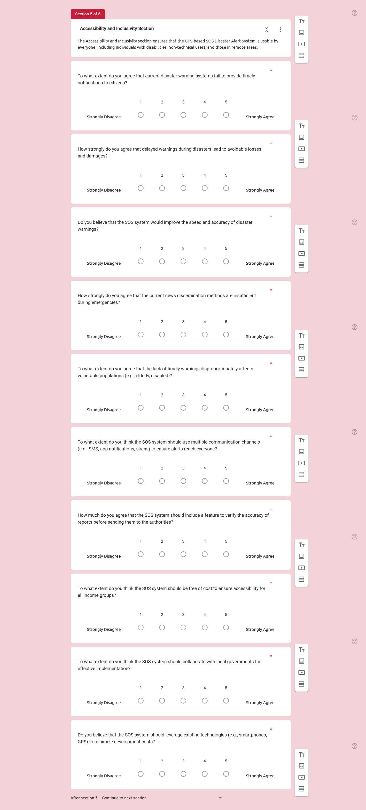

Figure 10: Accessibility and Inclusivity questions for the responders, part 1



Figure 11: Accessibility and Inclusivity questions for the responders, part 2

The Accessibility and Inclusivity section ensures that the GPS-based SOS Disaster Alert System is usable by everyone, including individuals who are disabled, non-technical users, and those in urban areas.

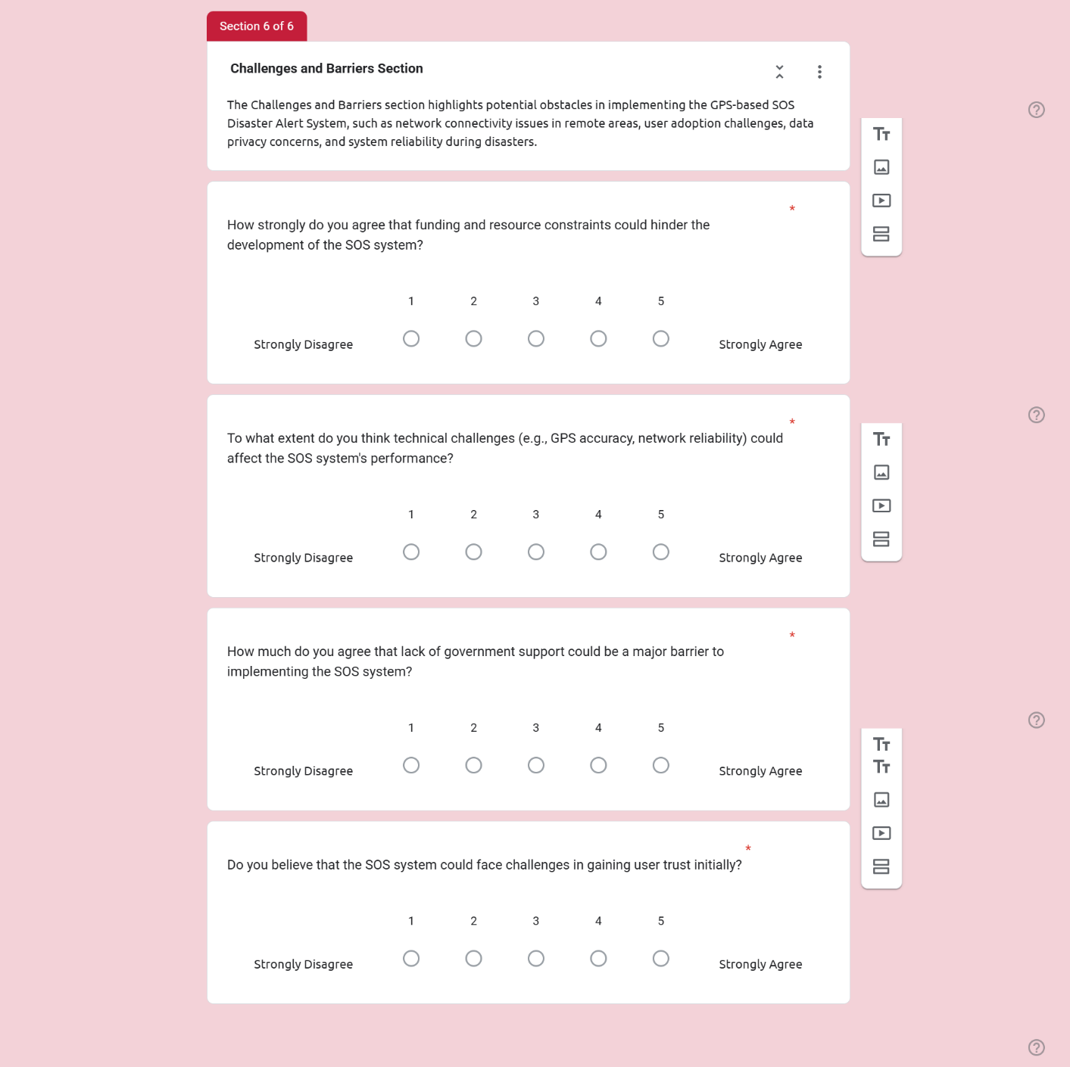

Figure 12: Challenges and Barriers questions for the responders

The Challenges and Barriers section highlights potential obstacles in implementing the GPS-based SOS Disaster Alert System, such as network connectivity issues in remote areas, user adoption challenges, data privacy concerns, and system reliability during disasters.

## 3.4 Data Analysis

In this section of the project, investigation of the responder’s demographic , community interactions, system settings, accessibility and inclusivity, and challenges and barriers. An in depth analysis will be conducted to see the use of each questions inquired.

### Section 1: Demographic Section

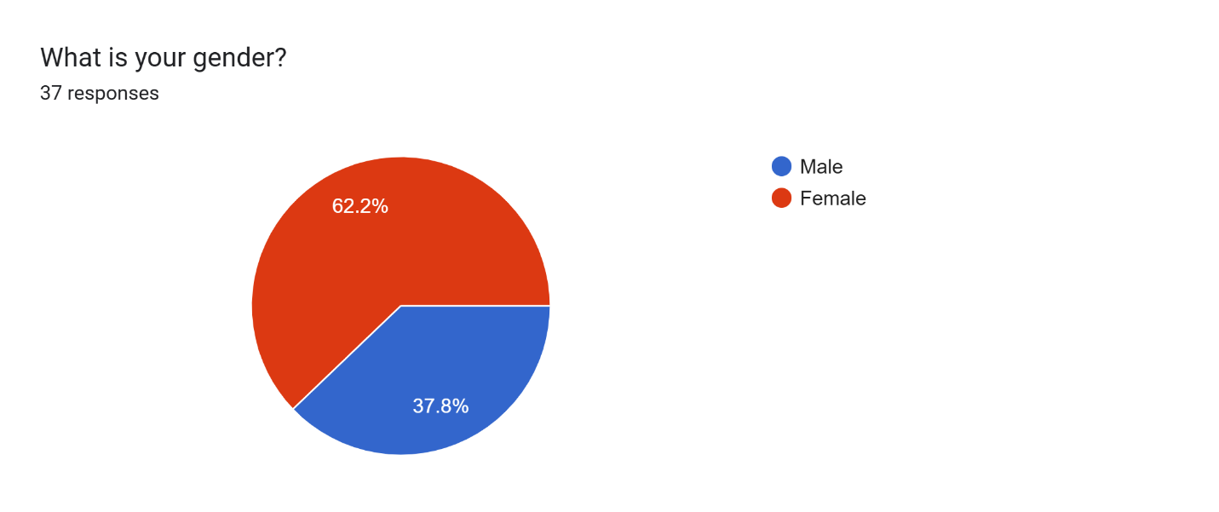

Figure 13: Gender of the total respondents.

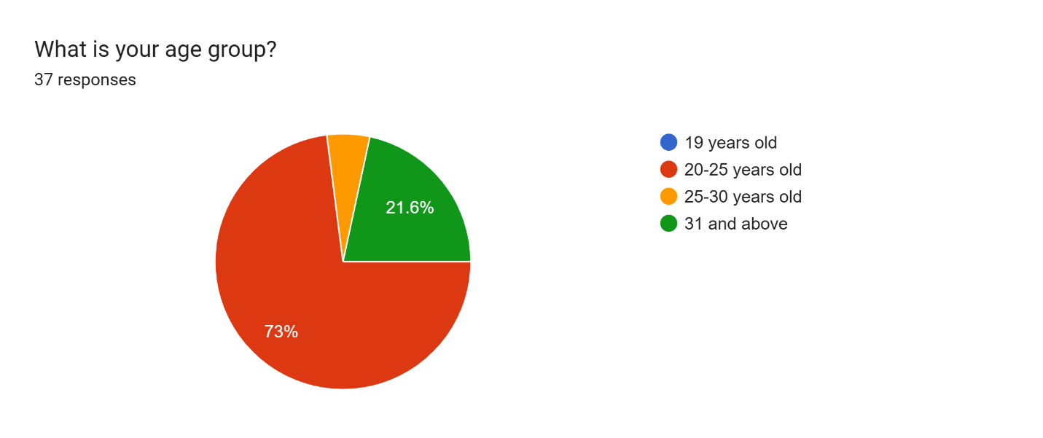

Figure 14: Different age group of the total respondents.

From the figure 14, most number of respondents are female with 62.2% which is 23 people. Next the age period of the respondents mostly consist of people 20 to 25 and 31 and above. Having a balanced ratio is important to get accurate and not biased results in this project.

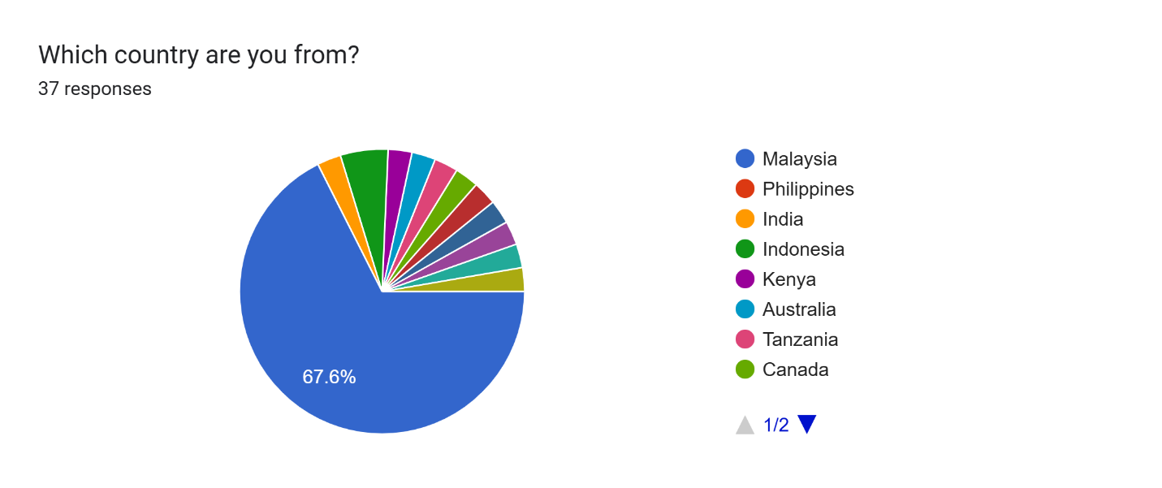

Figure 15: Different country nationality residing in Malaysia.

|  |  |
| --- | --- |
| Country | Number of responses |
| Malaysia | 25 Respondents |
| Philippines | 1 Respondents |
| India | 1 Respondents |
| Indonesia | 2 Respondents |
| Kenya | 1 Respondents |
| Australia | 1 Respondents |
| Tanzania | 1 Respondents |
| Canada | 1 Respondents |
| Sri Lanka | 1 Respondents |
| Pakistan | 1 Respondents |
| Syria | 1 Respondents |
| Bangladesh | 1 Respondents |
| Sudan | 1 Respondents |

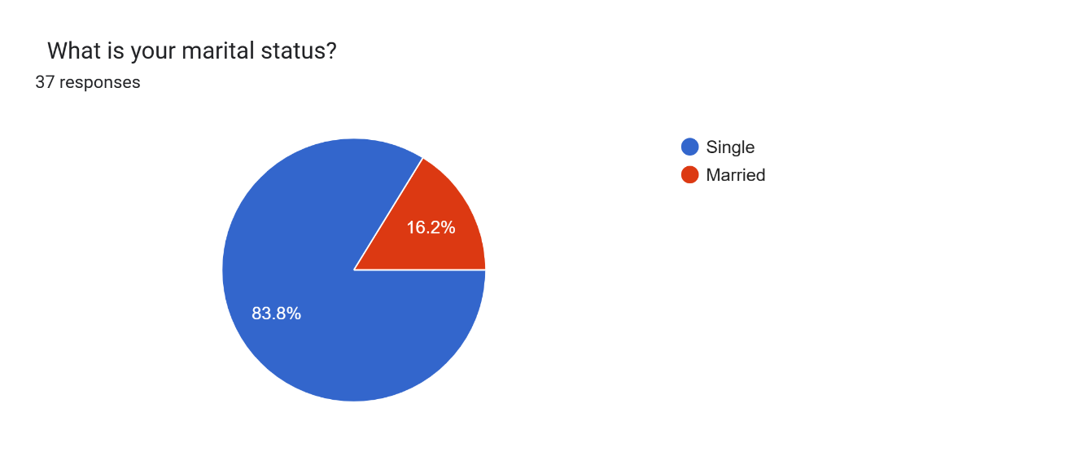

Figure 16: Martial status of the total respondents.

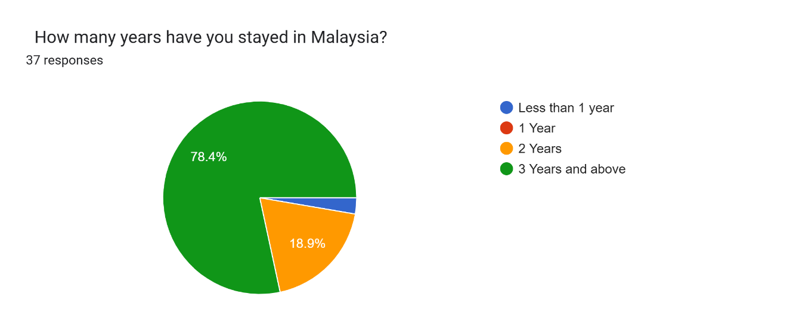

Figure 17: Number of years the respondents have resided in Malaysia.

As from figure 17, all respondents are residing in Malaysia which makes my ethics form valid and does not interfere with the data collect as an outlier. The percentage of people that resides in Malaysia for three years and above is a total of 78.4% which is 29 people in total. On the other hand, marital status is to confirm the lifestyle of both people who have undergone natural disaster and who haven not. According to the research, most people are single that are effected with this phenomena.

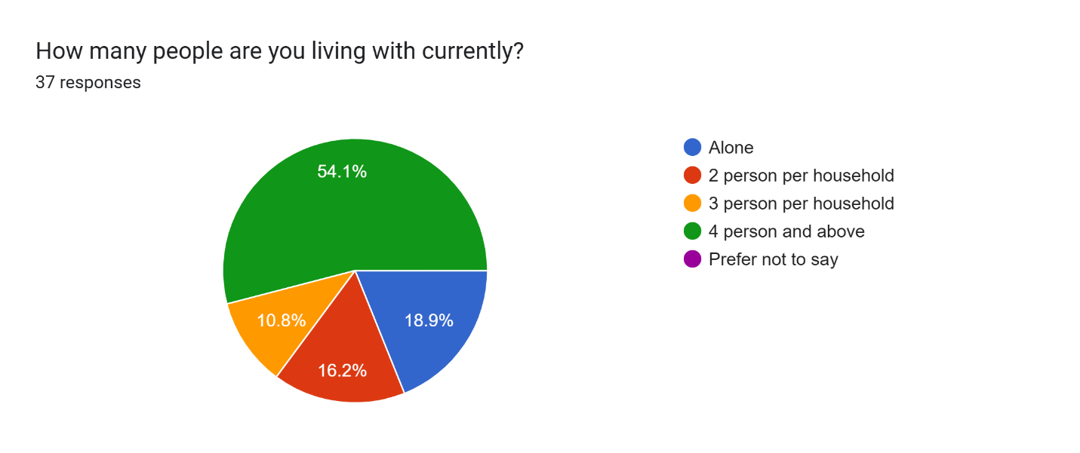

Figure 18: Total number of people the respondents live with

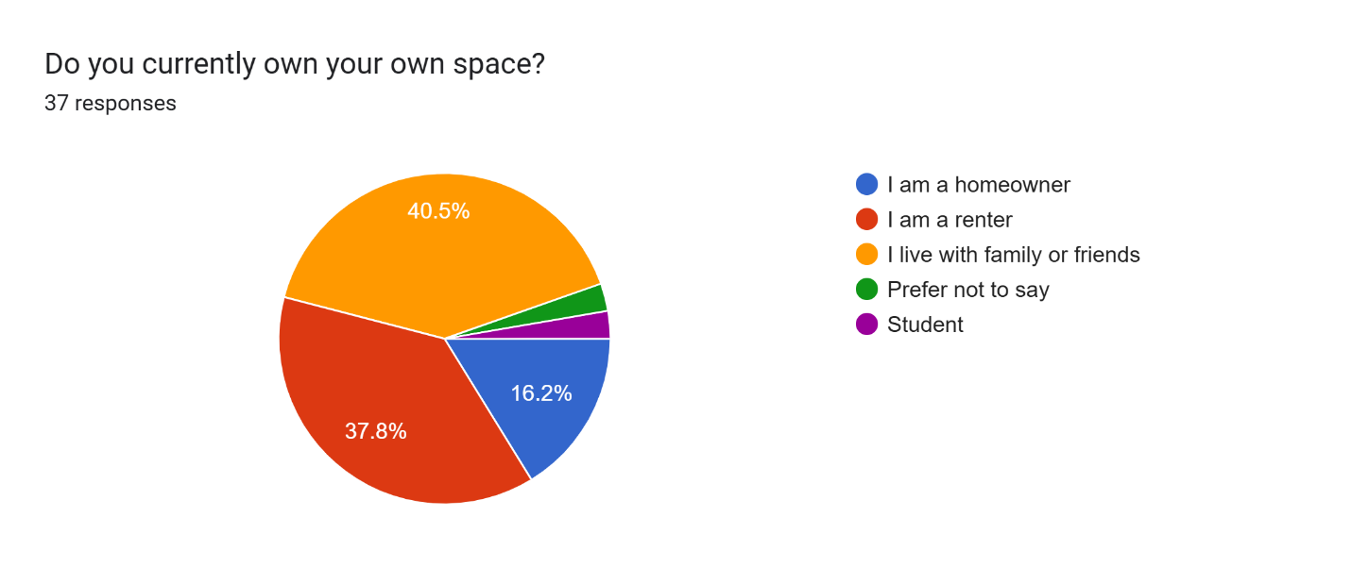

Figure 19: Total number of people owns their space

Based on figure 18 and 19 , the purpose of asking respondents these questions is to investigate, how natural disaster affects a person. From figure 18, it is revealed that most people live with 3 or more people in their household with a combination of friends or family. Hence, it shows that most people would have support mentally and physically when dealing with a natural crisis within their house. This enables people to be more relaxed and think clearly when they are in a panic, while depending on each other for support.

### Section 2: Community Section

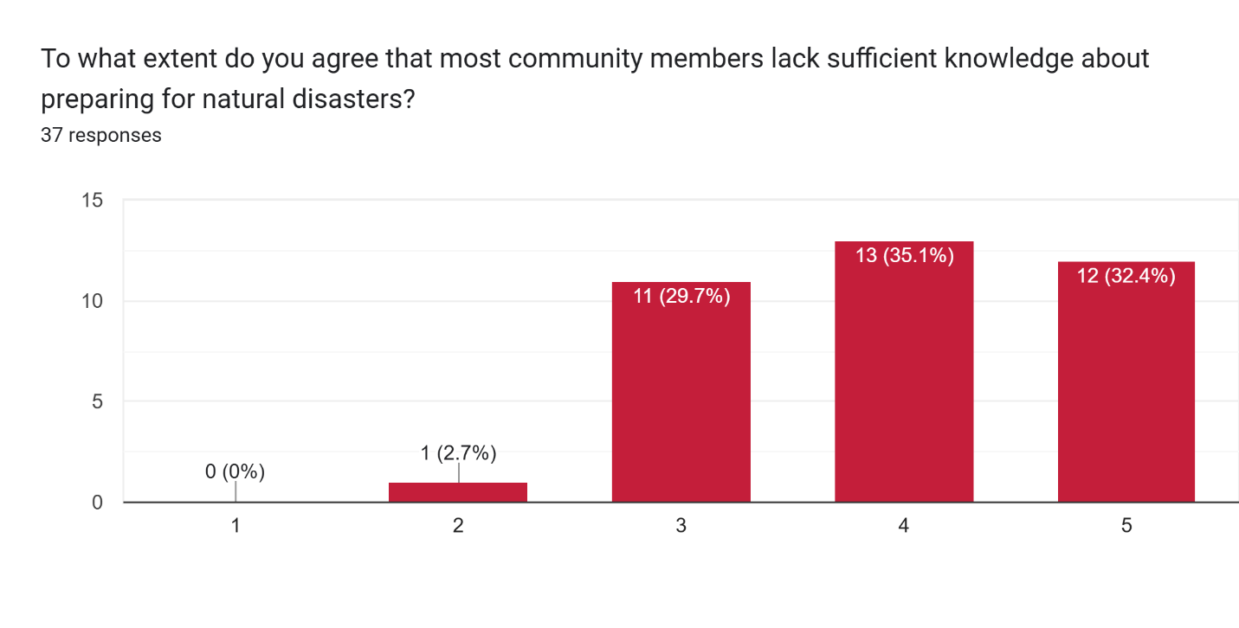

Figure 20: Statistic of knowledge on preparation of a natural disaster

According to the figure 20, there is 13 respondent (35.1%) that partially agree that there is a lack of preparation knowledge on natural disaster. While 12 respondents strongly agree that their community does not know anything about natural disaster management. This shows that, people lack the guidance and education on how to prepare before a natural disaster.

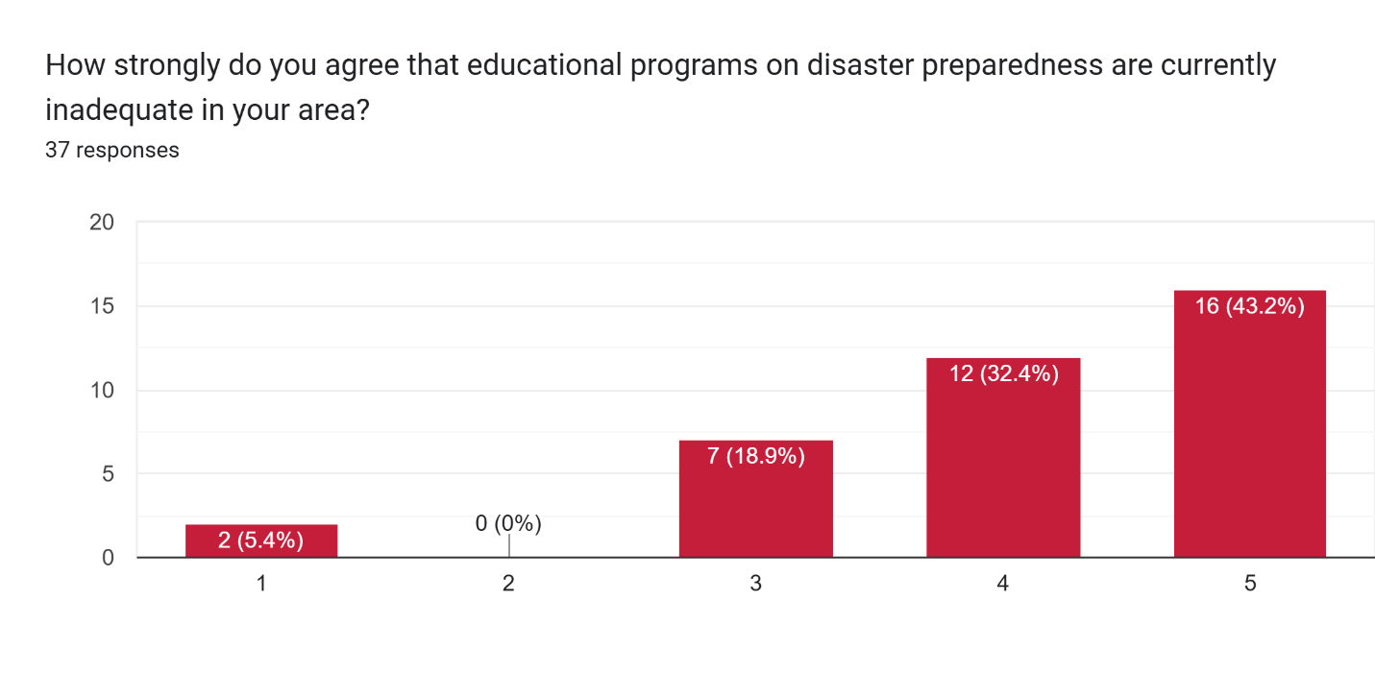

Figure 21: Statistic of education programs about natural disaster

From the bar chart above, the majority of respondents have strongly agreed that educational programs on natural disaster knowledge is not thoroughly learnt in their areas. These knowledge can be derived from schools, public knowledge or residential learning. However, there is two responders that strongly disagree to this. This could be because of the area they were brought up in or the complex that they are residing in. One respondent came from the country Canada, which shows that they have interest in teaching their people about it

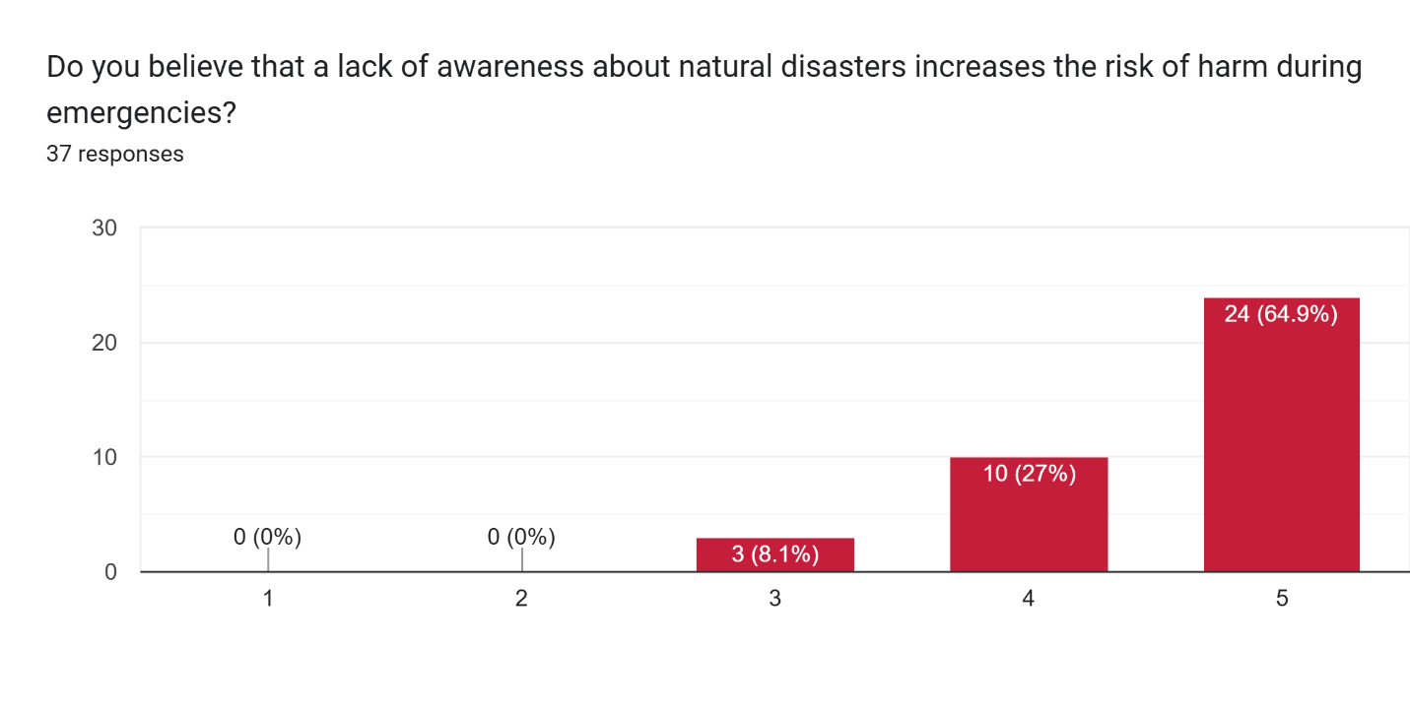

Figure 22: Statistic of education programs about natural disaster

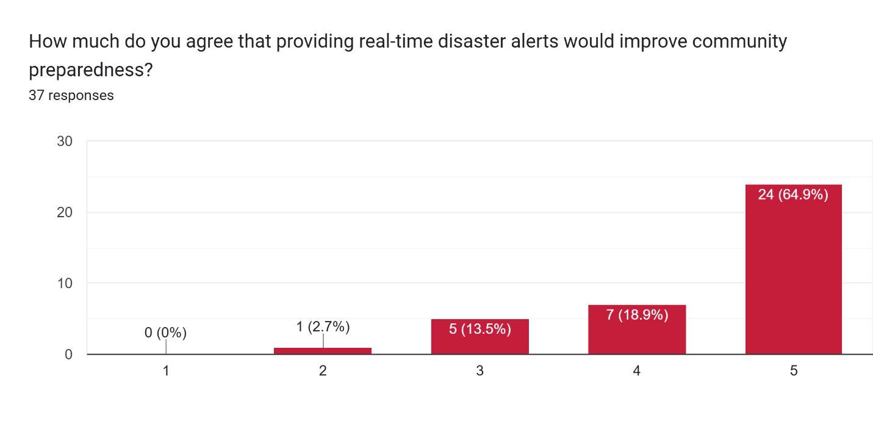

Figure 23: Statistic of real-time disaster alert about natural disaster

From figure 22 and 23, links to each other because of how natural disaster causes injuries and to counter that, a real-time disaster alert can be developed. In both graphs, all 24 respondent (64.9%) strongly agree that a system is needed for safety management and providing appropriate knowledge to the public.

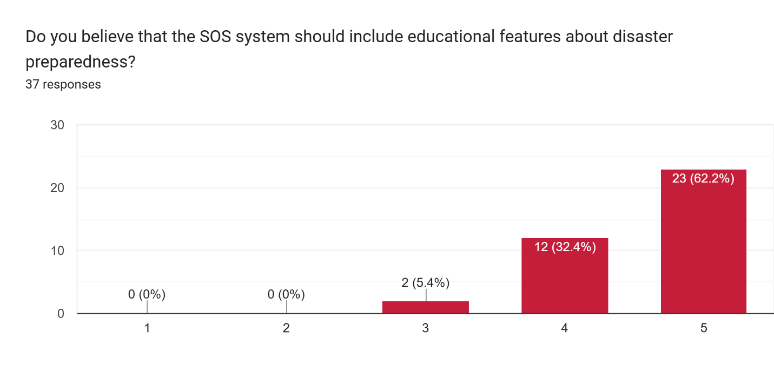

Figure 24: Statistic of SOS system feature about natural disaster

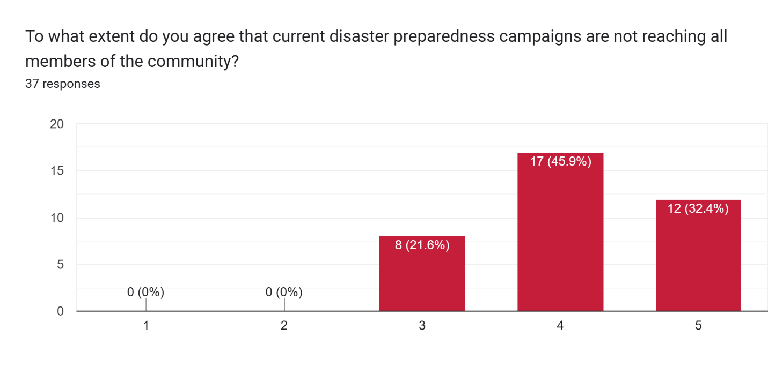

Figure 25: Statistic of campaign programs reach about natural disaster

Campaigns are one the common category on where people can easily learn natural disaster safety tips, as there are experts in the venue. Therefore according to the figure above, 17 respondent can somewhat agree that the campaigns do not reach them, therefore they don’t have much knowledge on how to prepare for a natural disaster.

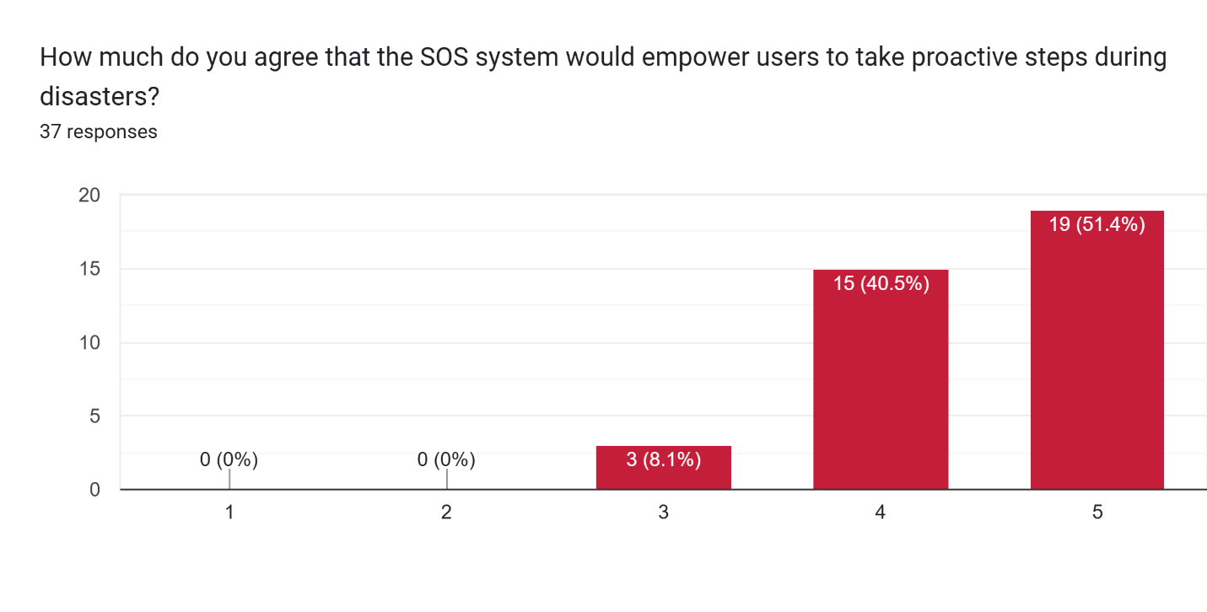

Figure 26: Statistic of empowerment of system on natural disaster

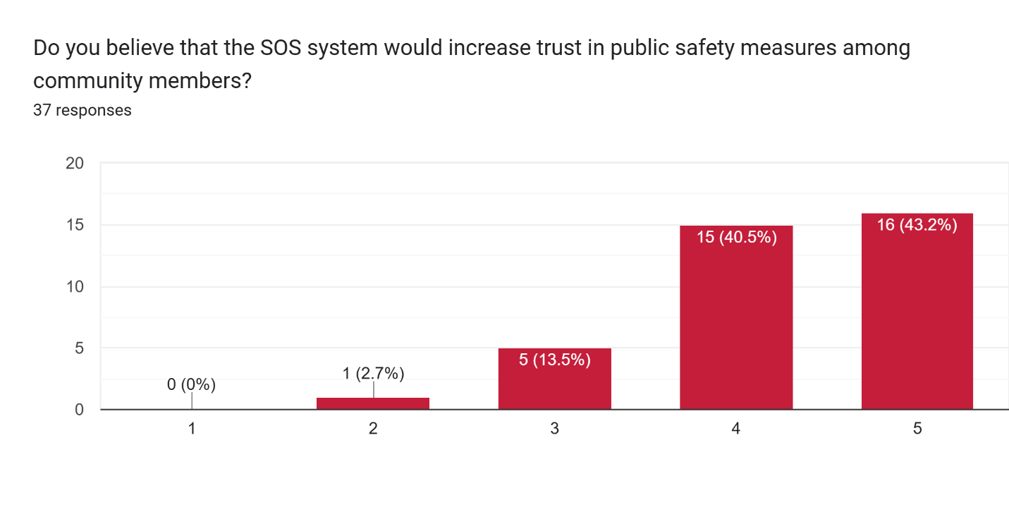

Figure 27: Statistic of trust in natural disaster system

Both figure from the above mentioned on public opinion on the SOS system. Majority of the respondents strongly agreed that a SOS system would empower them and secure public trust. The positive potential can help users to download the app more because they trust it to save themselves.

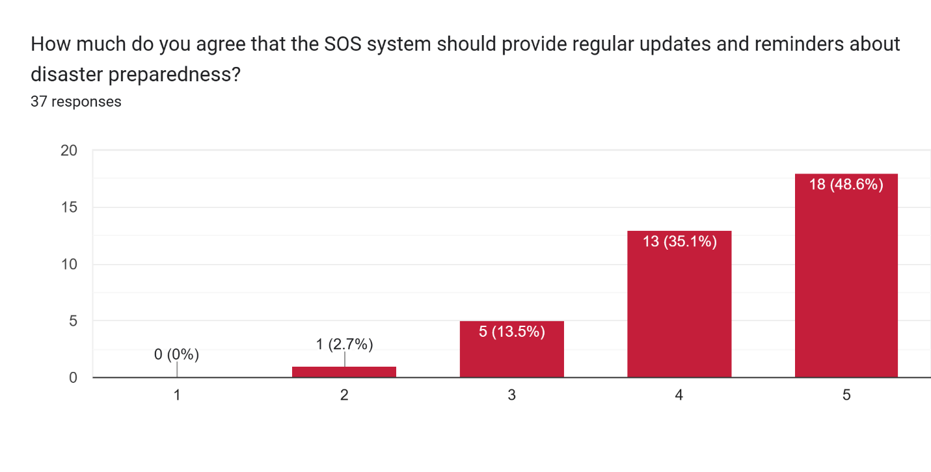

Figure 28: Statistic of reminder system about natural disaster

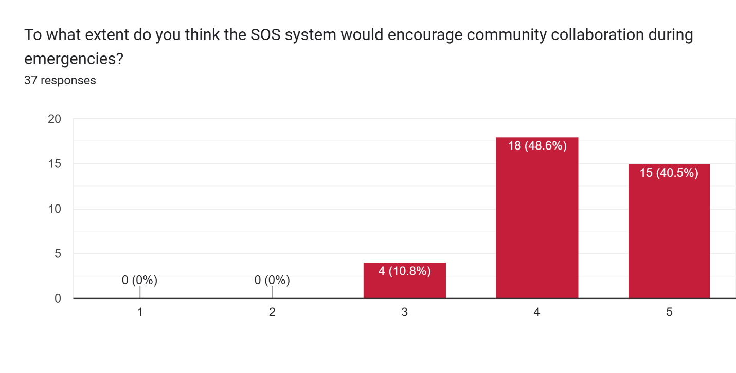

Figure 29: Statistic of collaboration of community in natural disaster

From figure 28, regular reminders are preferred to 18 out of 37 respondents because of the need to be consistently updated when a crisis occurs. However, 1 respondent slightly disagree to this statement. This could possibly be due to the access of information elsewhere for the responder to learn about the crisis. Furthermore in figure 29, 18 respondent slightly agree to have community help during emergencies. Overall this section shows the need for a feature in community engagements.

### Section 3: System Section

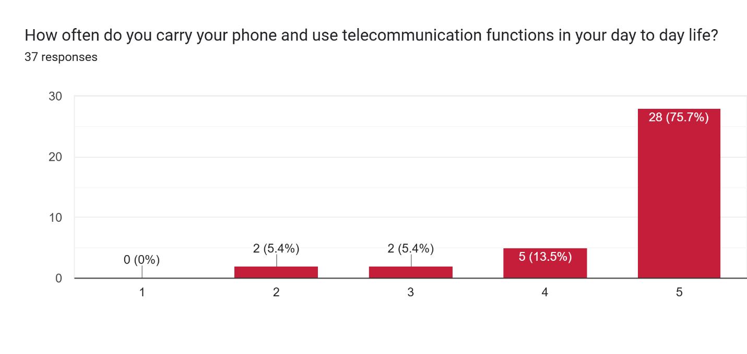

Figure 30: Bar chart for respondents who carry their mobile phones.

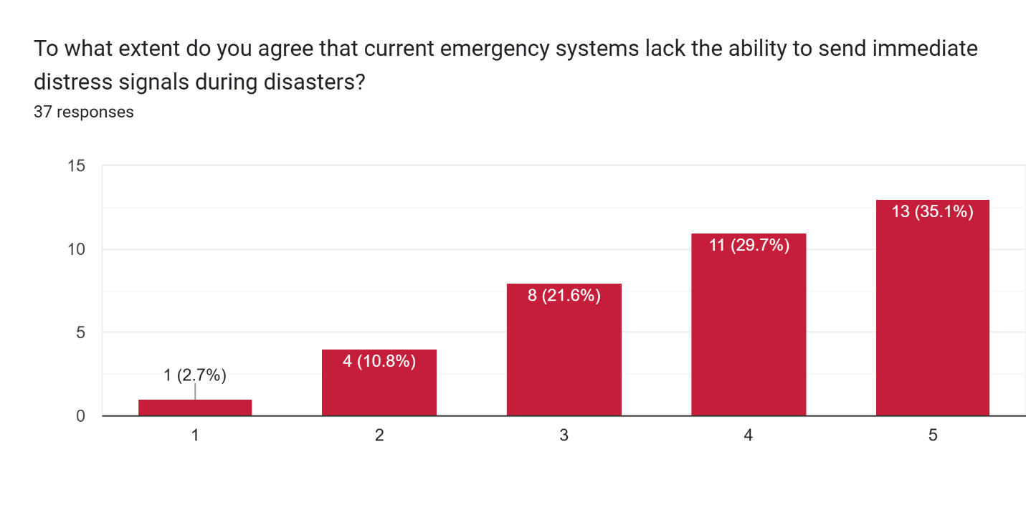

Figure 31: Bar chart for lack of sending signals.

Figure 30 is to find out how often does a person use to carry their phone and use the app provided in the future. 75.5% of the respondent carry their phone and uses telecommunication app. In figure 31, there is an increase distribution of respondent selecting each category. The respondent choose strongly agree as the highest frequency due to current emergency system lack the ability to send immediate distress signals to obtain help during natural disaster. This means traditional system should be updated into an application system to have a more effective engagement with the victims.

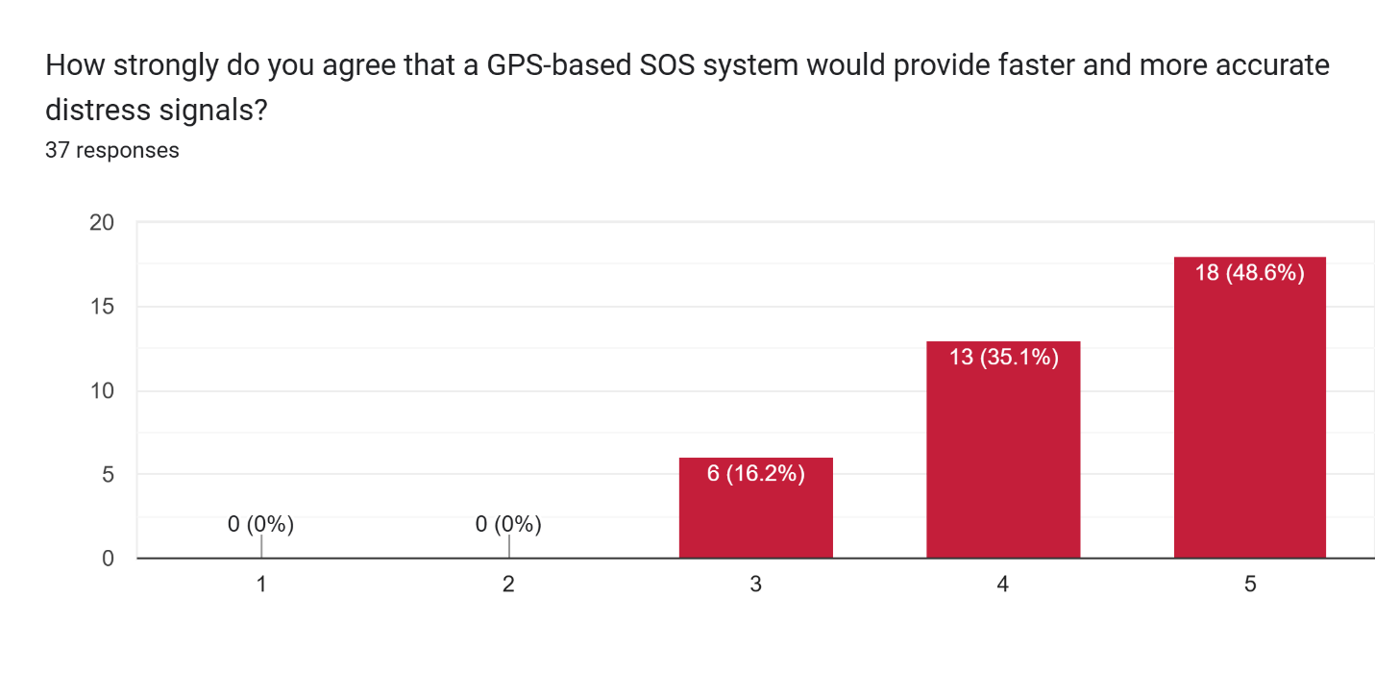

Figure 32: Bar chart for GPS system.

In this figure, we can conclude that 18 respondents agree that GPS-based system is a need to send more accurate distress signals , than other method such as calls and evacuation guidelines.

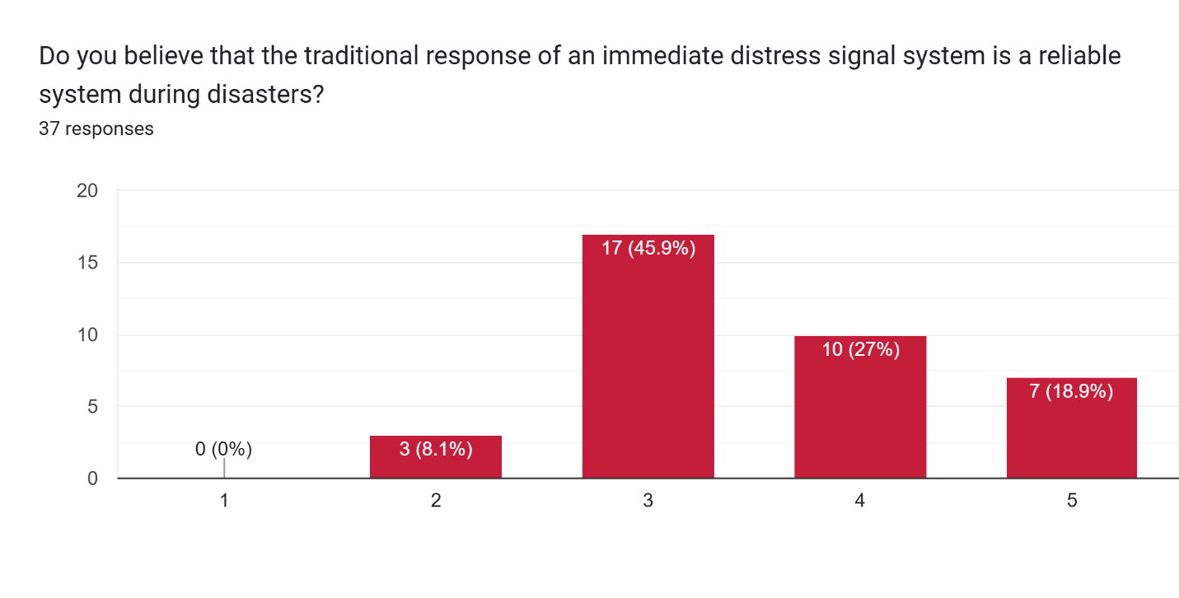

Figure 33: Bar chart for traditional response system.

In figure 33, 17 respondent (46%) believe that the traditional method is still somewhat effective and is neutral on the matter. This is because in most cases the government must be notified of big news such as natural disaster, therefore the relief team sent would be helpful in some cases.

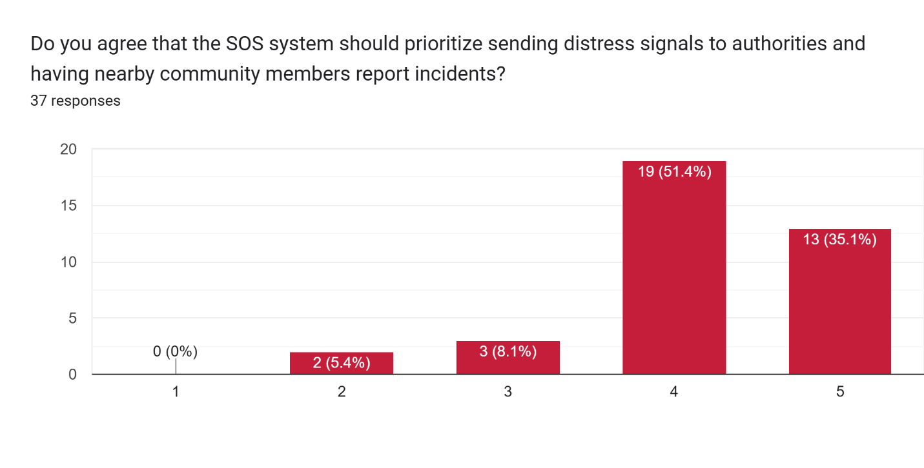

Figure 34: Bar chart for SOS system in sending signals to relevant parties.

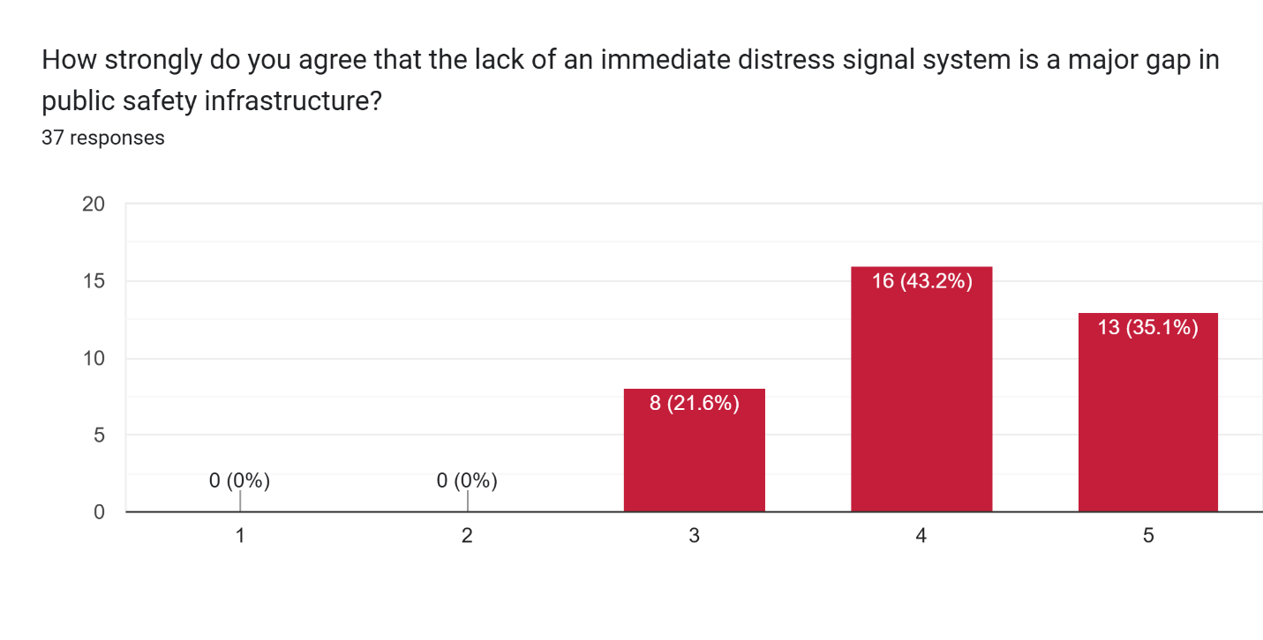

Figure 35: Bar chart for gaps in public safety infrastructure.

From figure 34, 19 respondent slightly agree that all SOS signals should be sent to the community around them and relevant parties for help. From figure 35, 16 respondents believe that the lack of distress signals from victims causes public safety issues. This is due to the fact, most people don’t realize that their area is affect from natural disaster.

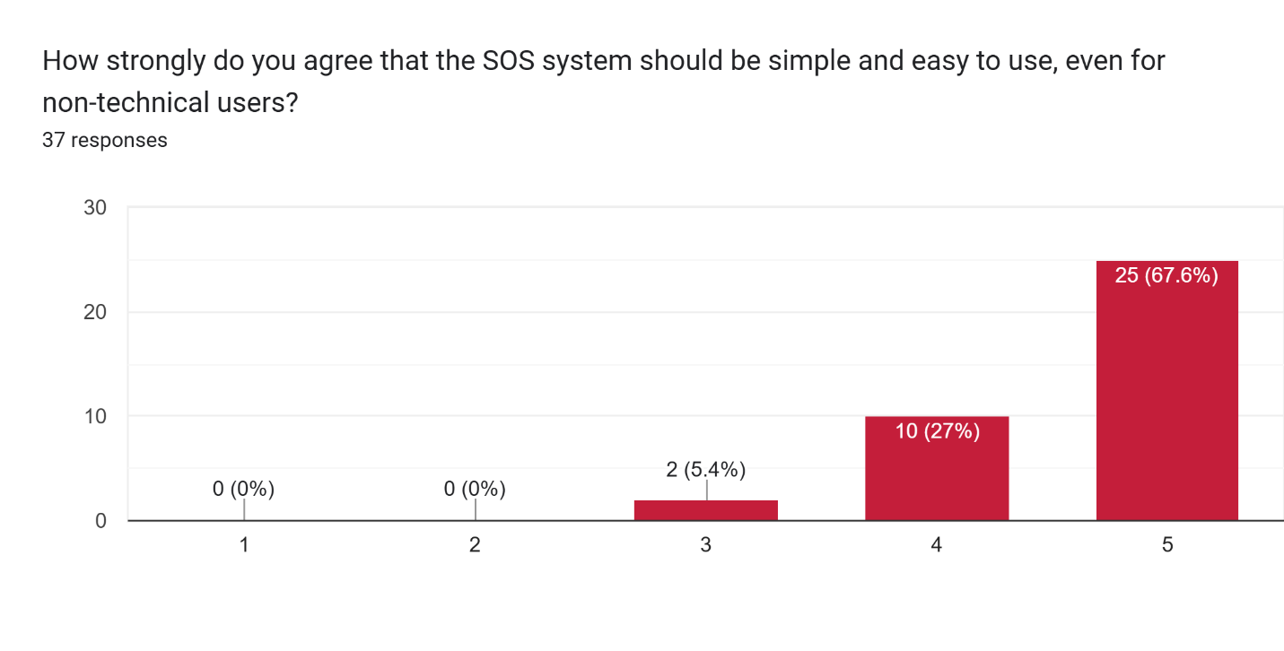

Figure 36: Bar chart for simple SOS system

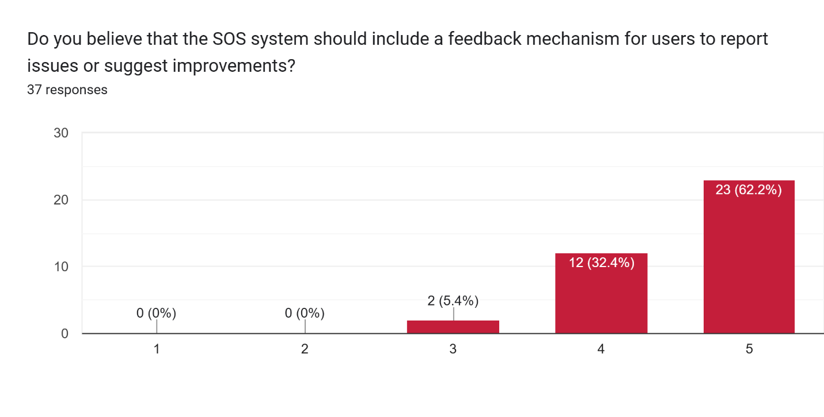

Figure 37: Bar chart for report mechanism.

Figure 36, explains majority of the respondent , that is 67.6% of people which is 25 respondents, strongly agrees that an SOS system such as the app, should be user friendly. This creates a welcoming environment for older or younger generations to download safety apps such as this. In figure 37, the feedback mechanism is strongly agreed among 23 respondents. This improves the ability of authorities to respond quicker and create smarter guidelines for the users.

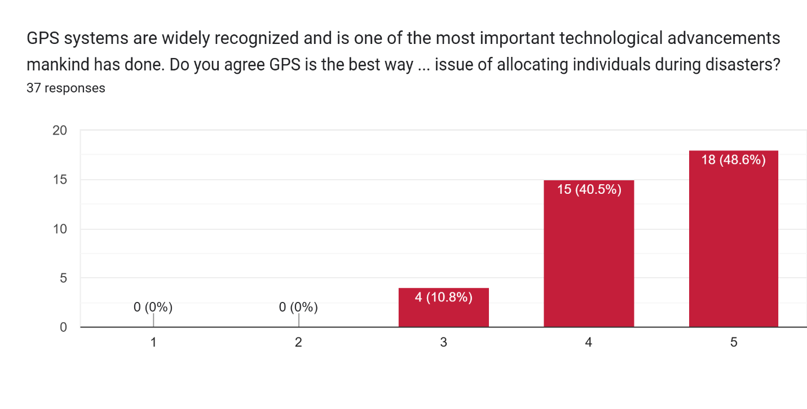

Figure 38: Bar chart for GPS use.

A positive response is recorded from this survey’s question, where 18 people have agreed that GPS is one of the best ways to help locating individuals. The range of GPS is 5 meters and is one of the best positioning system out there in terms of technology. Some may disagree, potentially due to oether country positioning system like GLONASS (Russia) or BeiDou (China).

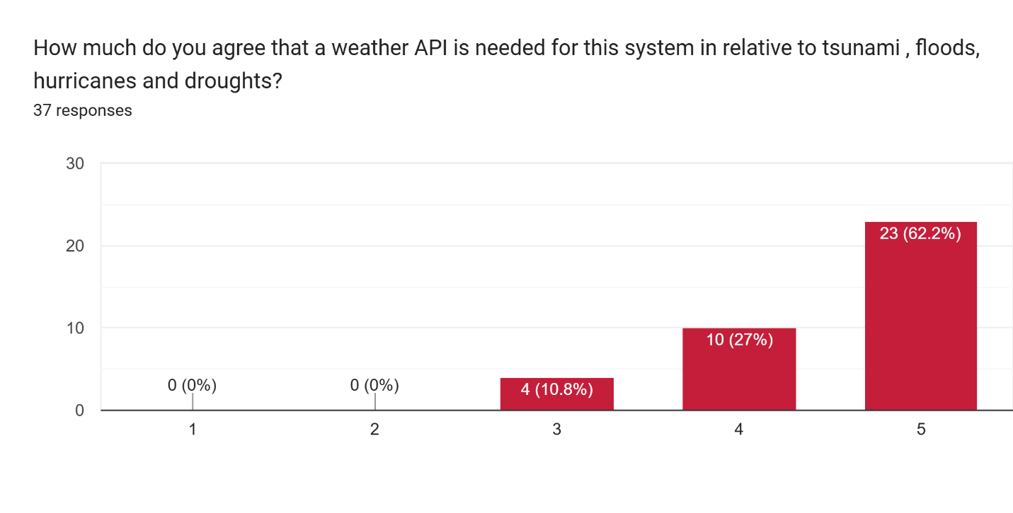

Figure 39: Bar chart for API integration.

The figure above, supports the need to use API for weather reports. Among 37 respondents, 23 of them strongly agree that this weather API (OpenWeatherMap) can give prior indications of a potential natural disaster. Strong winds and rainy days will absolutely question the user of when a natural disaster would happen.

### Section 4: Accessibility and Inclusivity Section

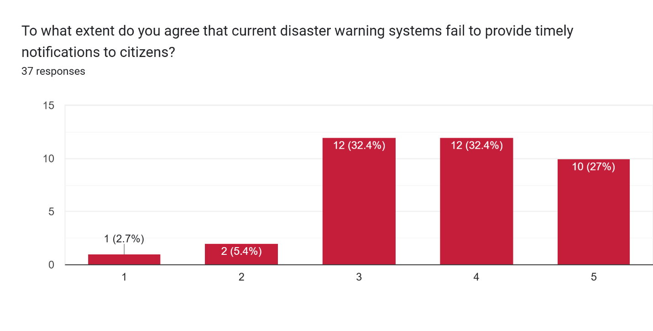

Figure 40: Timely notifications

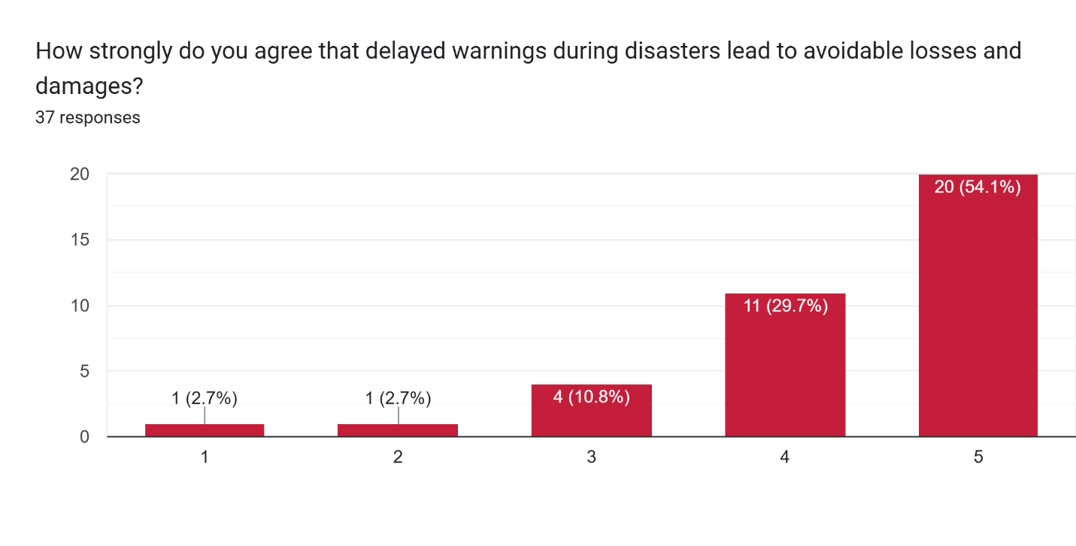

Figure 41: Timely notifications on losses and damages.

From figure 40, a total of 12 participants remained neutral and 12 participants slightly agree that current notification system failed to give timely notifications. Figure 41, 20 participants agree that timely warning could inevitably avoid losses and damages. This concludes that when the warnings are set, users are able to avoid the area that is affected or take precautions to avoid losses.

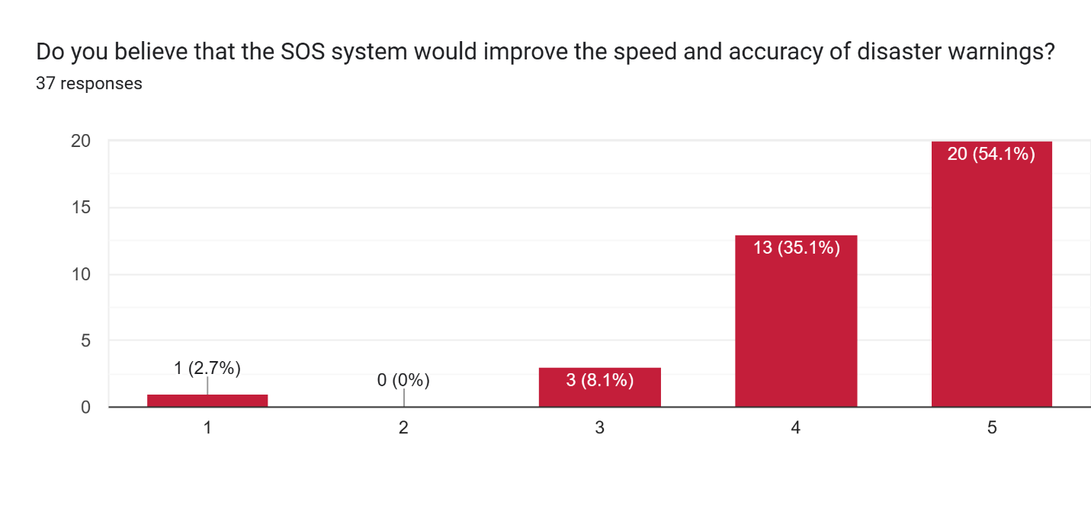

Figure 42: SOS system for accuracy and speed

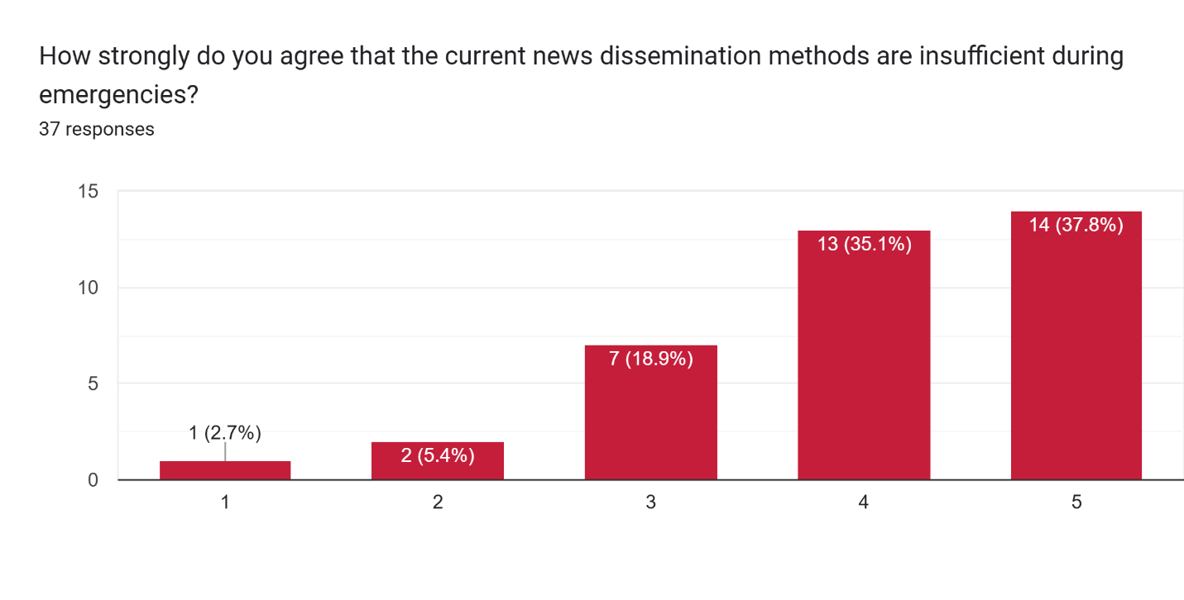

Figure 43: News notifications.

According to figure 42, SOS system can improve the speed and accuracy of disaster warnings, said 20 responders of the survey. This is because the function of the app can include real-time data collection of the victims. Next figure 43, 14 respondents strongly agree that current spreading of news is insufficient. Therefore, the app developed should have a news outlet where people can learn about the current natural disaster.

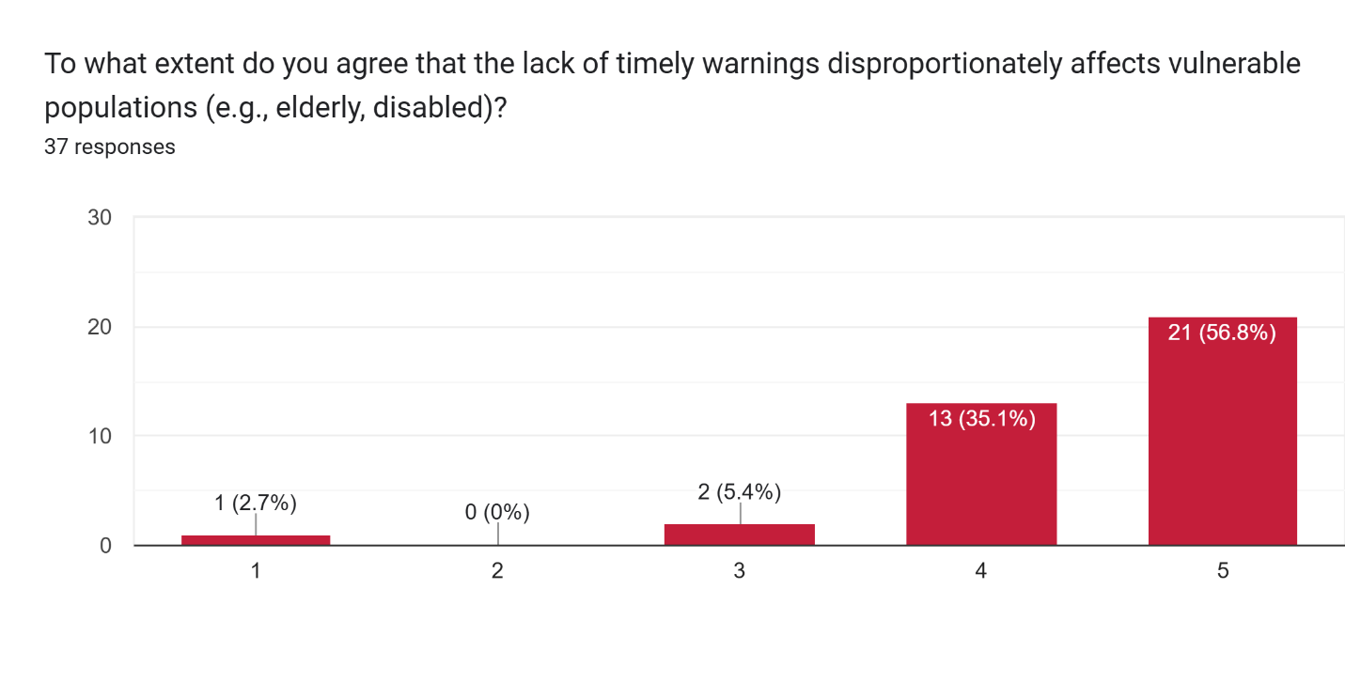

Figure 44: Timely notifications for vulnerable population.

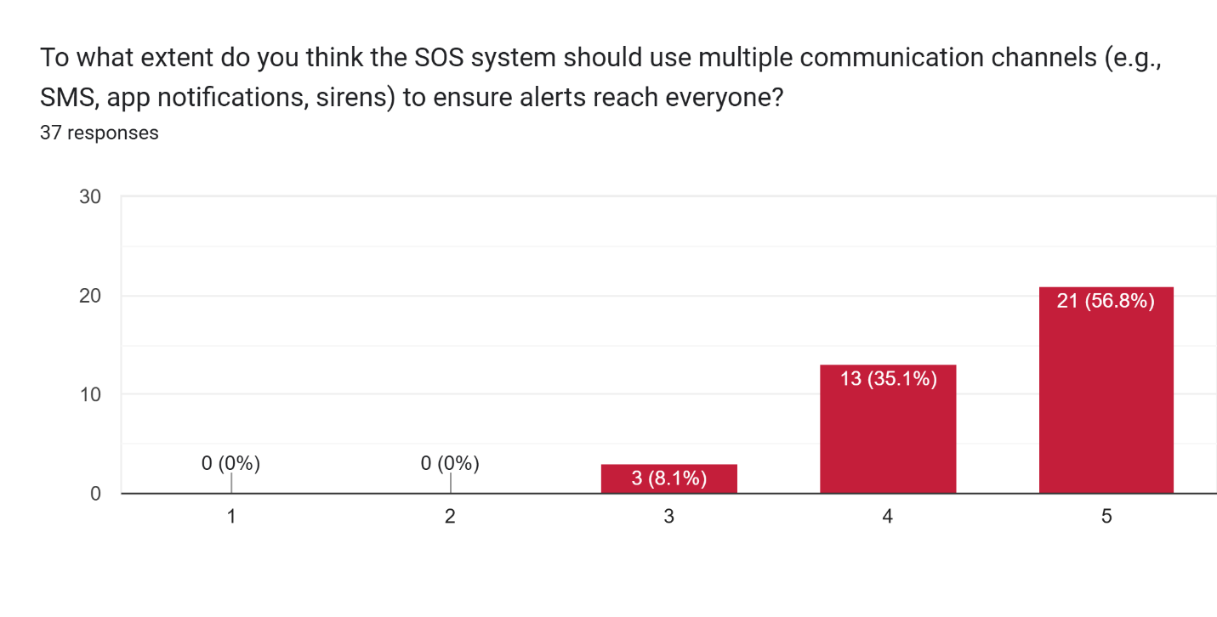

Figure 45: SOS notifications graph.

Inclusivity is very important, so does 21 of the responders strongly agree to it from figure 44. People who are older or disabled have difficulty in maneuvering through a natural disaster. If the relevant parties recognize this, they can help them far more effectively and increase the likelihood of their survival. Next figure 45, 21 respondents strongly agree that there is a need for SMS or app notifications to help get alert signals. Most major alerts are not notified as urgently as a notification. Thus, having this system helps users to get information quicker than news.

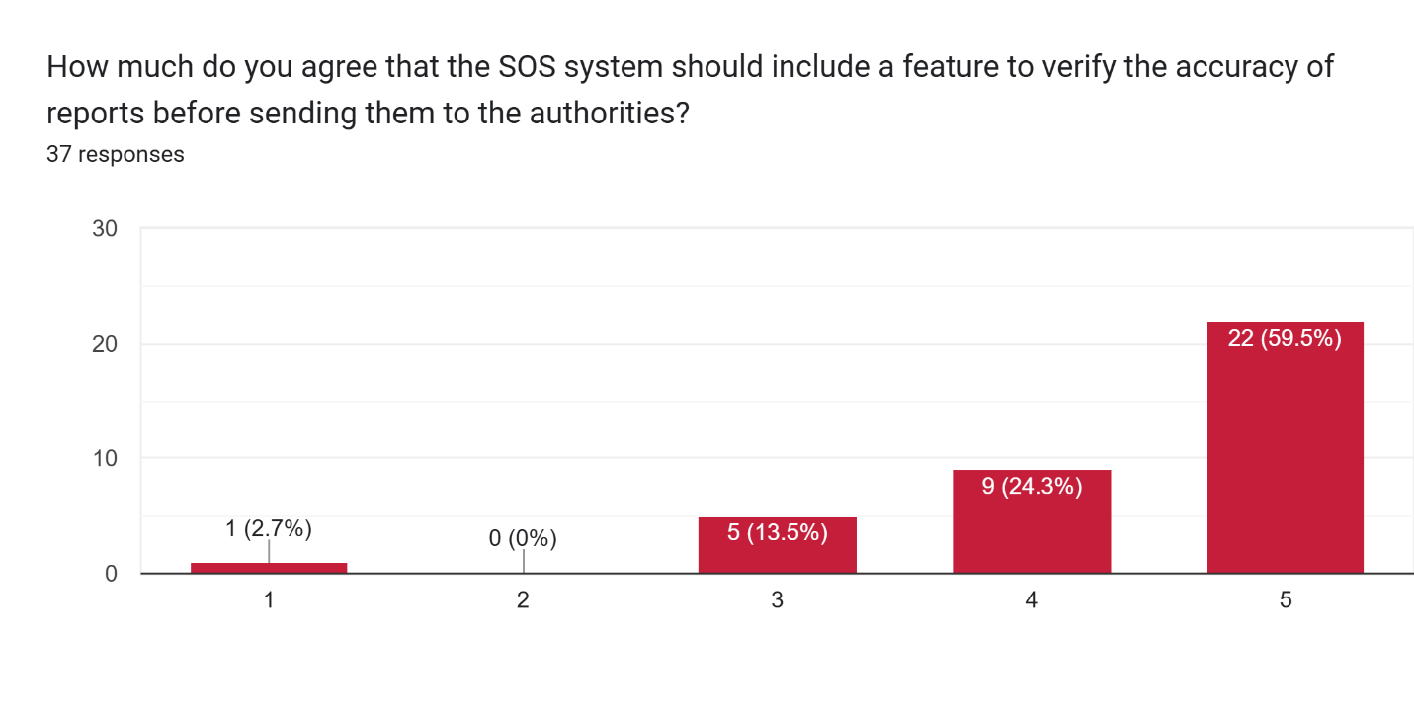

Figure 46: Verifying reports graph

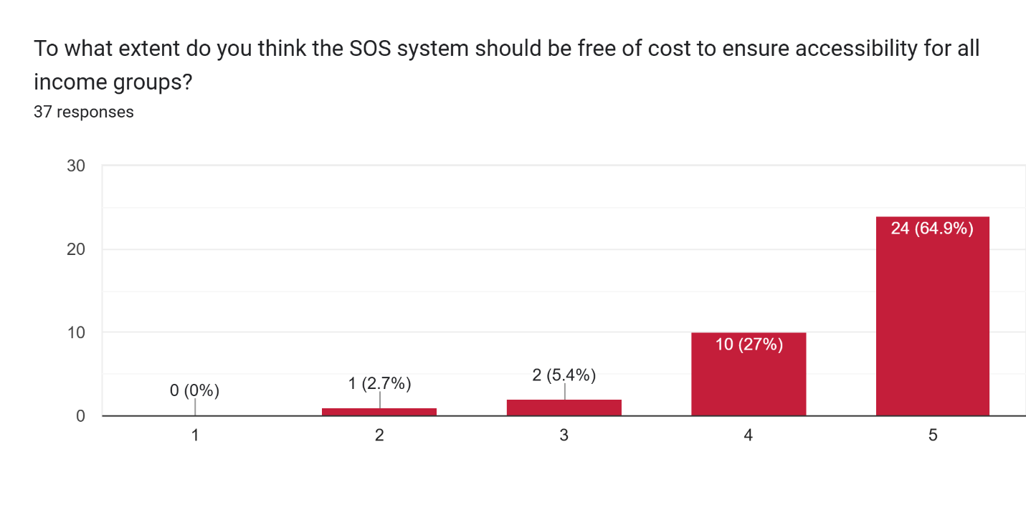

Figure 47: Cost free graph.

Based on figure 46, verifying the reports is important to 22 respondents. While based on figure 47, the respondent wants the application to be accessible for all income groups.

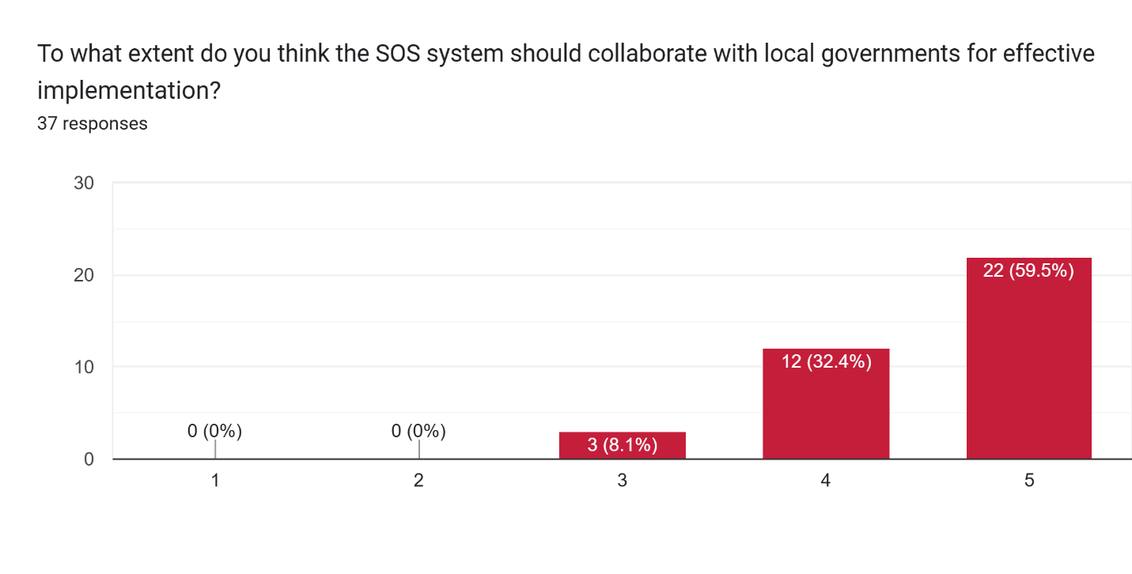

Figure 48: Collaborating with government.

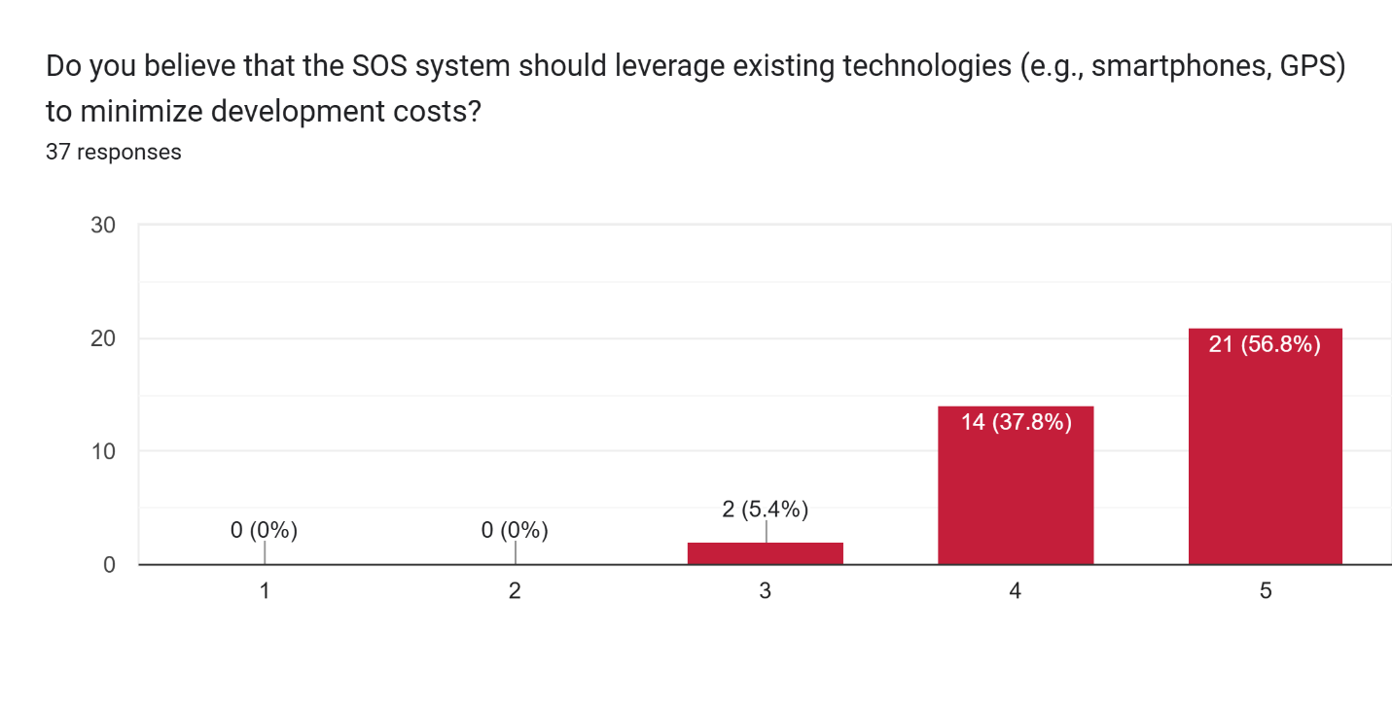

Figure 49: Development cost graph.

Figure 48, states that 22 repondent which is a total of 60% of the group, strongly agrees with collaborating with the government to be more safe during natural disaster. Next figure 48, shows 21 respondents uses system such as mobile GPS to minimize development cost. Hardware can be expensive to purchase, and the use of hardware can only be once while it can be easily damaged.

### Section 5: Challenges and Barriers Section

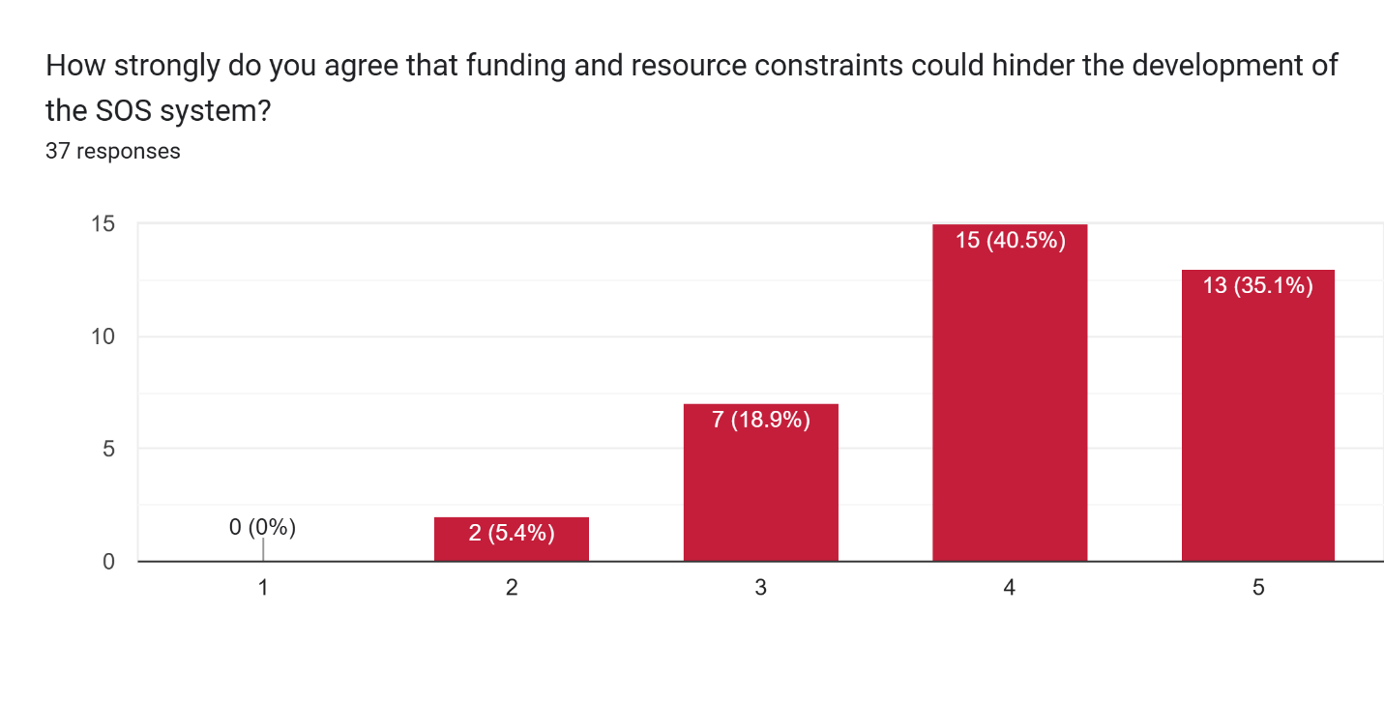

Figure 50: Funding and resources graph.

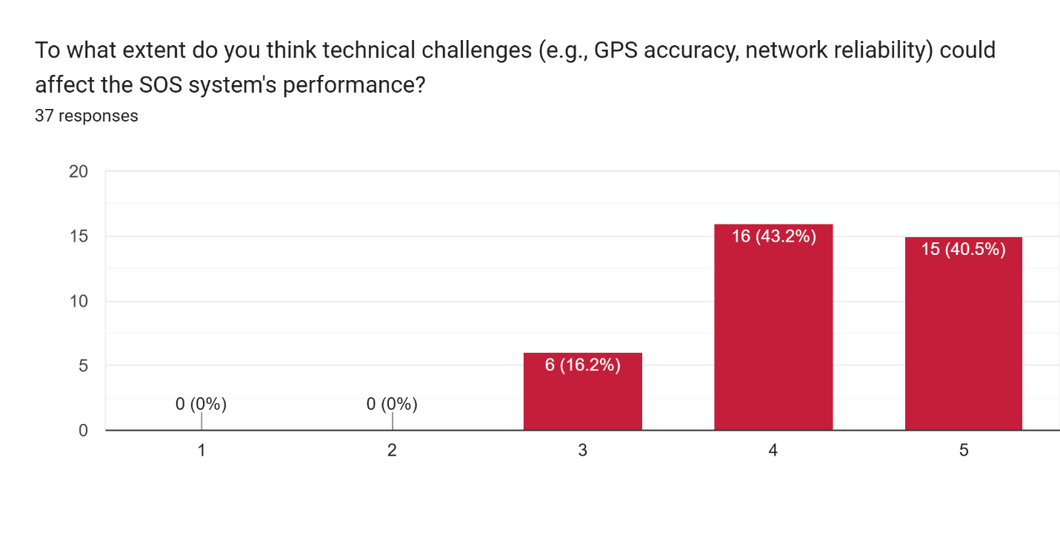

Figure 51: Technical challenges graph.

Figure 50, states that 15 people agree partially that funding and resource constrains can hinder development of SOS system. Next figure 51, shows the technical challenges that could potentially affect the performance of the GPS. Almost 16 people believe so, because in a natural disaster there is always less Wi-Fi and cellular data due to collapsed towers and floods affecting the signals.

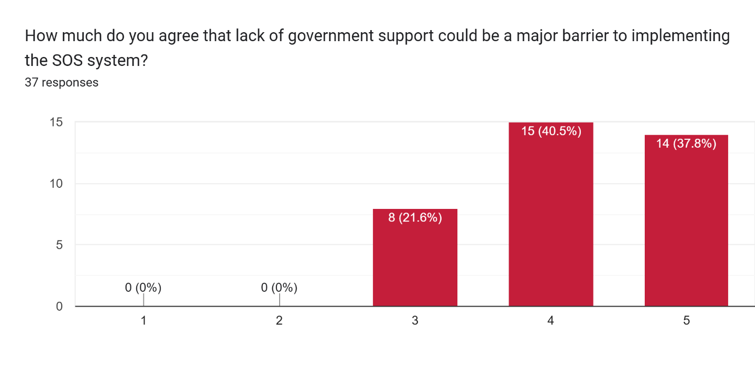

Figure 52: Funding and resources graph.

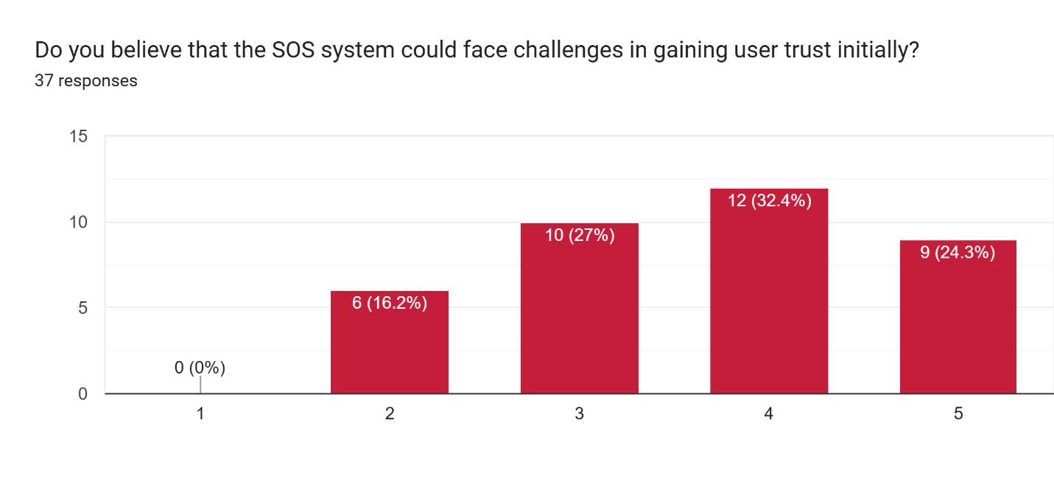

Figure 53: System trust graph.

Figure 52 shows that people slightly agree that the government does not put enough funding for the SOS system to be implemented in Malaysia. Based on figure 53, the SOS system will slightly face challenges on gaining people’s trust because of invasion of privacy when using location data.

### Summary for Analysis

The survey results highlight several key insights regarding the implementation and challenges of an SOS system in Malaysia. Respondents slightly agree that the government does not allocate sufficient funding for the SOS system, and there are concerns about gaining public trust due to potential privacy invasions related to location data usage. Additionally, funding and resource constraints are seen as significant barriers to the system's development. Technical challenges, such as limited Wi-Fi and cellular connectivity during natural disasters due to collapsed towers or floods, are also a concern. Inclusivity is a critical factor, with 21 respondents strongly agreeing that older or disabled individuals face difficulties during disasters and require targeted assistance. Furthermore, agreement on the need for SMS or app notifications reaches its consensus to deliver urgent alerts, as current systems often fail to provide timely warnings. Overall, the findings underscore the importance of funding, inclusivity, timely notifications, and technical reliability in developing an effective SOS system.

## 3.5 Summary

This chapter covers research on SOS system, its cost benefits, knowledge acquisitions, benefits of the followed methodology with mobile architecture, and inclusivity and adaptability of the system. These findings create a large understanding of the application, and its followed methodology used to conquer SDG 13 goal.

# CHAPTER 4: CONCLUSION

## 4.1 Achievements Reached

In conclusion, the research done and achievements reached will be a benchmark for future geolocation studies that apply application tools as their main technology. Domain research as well as similar system research made this project clearer and suggested the direction of the project a set destination. The researcher carried out multiple justifications of why each tool presented in this project is important in this own way and chooses to use them in the future. The planning from the project proposal form till the investigation report had multiple learning experience that can only be achieved when this type of research is done. The researcher successfully interprets all the data from the respondent in a thorough manner and each question has its own unique outcomes. These findings not only validate the methodology but also create meaningful insights to the domain of geological technology. Processes such as notification alerts, news dissemination and natural disaster guidance were all learnt collectively in this process. Overall, the accomplished achievements prepare a solid foundation for the next step of this investigation.

## 4.2 Adequate Research and Analysis Justification

From the beginning the aim and objective of the project was drawn out to research on various topics and domains. The main domain explored in this project was Global Positioning System (GPS), Emergency communication system, Distributed and Mobile Collaborative (DMC) Systems and Media Richness Theory (MRT). All these domains were sufficient to help realize the capability to reduce its impact on earth with SDG 13. Furthermore, features and methodology created a learning curve on how to follow guidelines to meet the future goals set in this project.

## 4.3 Gaps and Future Enhancement

With technology always on the improving, the next step is to present the gaps and potential future enhancements that can be done.

**Dependence on Manual Input**:

The SOS signal sent from the client’s phone to the relevant parties is not feasible in a natural disaster situation. Most often people may forget the app exists as not many people uses it daily.

**Internet Dependency**:

This system that will be deployed depends on Wi-Fi or mobile data to send notifications to the database and vice versa. In areas with poor internet, the system will fail to function making it a high-risk casualty area. Area such as that, could use Bluetooth system from the similar system discussed earlier.

**Limited Integration with External Systems**:

Due to the limited scope of finding victims using GPS location and only providing them with rescue aid, the system does not include external emergencies service from the hospitals, police or fire department. This makes the app unreliable and non-versatile by primarily serving only one party at a time.

# REFERENCES

*A Significant Year of Disaster Impact 399*. (2023). Retrieved from https://files.emdat.be/reports/2023_EMDAT_report.pdf

Abulkhair, M., & Fattouh, L. (2016). Using Rule Base System in Mobile Platform to Build Alert System for Evacuation and Guidance. *IJACSA) International Journal of Advanced Computer Science and Applications*, *7*(4). Retrieved from https://thesai.org/Downloads/Volume7No4/Paper_9-Using_Rule_Base_System_in_Mobile_Platform_to_Build_Alert_System.pdf

Akanksha Mathur, & Archana Acharya. (2015). A Comparative Study on Utilization of Scrum and Spiral Software Development Methodologies: A Review. *International Journal of Engineering Research And*, *V4*(11). https://doi.org/10.17577/ijertv4is110154

Arun Raj S, Anees H, Johnson, J., & Anil, N. (2019). Implementation of Panic Button in Mobile Phones. *International Journal of Scientific Research in Science Engineering and Technology*, *5*(9), 126–131. https://doi.org/10.32628/ijsrset195922

Asian Disaster Reduction Center（ADRC）. (2017). Retrieved from www.adrc.asia website: https://www.adrc.asia/acdr/2017/documents/7%20Malaysia%20National%20Disaster%20Management%20Agency%20(NADMA)%20and%20its%20philosophy

Atlassian. (2025). Cost Benefit Analysis: What Is It and How to Do It. Retrieved March 12, 2025, from Atlassian website: https://www.atlassian.com/zh/work-management/strategic-planning/cost-benefit-analysis

Aziyati Yusoff, Norashidah Md Din, Salman Yussof, & Khan, S. U. (2015). *Big data analytics for Flood Information Management in Kelantan, Malaysia*. <https://doi.org/10.1109/scored.2015.7449346>

*Building user interfaces with flutter*. Flutter. (n.d.). https://docs.flutter.dev/ui

Bergin, R. (2016). *Media Richness Theory RICHARD BERGIN CENTER FOR HOMELAND DEFENSE AND SECURITY DEPT. OF NATIONAL SECURITY AFFAIRS NAVAL POSTGRADUATE SCHOOL*. Retrieved from https://www.chds.us/coursefiles/IS4010/lectures/tech_media_richness_long/story_content/external_files/Media%20Richness%20Theory%20Script.pdf

Canillo, L. J. L., & Hernandez, A. A. (2021). Sci-Hub | Flood Risk Visualization and Prediction Information System: Case of City Manila, Philippines. 2021 IEEE 17th International Colloquium on Signal Processing & Its Applications (CSPA) | 10.1109/cspa52141.2021.9377276. *Sci-Hub.se*. https://doi.org/10.1109/cspa52141.2021.9377276%3C

Chen, Z., Zou, H., Jiang, H., Zhu, Q., Soh, Y., & Xie, L. (2015). Fusion of WiFi, Smartphone Sensors and Landmarks Using the Kalman Filter for Indoor Localization. *Sensors*, *15*(1), 715–732. https://doi.org/10.3390/s150100715

Digvijay's. (2024, February 16). Flutter, Angular, or React: Which Is The Right Framework for Your Next Web and Mobile App Development Project? Retrieved March 12, 2025, from Medium website: https://medium.com/@digvijayackrolix/flutter-angular-or-react-which-is-the-right-framework-for-your-next-web-and-mobile-app-a9d9f2f3fea1

Doshi, D., Jain, L., & Gala, K. (2021). REVIEW OF THE SPIRAL MODEL AND ITS APPLICATIONS. *International Journal of Engineering Applied Sciences and Technology*, *5*(12). https://doi.org/10.33564/ijeast.2021.v05i12.053

Dustdar, S., & Gall, H. (2003). Architectural concerns in distributed and mobile collaborative systems. *Journal of Systems Architecture*, *49*(10-11), 457–473. https://doi.org/10.1016/s1383-7621(03)00092-4

Fernando, M. C. G., Solomo, M. V., & Lagman, A. (2019). iHanda: A Mobile Application for Disaster Preparedness. *International Journal of Simulation: Systems, Science & Technology*. https://doi.org/10.5013/ijssst.a.20.s2.25

Frederiksen, M. R., Stoy, K., & Maja Matarić. (2024). Toward Anxiety-Reducing Pocket Robots for Children. *2024 21st International Conference on Ubiquitous Robots (UR)*, 13–20. https://doi.org/10.1109/UR61395.2024.10597525

Gall, M., & Friedland, C. J. (2020). If Mitigation Saves $6 Per Every $1 Spent, Then Why Are We Not Investing More? A Louisiana Perspective on a National Issue. *Natural Hazards Review*, *21*(1), 04019013. https://doi.org/10.1061/(asce)nh.1527-6996.0000342

H.K, S., RB, M., Keerthana, C., S, P., Meghana, R., & Thanmai, Y. (2022, April 1). Smart Reminder SOS & Emergency Detection Device. https://doi.org/10.1109/ICDCECE53908.2022.9793171

Han, Z., & Wu, G. (2024). Why do people not prepare for disasters? A national survey from China. *Npj Natural Hazards*, *1*(1), 1–7. https://doi.org/10.1038/s44304-024-00001-2

Hasan, R., Hasan, R., & Islam, T. (2021, January 1). InSight: A Bluetooth Beacon-based Ad-hoc Emergency Alert System for Smart Cities. https://doi.org/10.1109/CCNC49032.2021.9369621

Indeed Editorial Team. (2024). What Is Research Methodology and Why Is It Important? Retrieved from Indeed Career Guide website: https://www.indeed.com/career-advice/career-development/research-methodology

Ishii, K., Lyons, M. M., & Carr, S. A. (2019). Revisiting media richness theory for today and future. *Human Behavior and Emerging Technologies*, *1*(2), 124–131. https://doi.org/10.1002/hbe2.138

James, V., Caballero, A. R., Albina, E. M., Hernandez, A. A., & Ronaldo Juanatas. (2023). *Acceptance of Mobile Application on Disaster Preparedness: Towards Decision Intelligence in Disaster Management*. https://doi.org/10.1109/icbir57571.2023.10147638

Kasimalla, S. R., Park, K., Zaboli, A., Hong, Y., Choi, S. L., & Hong, J. (2024). An Evaluation of Sustainable Power System Resilience in the Face of Severe Weather Conditions and Climate Changes: A Comprehensive Review of Current Advances. *Sustainability*, *16*(7), NA–NA. https://doi.org/10.3390/su16073047

Laya, M., Setianingrum, F., Mera, K., Delimayanti, Mahmudah, A., Mardiyono, A., & Anggraini, D. (n.d.). *Classification of Natural Disaster on Online News Data Using Machine Learning* . Retrieved from https://repository.pnj.ac.id/id/eprint/4921/5/MERA-328086-ELTICOM.pdf

Moreno, A., Garrison, P., & Bhat, K. (2017). *WhatsApp for Monitoring and Response during Critical Events: Aggie in the Ghana 2016 Election*. Retrieved from https://collections.unu.edu/eserv/unu:6189/iscram_unu_cs.pdf

MyGOV - The Government of Malaysia’s Official Portal. (n.d.). Retrieved from www.malaysia.gov.my website: https://www.malaysia.gov.my/portal/content/31326

Natural Disaster Support and Guidance. (2024). Retrieved from U.S. Department of Education website: https://www.ed.gov/teaching-and-administration/safe-learning-environments/natural-disaster-resources/natural-disaster-support-and-guidance

Prasad, N., Kumar, V., & Kumar, S. (2024). Survey research-concept and development. *Journal of Indira Gandhi Institute of Medical Sciences*, *10*(2). https://doi.org/10.4103/jigims.jigims_10_24

Ready. (2023, September 7). Emergency Response Plan | Ready.gov. Retrieved from www.ready.gov website: https://www.ready.gov/business/emergency-plans/emergency-response-plan

Reynolds, B., & Seeger, M. (n.d.). (PDF) Crisis and Emergency Risk Communication as An Integrative Model. Retrieved from ResearchGate website: https://www.researchgate.net/publication/7970925_Crisis_and_Emergency_Risk_Communication_as_An_Integrative_Model

Rinayat, B., Katre, N., Lanjewar, A., & Dongre, H. (2023). SMART NEWS APP FOR COLLEGE. *International Research Journal of Modernization in Engineering Technology and Science*. https://doi.org/10.56726/irjmets35108

Ritchie, H., & Roser, M. (2024). The world has become more resilient to disasters, but investment is needed to save more lives. *Our World in Data*. Retrieved from https://ourworldindata.org/the-world-has-become-more-resilient-to-disasters-but-investment-is-needed-to-save-more-lives

Salim, K., & Idrees, I. M. (2013). *Design and Implementation of Web-Based GPS-GPRS Vehicle Tracking System*. *3*(12). Retrieved from https://www.researchgate.net/publication/310267800_Design_and_Implementation_of_Web-Based_GPS-GPRS_Vehicle_Tracking_System

Setia, L. D., Yulianto, S. V., & Atmaja, A. P. (2021). Android Based Emergency Button with Position Share System. *Journal of Physics: Conference Series*, *1845*(1), 012013. https://doi.org/10.1088/1742-6596/1845/1/012013

Shafiee, S., Wautelet, Y., Hvam, L., Sandrin, E., & Forza, C. (2020). Scrum versus Rational Unified Process in facing the main challenges of product configuration systems development. *Journal of Systems and Software*, *170*, 110732. https://doi.org/10.1016/j.jss.2020.110732

Swagata Upreti, & Kumar, M. (2008, March 8). Perspectives of Global Positioning System (GPS) Applications. Retrieved March 12, 2025, from ResearchGate website: https://www.researchgate.net/publication/232710082_Perspectives_of_Global_Positioning_System_GPS_Applications

U.S. Department of the Interior. (2019, September 4). Natural disaster response and recovery. Retrieved from U.S. Department of the Interior website: https://www.doi.gov/recovery

UNFCCC. (2015). The Paris Agreement. Retrieved from United Nations Climate Change website: https://unfccc.int/process-and-meetings/the-paris-agreement

Vernick, D. (2025, January 14). Is Climate Change Increasing the Risk of Disasters? Retrieved from World Wildlife Fund website: https://www.worldwildlife.org/stories/is-climate-change-increasing-the-risk-of-disasters

Zhu, D. H., & Deng, Z. Z. (2020). Effect of Social Anxiety on the Adoption of Robotic Training Partner. *Cyberpsychology, Behavior, and Social Networking*. https://doi.org/10.1089/cyber.2020.0179

# APPENDICES

## Screenshot of PPF

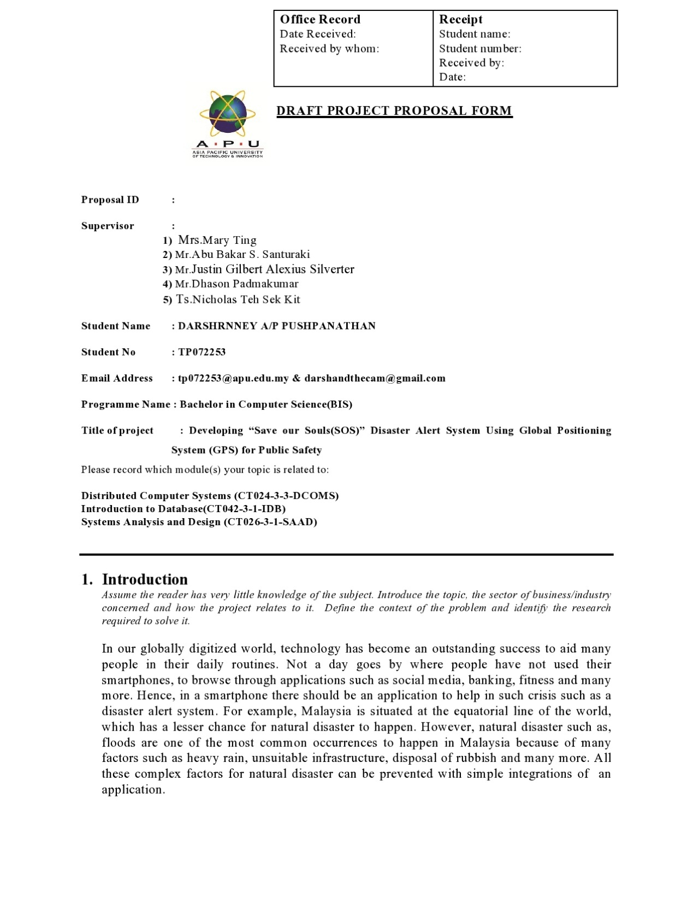

Figure 54: PPF page 1

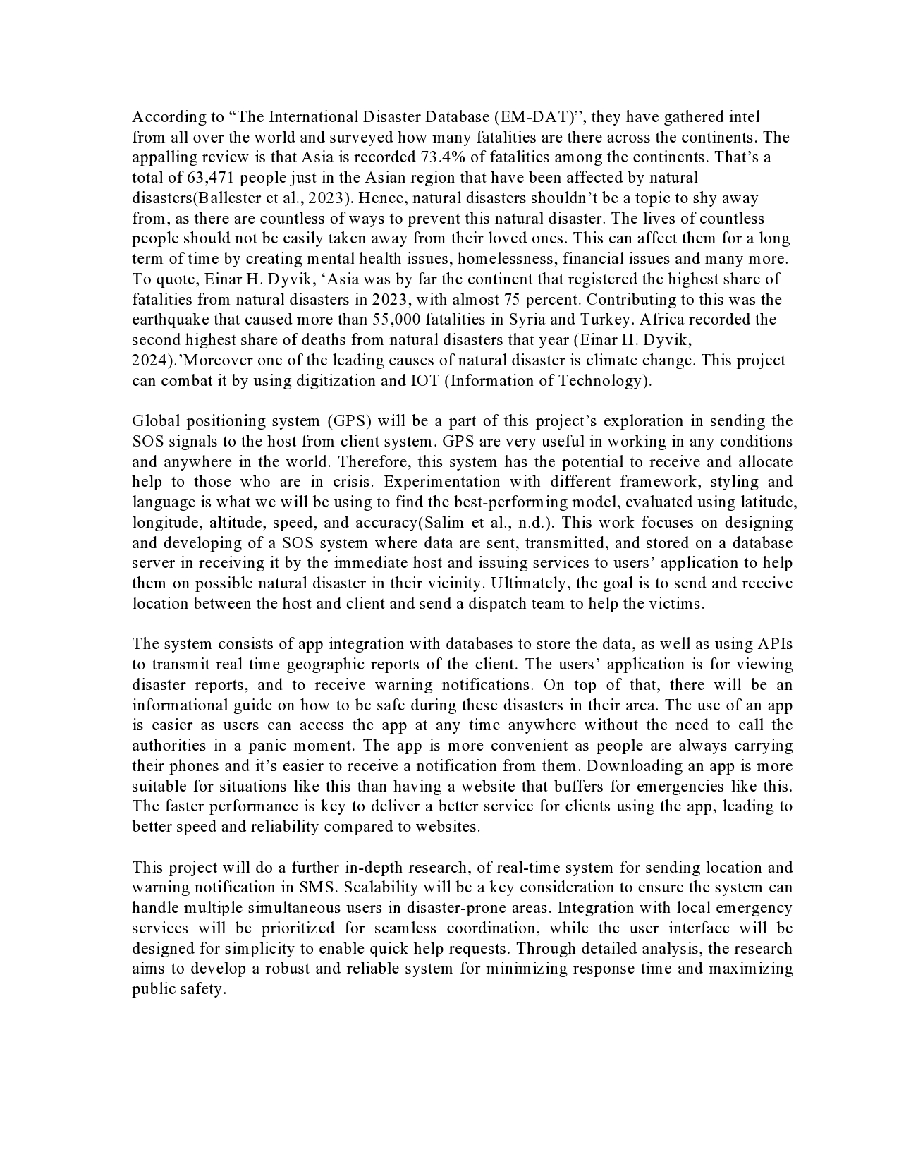

Figure 55: PPF page 2

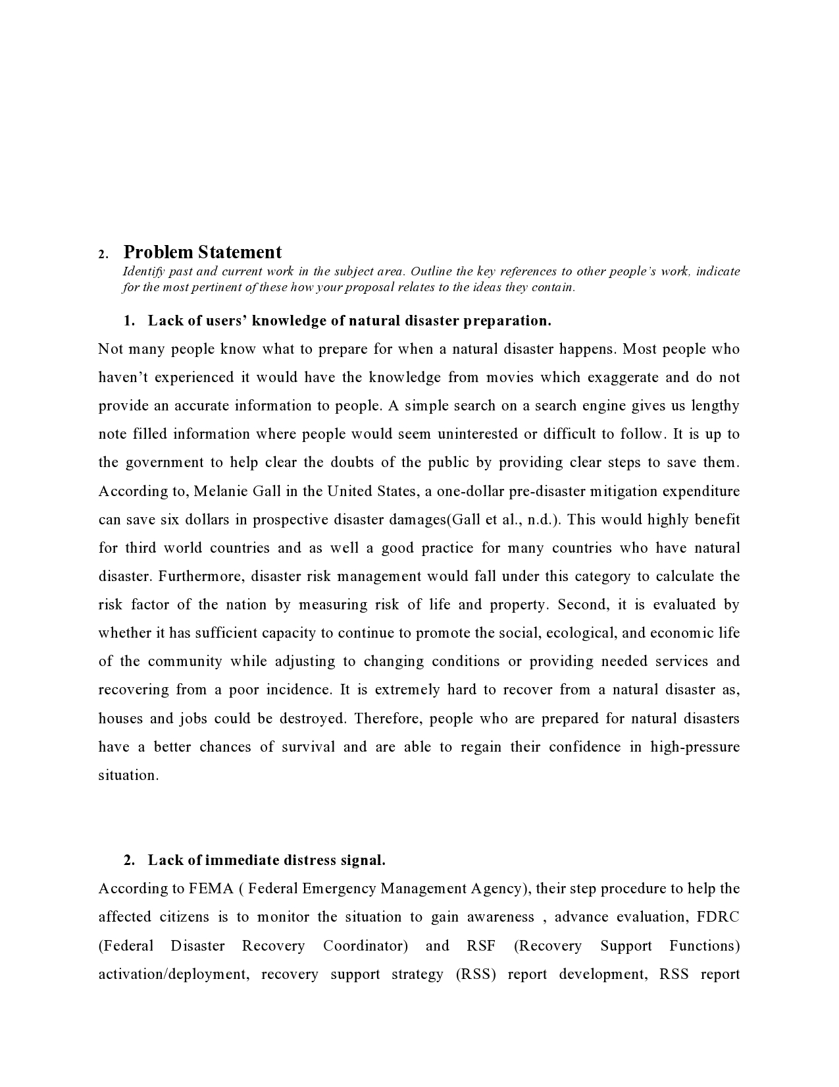

Figure 56: PPF page 3

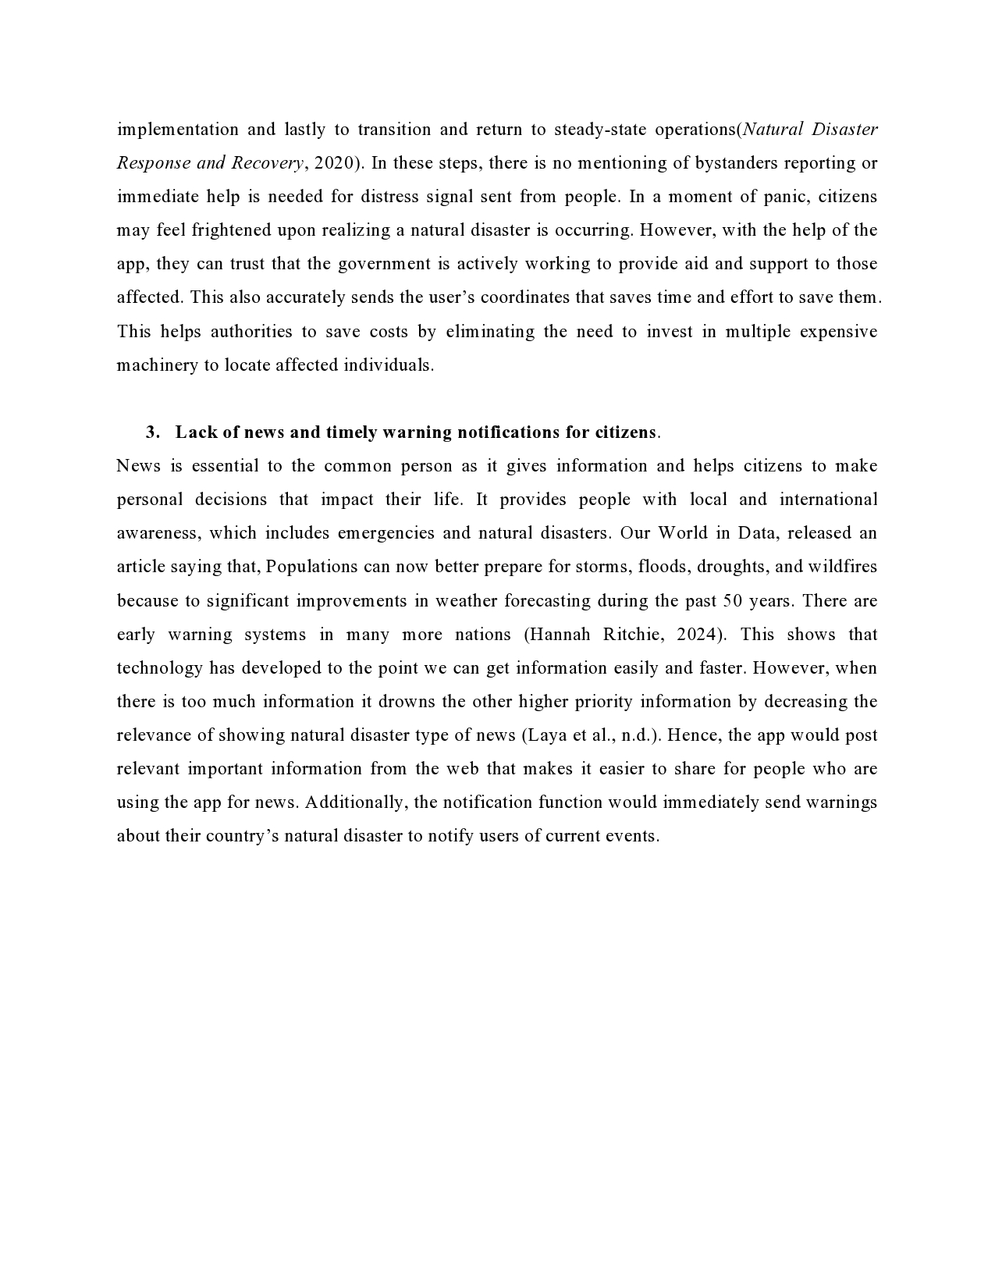

Figure 57: PPF page 4

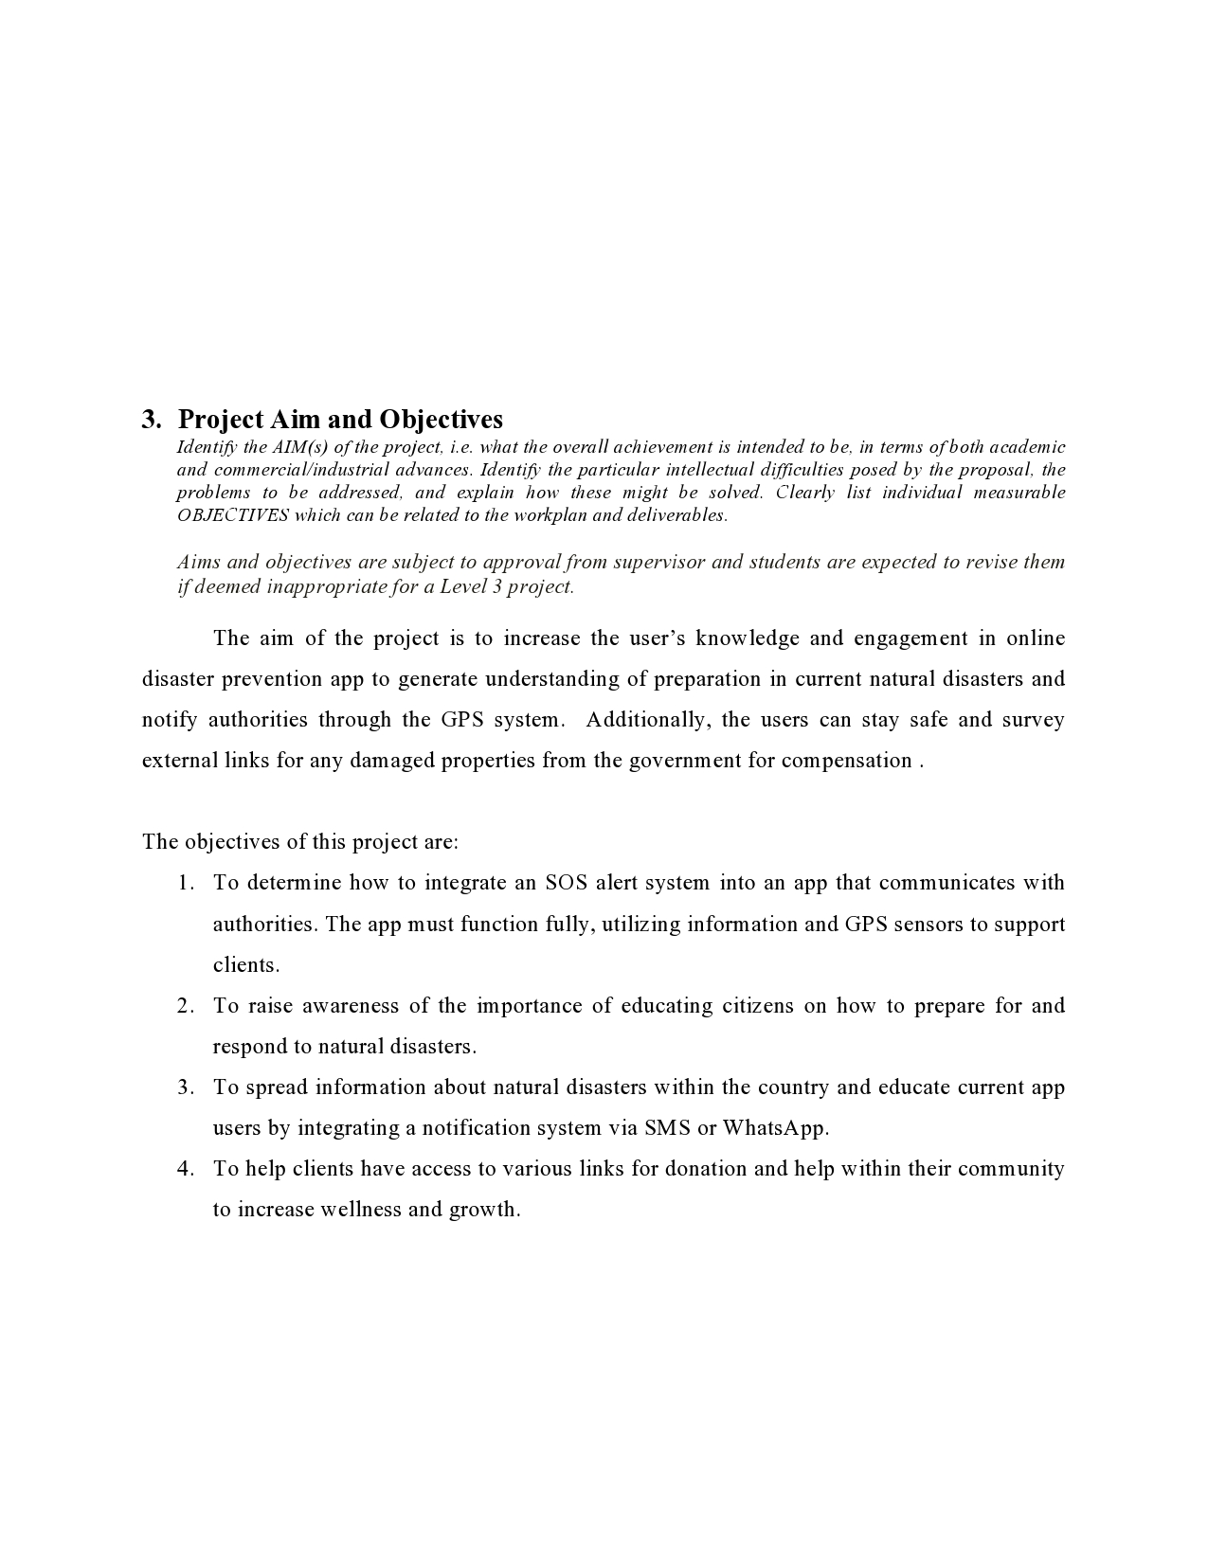

Figure 58: PPF page 5

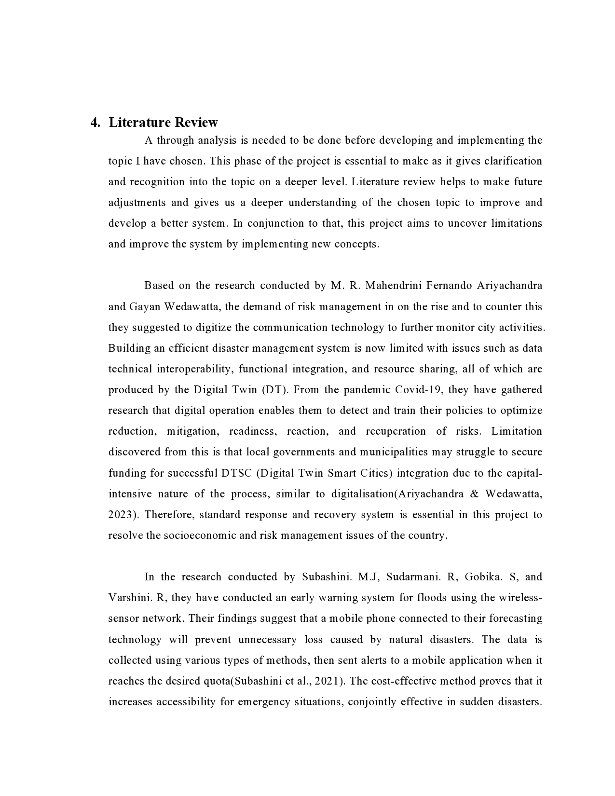

Figure 59: PPF page 6

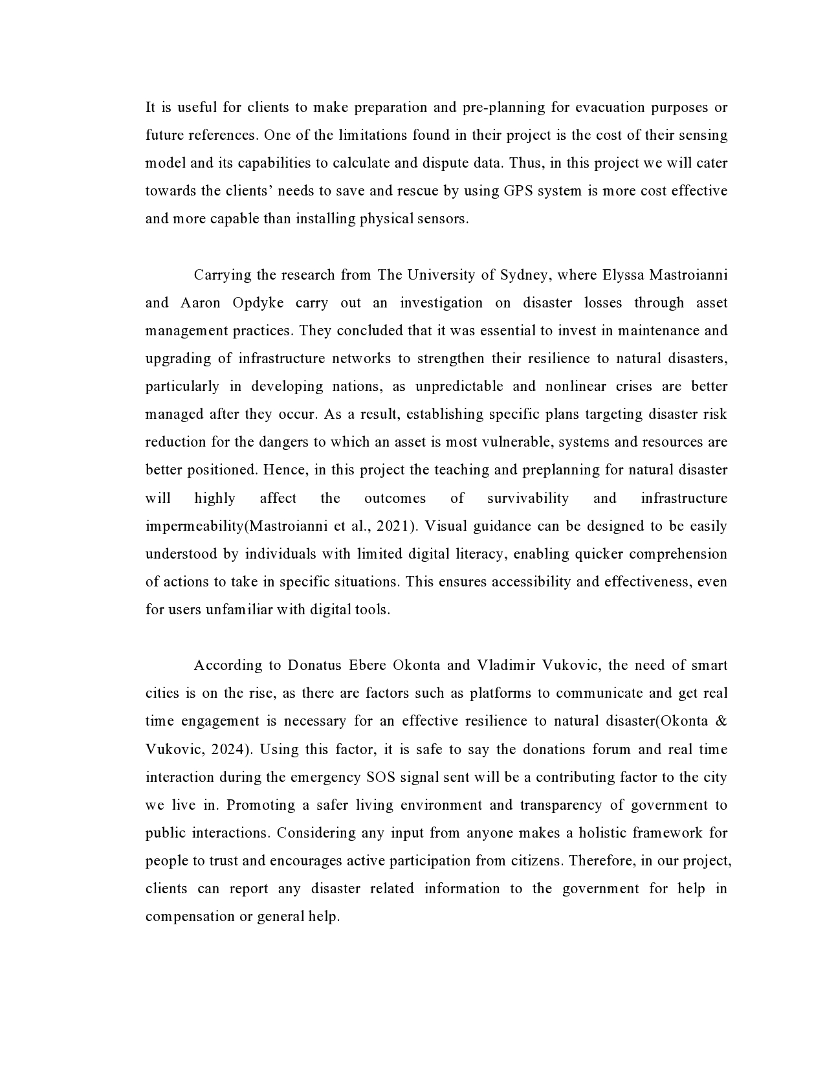

Figure 60: PPF page 7

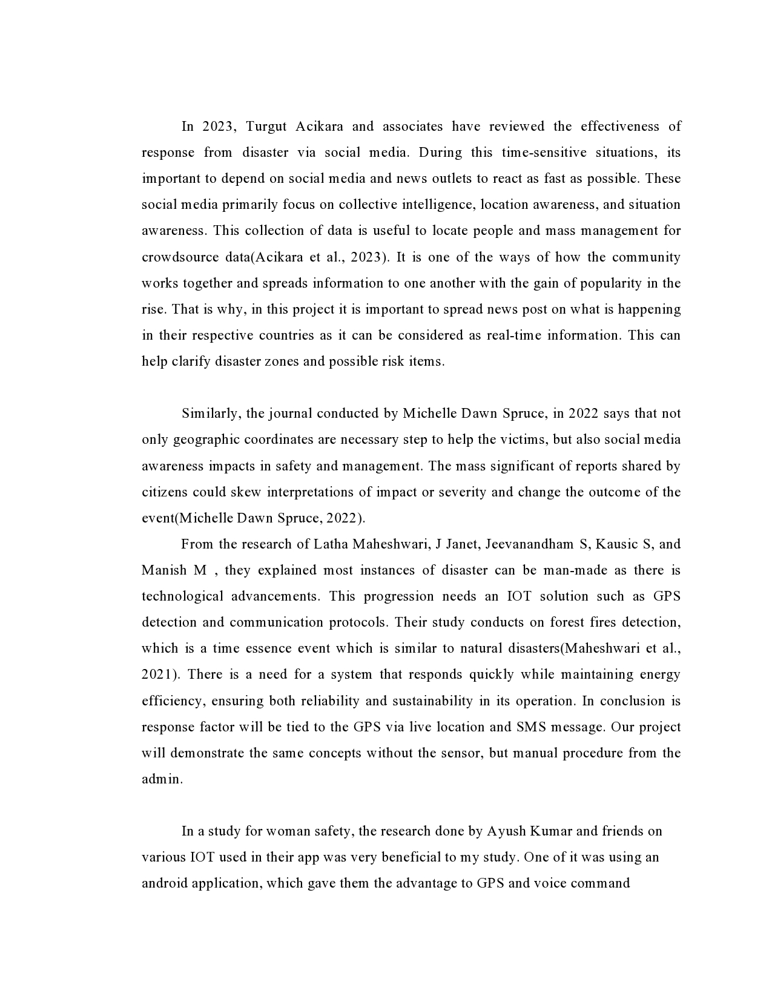

Figure 61: PPF page 8

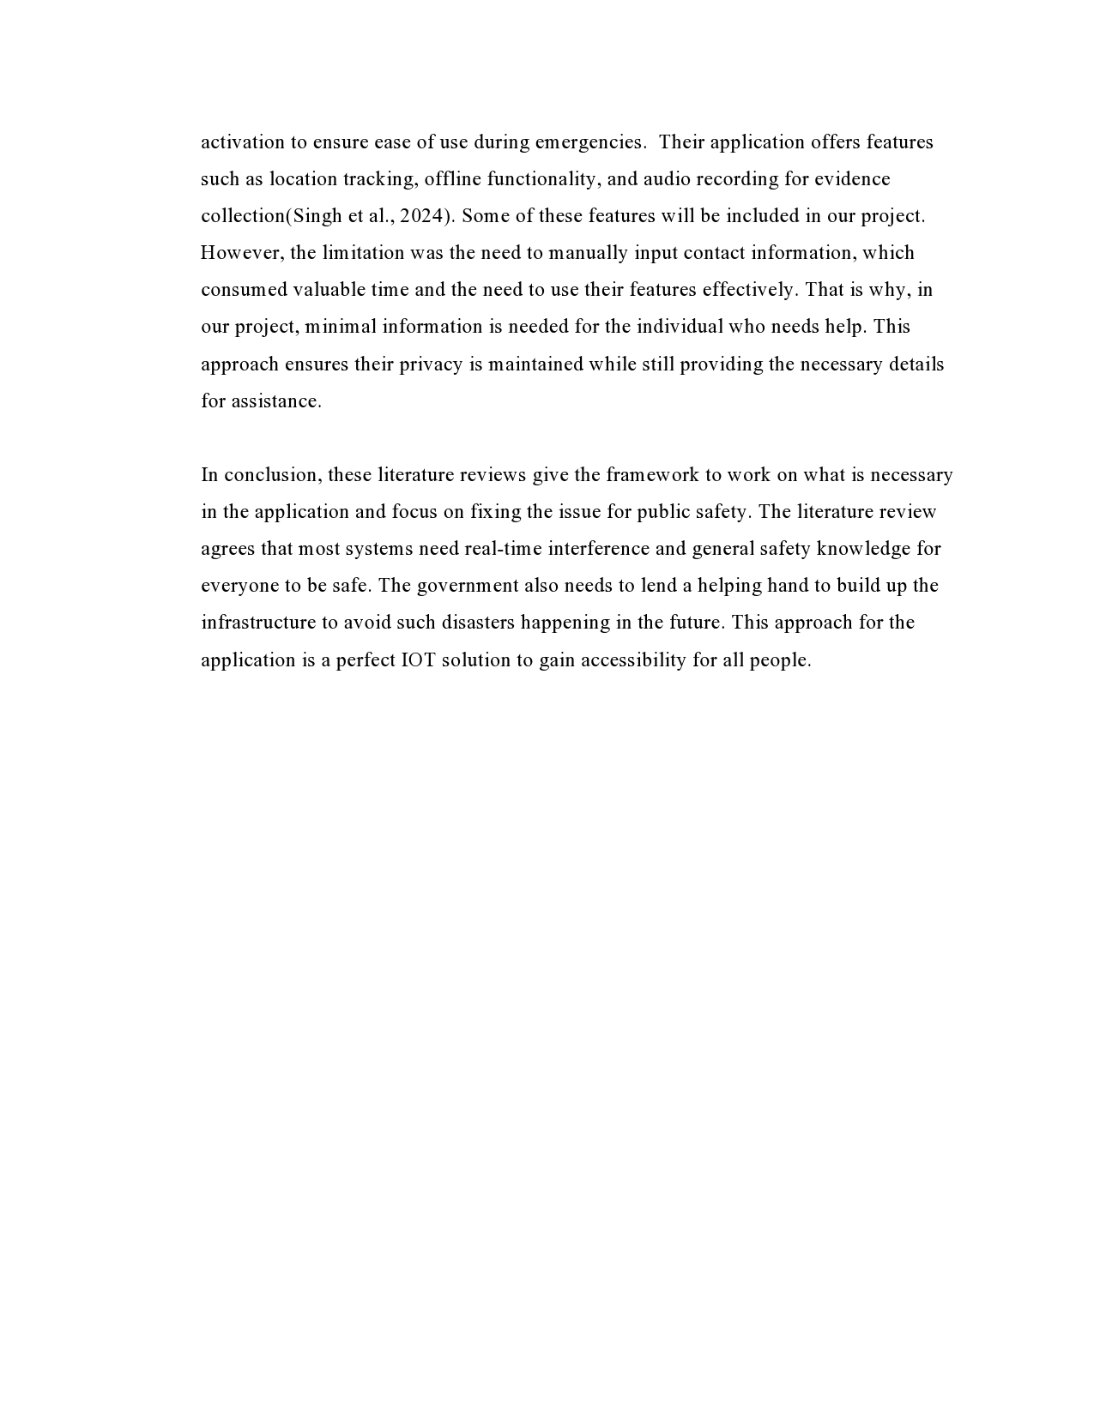

Figure 62: PPF page 9

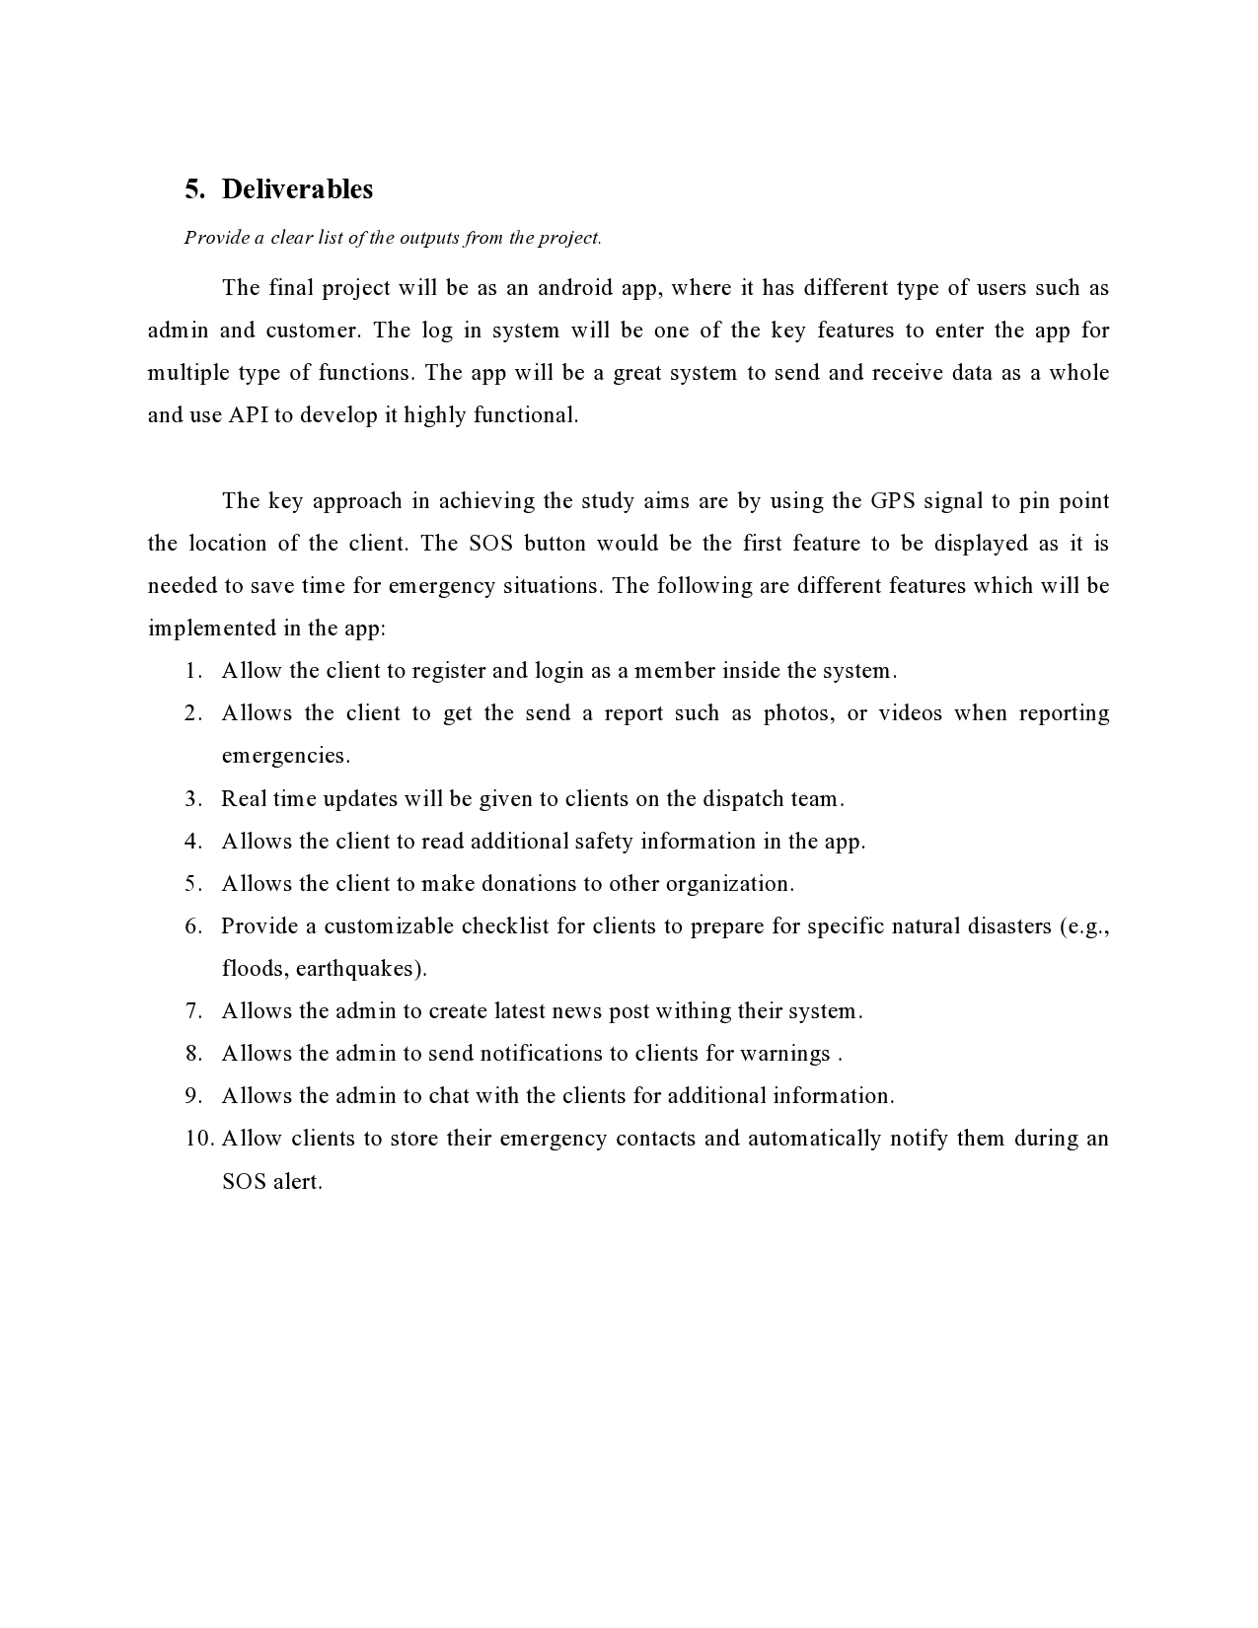

Figure 63: PPF page 10

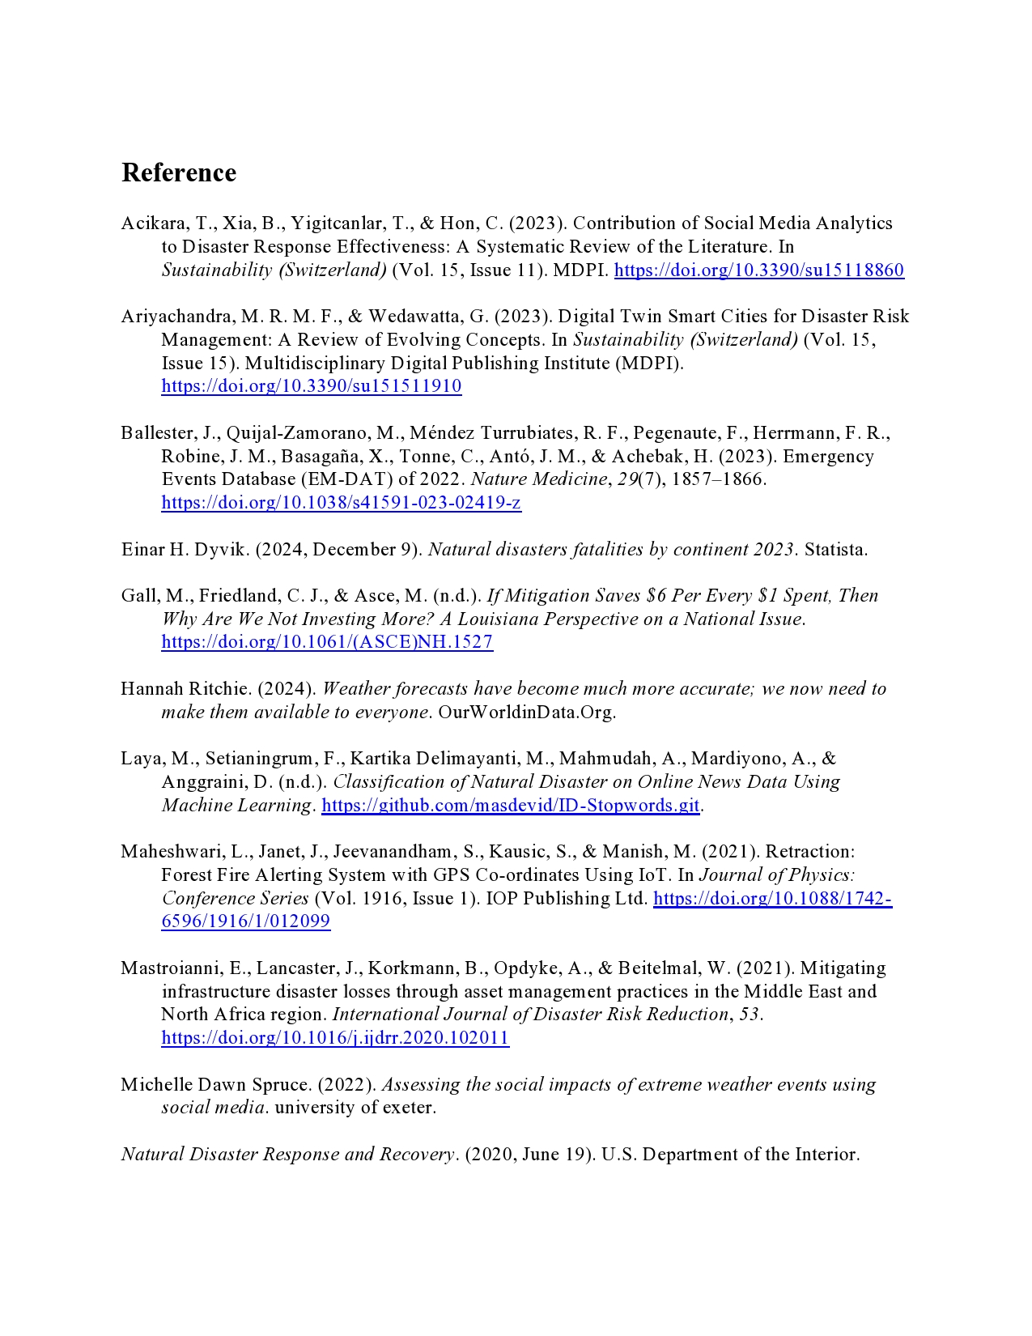

Figure 64: PPF page 11

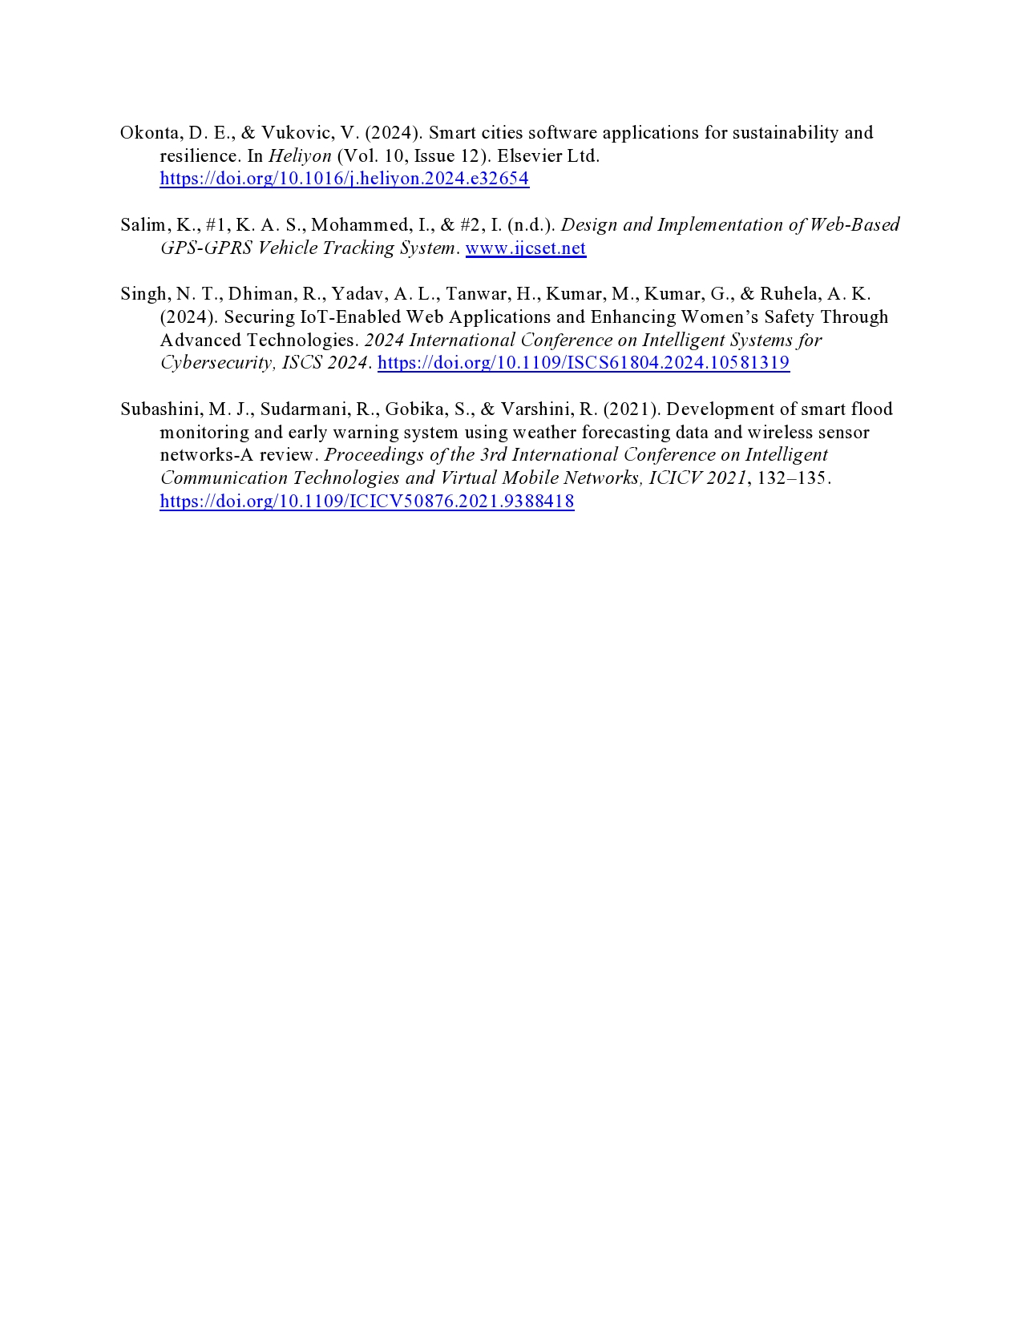

Figure 65: PPF page 12

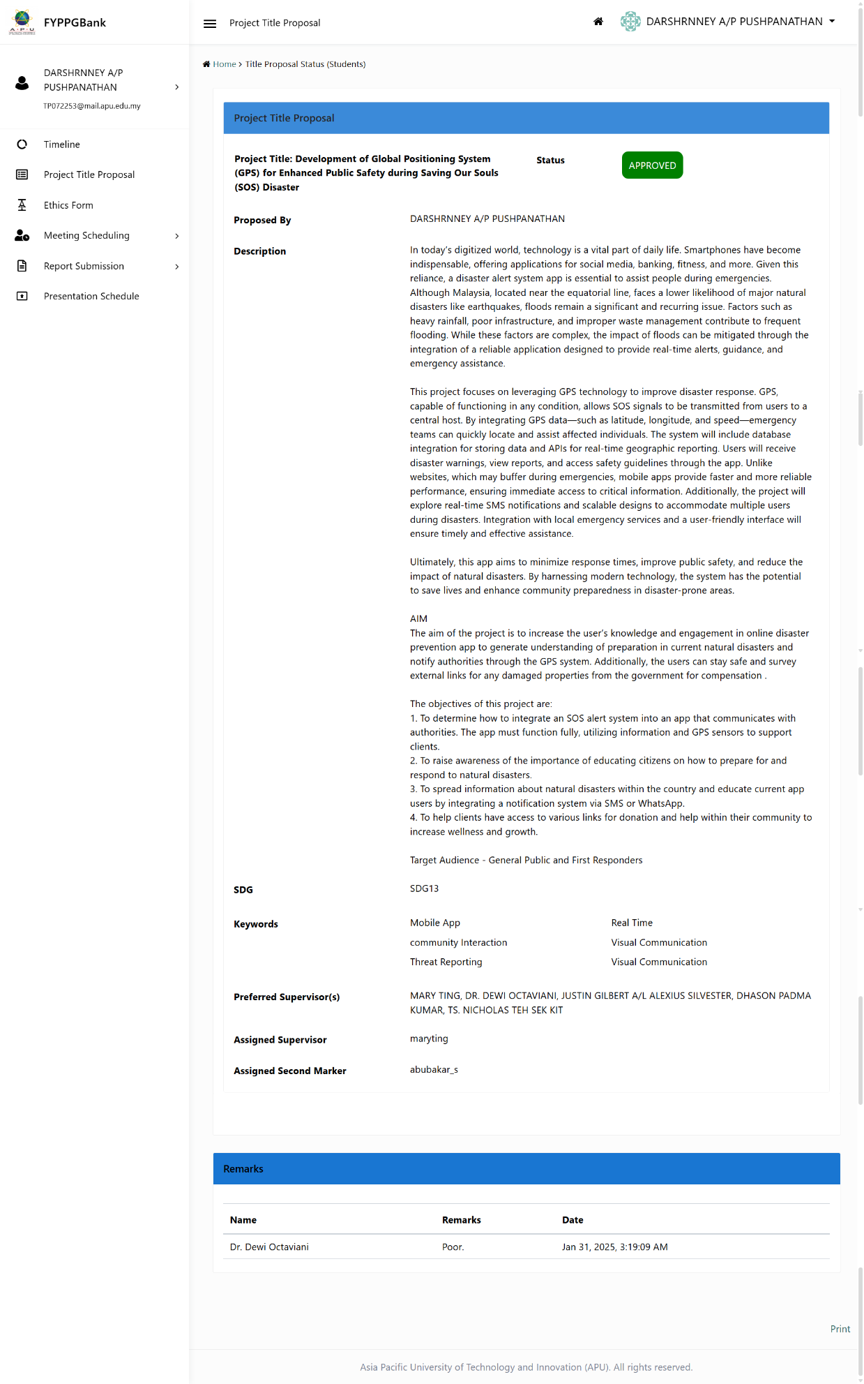

Figure 66: PPF page 13

# Screenshot of signed ethics form

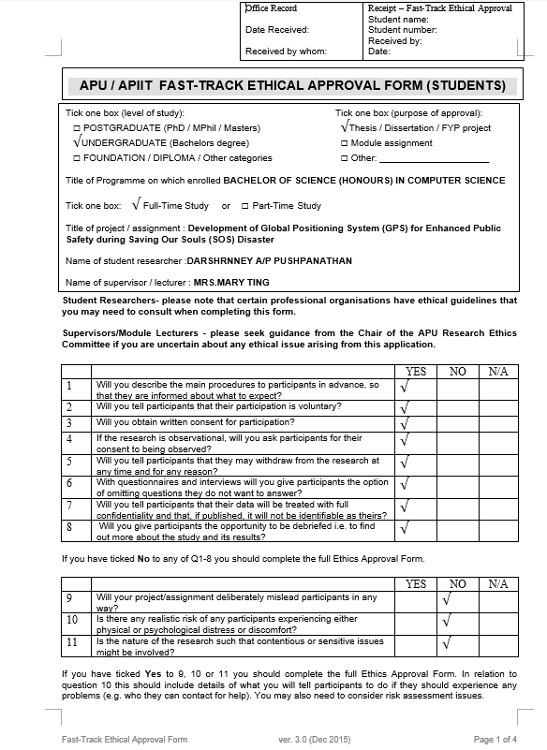

Figure 67: Ethic form page 1

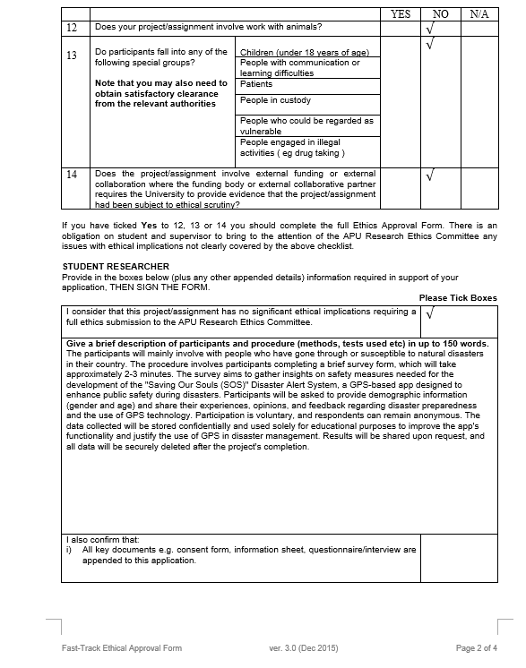

Figure 68: Ethic form page 2

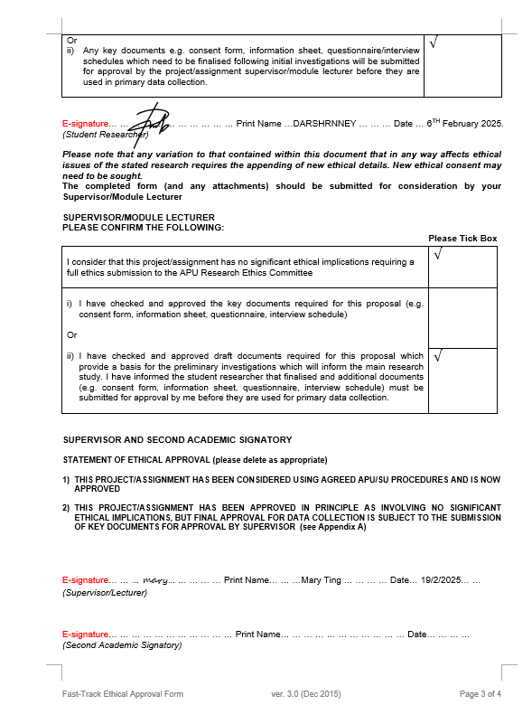

Figure 69: Ethic form page 3

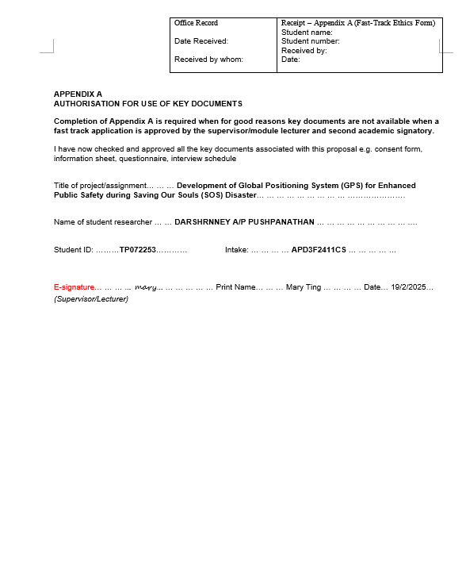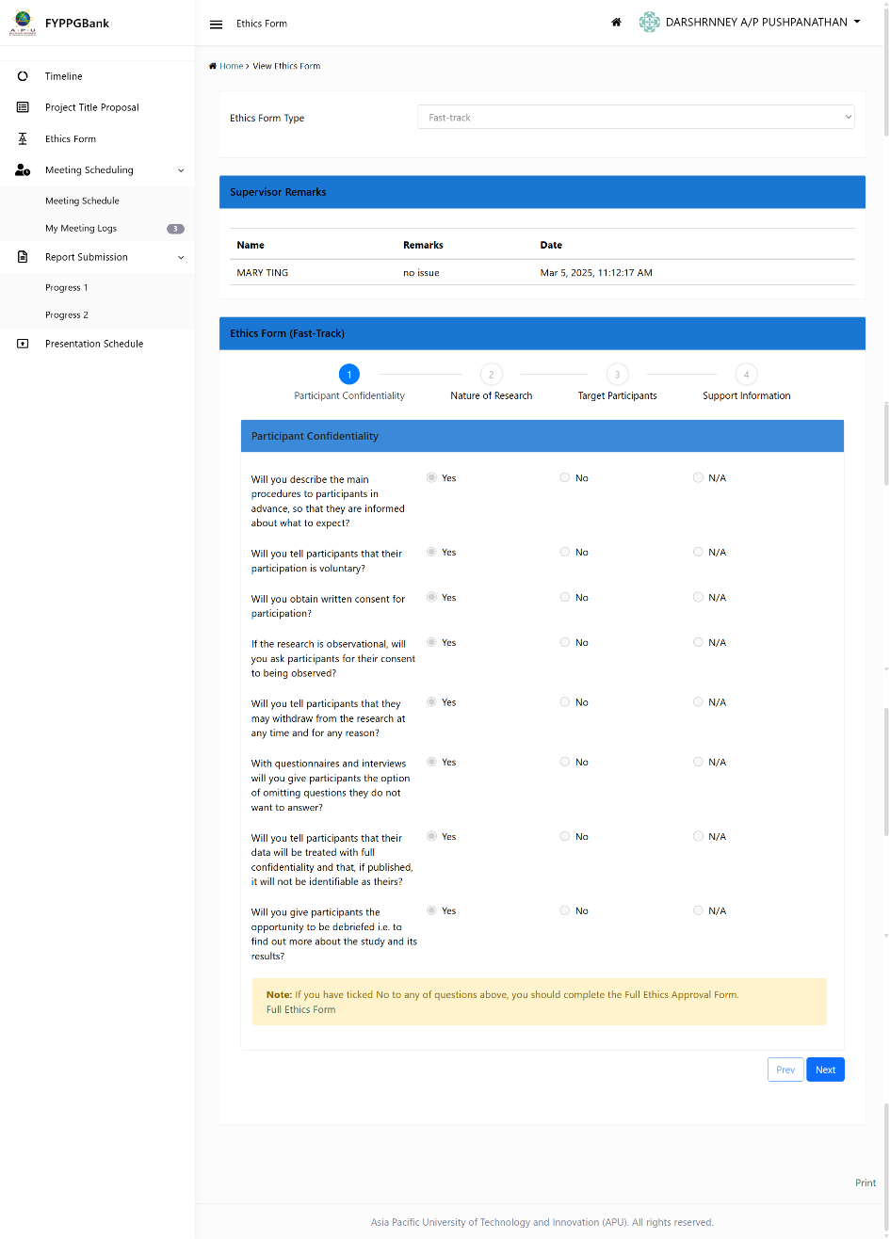

Figure 70: Ethic form page 4

# Screenshot of Log sheets

# Log sheets 1

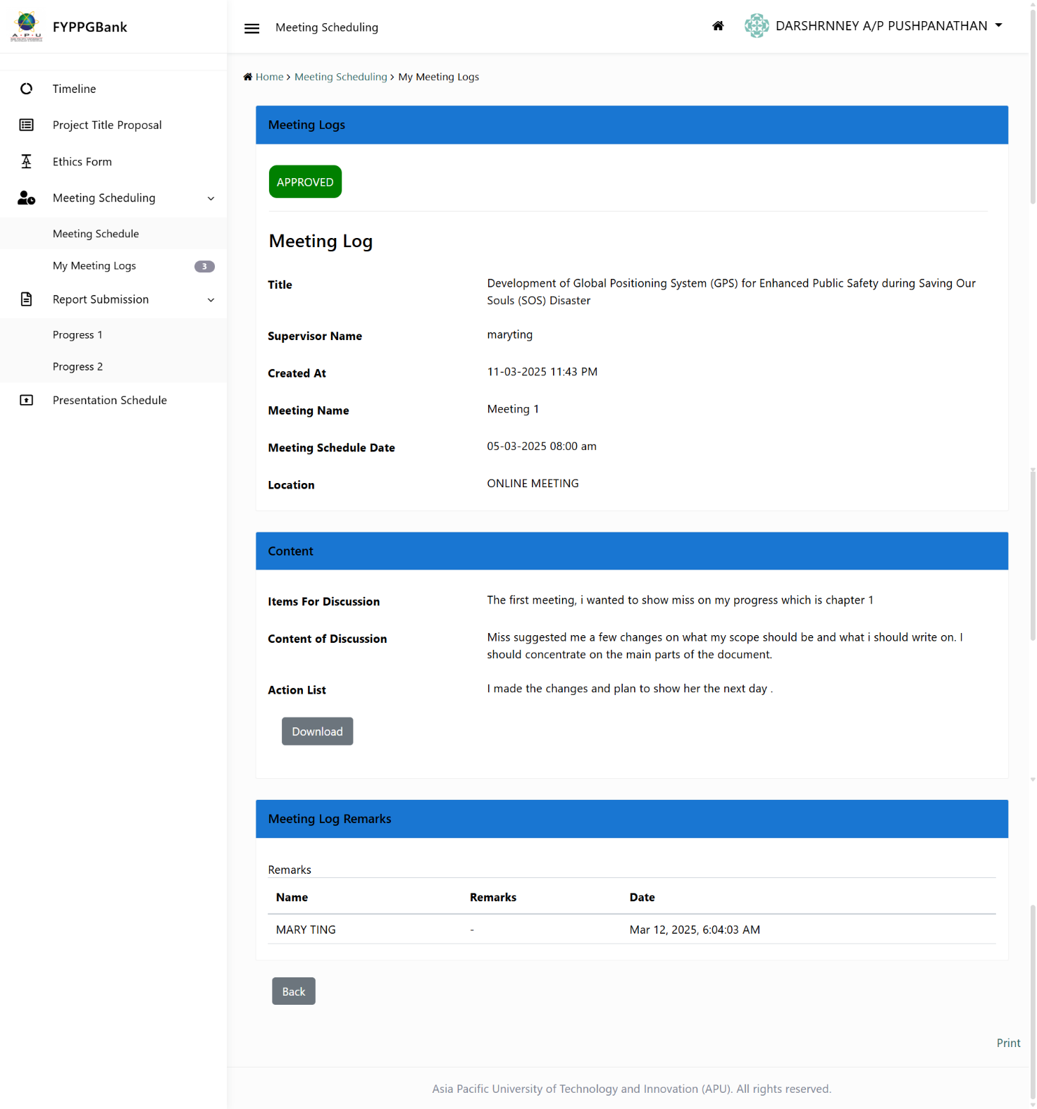

Figure 71:Log sheets 1

# Log sheets 2

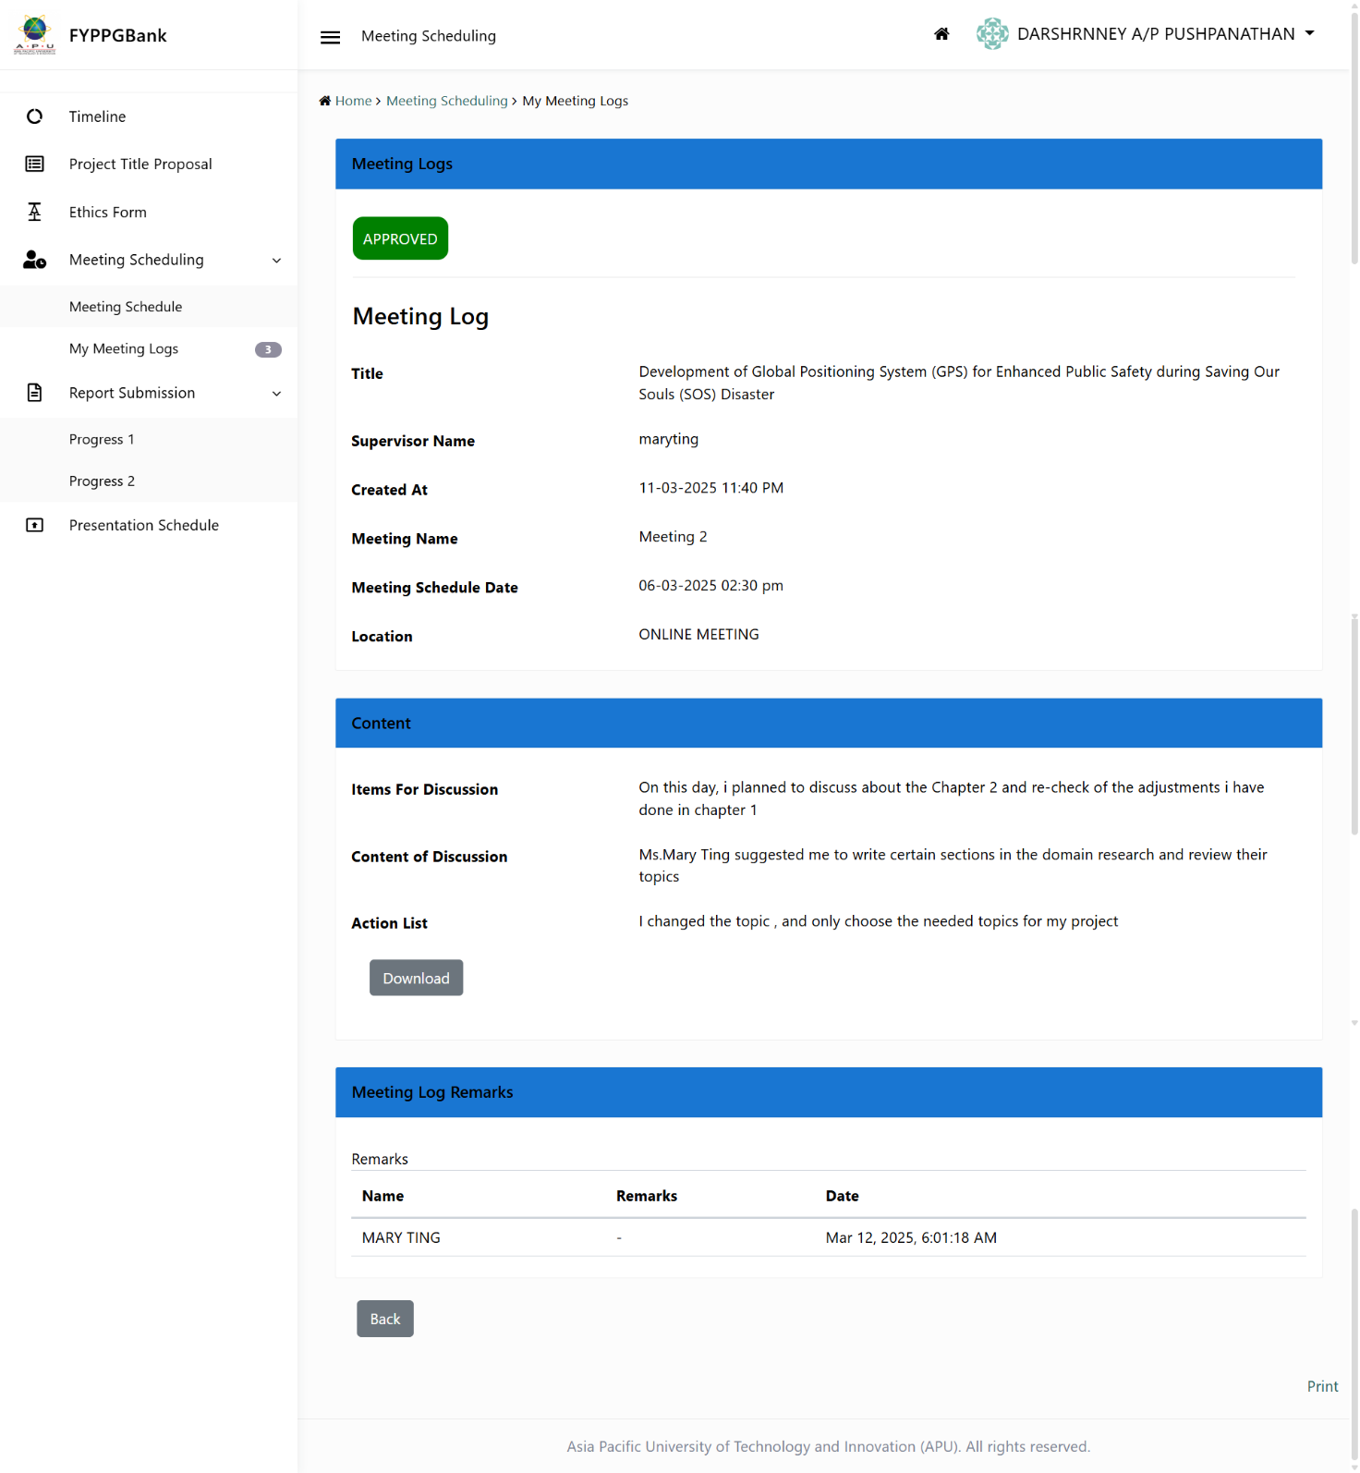

Figure 72:Log sheets 2

# Log sheets 3

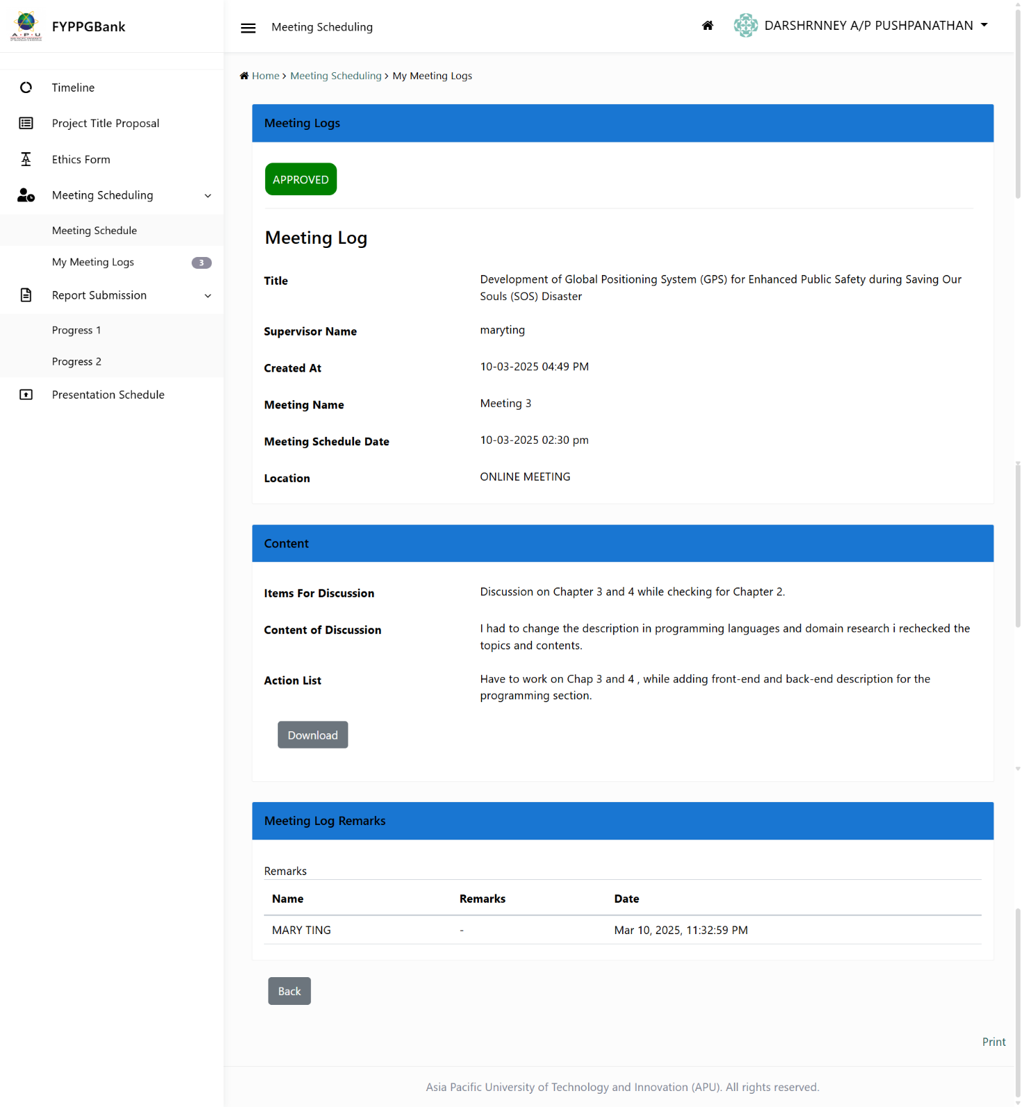

Figure 73:Log sheets 3

# Gantt chart for FYP Semester 1

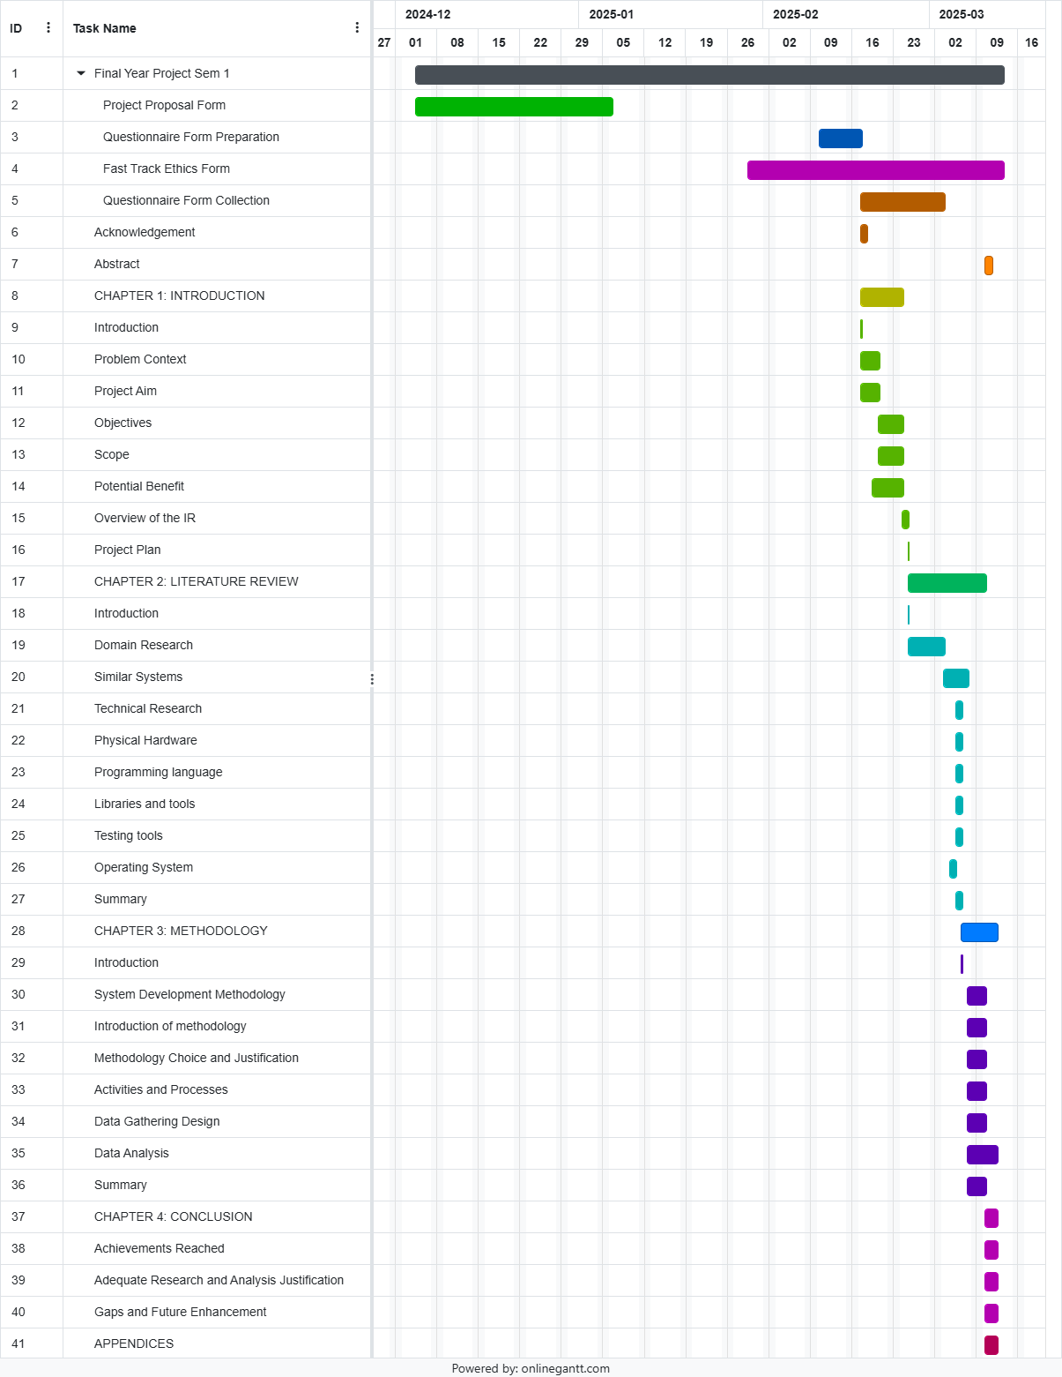

Figure 74:Gantt chart for FYP Semester 1

# Respondence Demographic Profile

|  |  |  |
| --- | --- | --- |
| **Nickname** | **Age Group** | **Gender** |
| adnimahmed8 | 20-25 years old | Female |
| 3eheng2988 | 20-25 years old | Male |
| linishalucky | 20-25 years old | Female |
| muhilan.nalarajah | 31 and above | Male |
| dimitricool88 | 31 and above | Male |
| spongebobrox38 | 20-25 years old | Male |
| khuantatlie0219 | 20-25 years old | Male |
| dhilipkumaar2 | 31 and above | Male |
| puvarajan1621 | 31 and above | Female |
| nithiyasree86 | 31 and above | Female |
| world2domin | 31 and above | Male |
| lubaina3074 | 20-25 years old | Female |
| karan.kumar4991 | 25-30 years old | Male |
| priyashaliniramesh | 31 and above | Female |
| ihaajarcher | 20-25 years old | Female |
| wongyf708 | 20-25 years old | Male |
| xulengteoh | 20-25 years old | Female |
| andysim1104 | 20-25 years old | Male |
| dass.jenna2704 | 20-25 years old | Female |
| mkhamisa500 | 20-25 years old | Female |
| 04sharonafernandez | 20-25 years old | Female |
| callylaw88 | 20-25 years old | Female |
| sharmaine.sam | 31 and above | Female |
| karenvinesha15 | 25-30 years old | Female |
| fareedali2514 | 20-25 years old | Male |
| jeremyaaron1603 | 20-25 years old | Male |
| feliciacalista15 | 20-25 years old | Female |
| mobtahilah | 20-25 years old | Female |
| clarissaramya | 20-25 years old | Female |
| xuanlim0304 | 20-25 years old | Female |
| kirthanassivabalan | 20-25 years old | Female |
| abdullahanjarini | 20-25 years old | Male |
| chuadeewen | 20-25 years old | Female |
| putriennaidil | 20-25 years old | Female |
| kualalumpur491 | 20-25 years old | Male |
| maddahatter25 | 20-25 years old | Female |
| caihongac | 20-25 years old | Female |

Table 5: Responder’s Demograph